Contents

Manage Azure subscriptions and resources 6

Manage Azure subscriptions 6

Assign administrator permissions 7

configure cost center quotas and tagging 9

configure policies at Azure subscription level 11

Analyze resource utilization and consumption 12

configure diagnostic settings on resources 12

Create baseline for resources 13

Create and test alerts 14

Analyze alerts across subscription 18

Analyze metrics across subscription 19

Create action groups and action rules 19

Monitor for unused resources 20

Monitor spend 22

Report on spend 23

Utilize log queries in Azure Monitory 24

Time filter in query 26

View alerts in Azure Monitor 27

Manage resource groups 28

Use Azure policies for resource groups 30

Configure resource locks 30

Configure resource policies 32

Implement and set tagging on resource groups 33

Move resources across resource groups 34

Remove resource groups 34

Managed role based access control (RBAC) 35

Create a custom role 38

Configure access to Azure resources by assigning roles 40

Configure management access to Azure 43

Troubleshoot RBAC 46

Implement RBAC policies 47

Assign RBAC Roles 47

Implement and manage storage 47

Create and configure storage accounts 47

Configure network access to the storage account 52

Create and configure storage account 53

Generate shared access signature 54

Install and use Azure Storage Explorer 55

Manage access keys 56

Monitor activity log by using Monitor Logs 57

Implement Azure storage replication 61

Implement Azure AD Authentication 61

Import and export data to Azure 61

Create export from Azure job 61

Create import into Azure job 62

Use Azure Data Box 63

Configure and use Azure blob storage 65

Configure Azure content delivery network (CDN) endpoints 66

Use Azure Data Factory to transfer data to Azure 67

Configure Azure files 68

Create Azure file share 68

Create Azure File Sync service 69

Create Azure sync group 70

Troubleshoot Azure File Sync 71

Implement Azure backup 72

Configure and review backup reports 73

Perform backup operation 75

Create Recovery Services Vault 76

Create and configure backup policy 78

Perform a restore operation 79

Deploy and manage virtual machines (VMs) 82

Create and configure a VM for Windows and Linux 82

Configure high availability 87

Configure monitoring, networking, storage, and virtual machine size 90

Deploy and configure scale sets 92

Automate deployment of VMs 95

Modify Azure Resource Manager (ARM) template 95

**Configure location of new VMs** 99

**Configure VHD template** 101

**Deploy from template** 101

**Save a deployment as an ARM template** 102

**Deploy Windows and Linux VMs** 102

Manage Azure VM 104

**Add data discs** 104

**Add network interfaces** 104

**Automate configuration management by using PowerShell Desired State Configuration (DSC) and VM Agent by using custom script extensions** 105

**Manage VM sizes** 105

**Move VMs from one resource group to another** 105

**Redeploy VMs** 108

**Soft delete for Azure VMs** 109

Manage VM backups 110

**Configure VM backup; define backup policies; implement backup policies; perform VM restore; Azure Site Recovery** 110

Configure and manage virtual networks 110

Create connectivity between virtual networks 110

Create and configure VNET peering 119

Create and configure VNET to VNET connections 120

Verify virtual network connectivity 122

Create virtual network gateway 123

Implement and manage virtual networking 125

Configure private and public IP addresses, network routes, network interface, subnets, and virtual network 125

Configure name resolution 125

Configure Azure DNS 125

Configure custom DNS settings 129

Configure private and public DNS zones 129

Create and configure a Network Security Group (NSG) 132

Create security rules 132

Associate NSG to a subnet or network interface 133

Identify required ports 134

Evaluate effective security rules 135

Implement Application Security Groups 136

Implement Azure load balancer 137

Configure internal load balancer 138

Configure load balancing rules 138

Configure public load balancer 139

Troubleshoot load balancing 139

Monitor and troubleshoot virtual networking 142

Monitor on-premises connectivity 142

Use Network resource monitoring 142

Use Network Watcher 143

Troubleshoot external networking 144

Troubleshoot virtual network connectivity 147

Integrate on premises network with Azure virtual network 148

Create and configure Azure VPN Gateway 148

Create and configure site to site VPN 151

Configure Express Route 152

Verify on premises connectivity 156

Troubleshoot on premises connectivity with Azure 157

VPN client error: A certificate could not be found 157

Symptom 157

Cause 157

Solution 157

Use Azure network adapter 158

Manage identities 159

Manage Azure Active Directory (AD) 159

Add custom domains 161

Azure AD Join 163

Configure self-service password reset 164

Manage multiple directories 164

In Azure Active Directory (Azure AD), each tenant is a fully independent resource: a peer that is logically independent from the other tenants that you manage. 164

Administrative independence 164

Manage Azure AD objects (users, groups, and devices) 165

Create users and groups 165

Manage user and group properties 166

Manage device settings 167

Perform bulk user updates 168

Manage guest accounts 169

Implement and manage hybrid identities 171

Install Azure AD Connect, including password hash and pass-through synchronization 172

Use Azure AD Connect to configure federation with on-premises Active Directory Domain Services (AD DS) 173

Manage Azure AD Connect 174

Manage password sync and password writeback 175

Implement multi-factor authentication (MFA) 178

Configure user accounts for MFA 178

Enable MFA by using bulk update 178

Configure fraud alerts 178

Configure bypass options 178

Configure Trusted IPs 178

Configure verification methods 178

# Manage Azure subscriptions and resources

## Manage Azure subscriptions

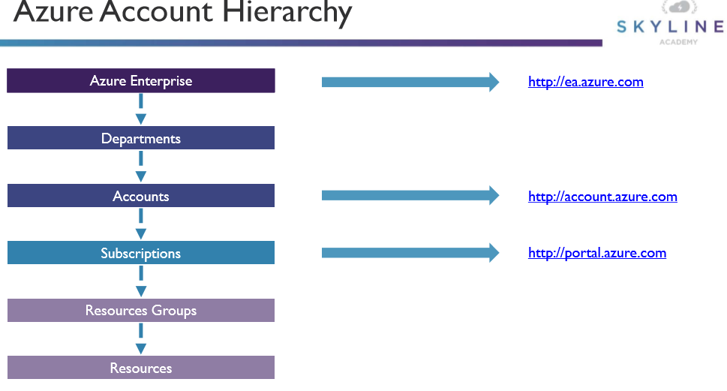

1. **Subscriptions**

A subscription is an agreement with Microsoft to use one or more Microsoft cloud platforms or services

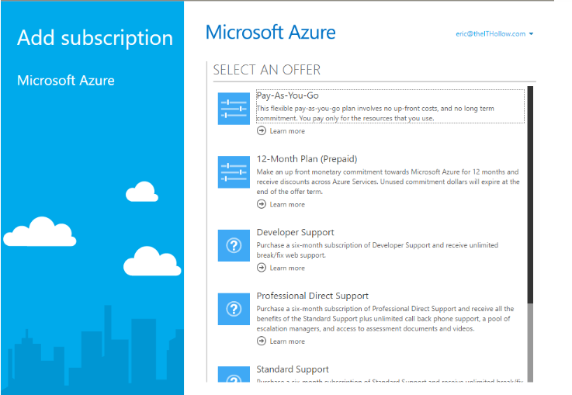

### Assign administrator permissions

1. In the Azure portal, click **All services** and then **Subscriptions**.
2. Click the subscription where you want to grant access.
3. Click **Access control (IAM)**.
4. Click the **Role assignments** tab to view the role assignments for this subscription.

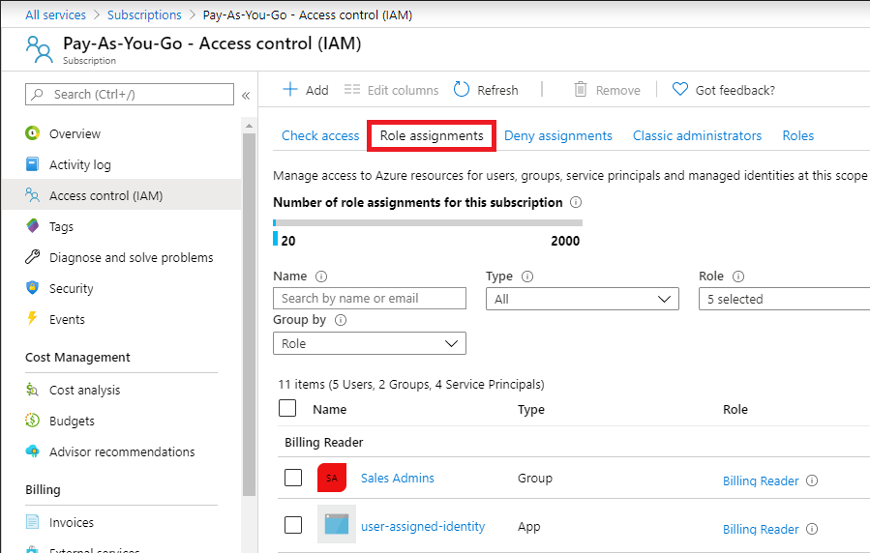

1. Click **Add** > **Add role assignment**.

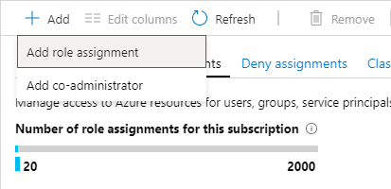

The Add role assignment pane opens.

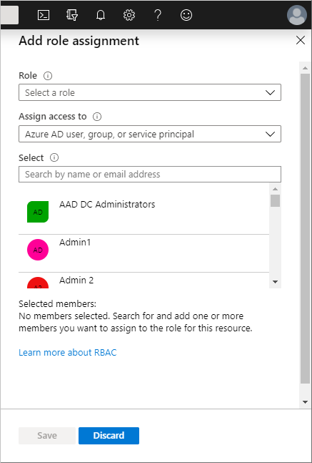

1. In the **Role** drop-down list, select the **Owner** role.
2. In the **Select** list, select a user. Or type in the **Select** box to search the directory for display names and email addresses.
3. Click **Save** to assign the role.

### configure cost center quotas and tagging

Quotas in Azure are basically the limits of creating an amount of resources in Azure. For example, there is a limit of 2,000 availability sets that can be created inside an Azure subscription. However, you can contact Microsoft support if you wish to increase this quota. We need to perform the following steps:

1. Navigate to the Azure portal by opening [https://portal.azure.com](https://portal.azure.com/).
2. In the left-hand menu, select **Subscriptions**.
3. Select the right subscription. In the **Subscriptions** overview blade, under **Settings**, select **Usage + quotas**. There, you can select a provider:

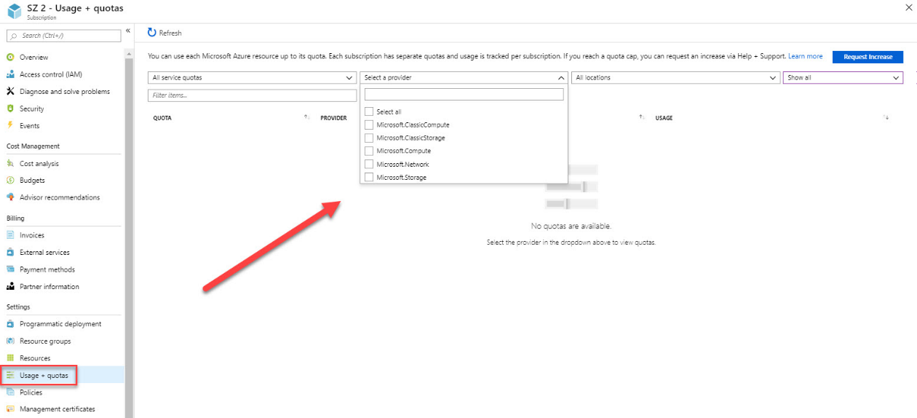

Usage and quotas overview

1. Select **Microsoft.Compute**.
2. You will see the amount of available availability sets for this subscription. If you want to increase this, select the **Request Increase** button on the right-hand side of the screen:

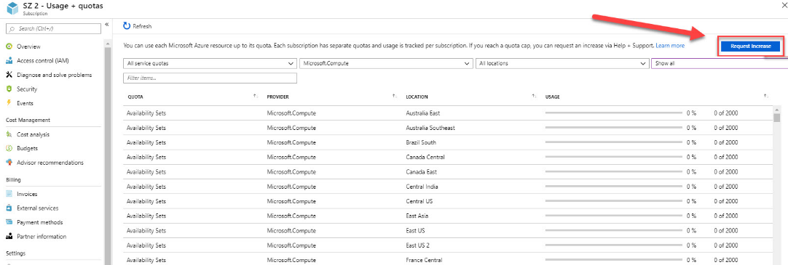

Increasing quotas

1. A new blade will open, where you can create a new support request for increasing the quota of an Azure resource.

**Tags**

Tags to Azure resources are for logically organizing them into a taxonomy. Each tag consists of a name and a value pair.

For example, you can apply the name "Environment" and the value "Production" to all the resources in production.

After you apply tags, you can retrieve all the resources in your subscription with that tag name and value.

### configure policies at Azure subscription level

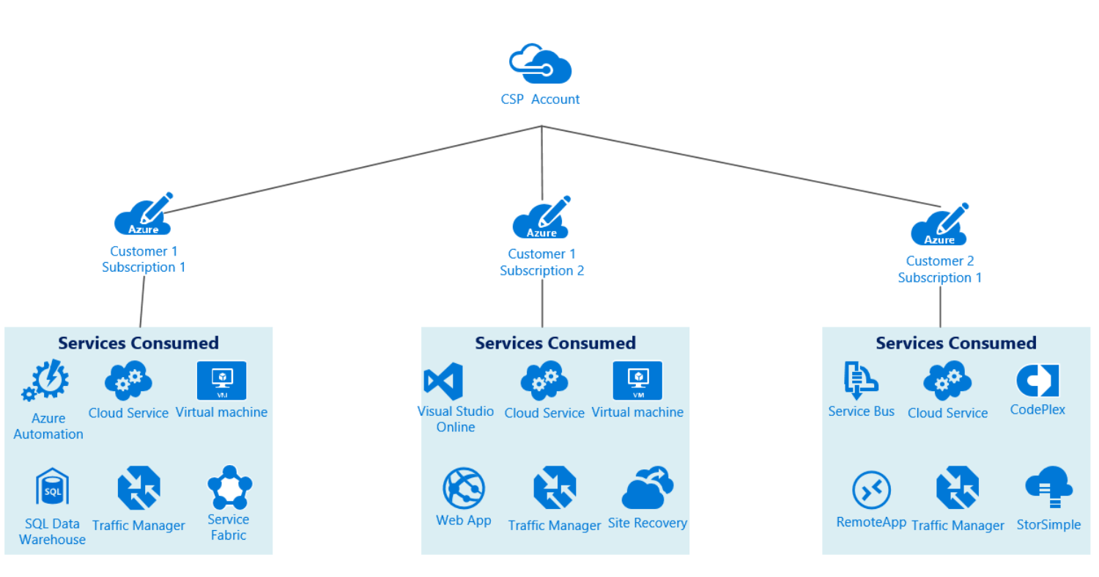

Azure Policy is a service in Azure that you use to create, assign, and manage policies. These policies enforce different rules and effects over your resources, so those resources stay compliant with your corporate standards and service level agreements. Azure Policy meets this need by evaluating your resources for non-compliance with assigned policies. All data stored by Azure Policy is encrypted at rest.

For example, you can have a policy to allow only a certain SKU size of virtual machines in your environment. Once this policy is implemented, new and existing resources are evaluated for compliance. With the right type of policy, existing resources can be brought into compliance. Later in this documentation, we'll go over more details on how to create and implement policies with Azure Policy.

In Azure Policy, we offer several built-in policies that are available by default. For example:

* **Allowed Storage Account SKUs**: Determines if a storage account being deployed is within a set of SKU sizes. Its effect is to deny all storage accounts that don't adhere to the set of defined SKU sizes.
* **Allowed Resource Type**: Defines the resource types that you can deploy. Its effect is to deny all resources that aren't part of this defined list.
* **Allowed Locations**: Restricts the available locations for new resources. Its effect is used to enforce your geo-compliance requirements.
* **Allowed Virtual Machine SKUs**: Specifies a set of virtual machine SKUs that you can deploy.
* **Add a tag to resources**: Applies a required tag and its default value if it's not specified by the deploy request.
* **Enforce tag and its value**: Enforces a required tag and its value to a resource.
* **Not allowed resource types**: Prevents a list of resource types from being deployed.

<https://docs.microsoft.com/en-us/azure/governance/policy/overview>

## Analyze resource utilization and consumption

### configure diagnostic settings on resources

1. Where you configure diagnostic settings in the Azure portal depends on the resource.
   * For a single resource, click **Diagnostic settings** under **Monitor** in the resource's menu.

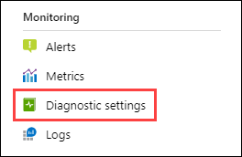

* + For one or more resources, click **Diagnostic settings** under **Settings** in the Azure Monitor menu and then click on the resource.

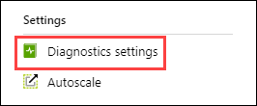

* + For the Activity log, click **Activity log** in the **Azure Monitor** menu and then **Diagnostic settings**. Make sure you disable any legacy configuration for the Activity log. See [Disable existing settings](https://docs.microsoft.com/en-us/azure/azure-monitor/platform/diagnostic-settings-legacy#disable-existing-settings) for details.

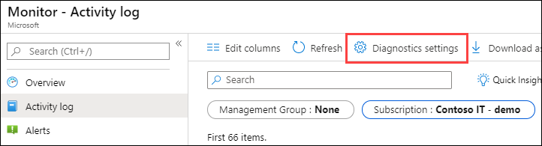

1. If no settings exist on the resource you have selected, you are prompted to create a setting. Click **Add diagnostic setting**.

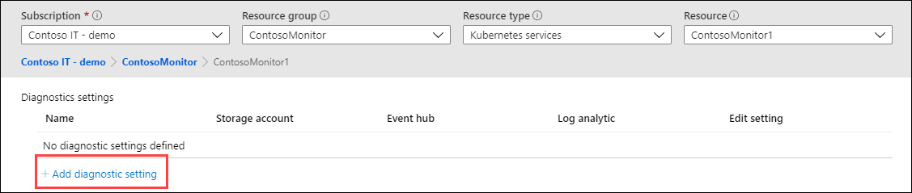

If there are existing settings on the resource, you will see a list of settings already configured. Either click **Add diagnostic setting** to add a new setting or **Edit setting** to edit an existing one. Each setting can have no more than one of each of the destination types.

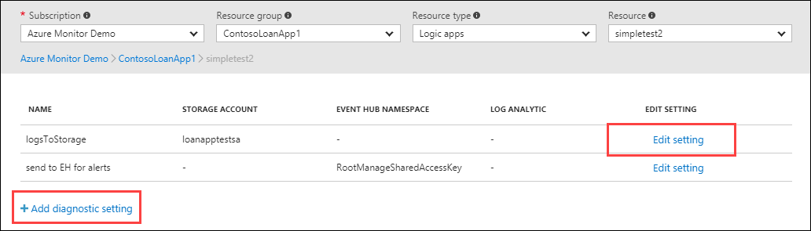

1. Give your setting a name if it doesn't already have one.
2. Check the box for each destination to send the logs. Click **Configure** to specify their settings

### Create baseline for resources

Baseline policies are a set of predefined policies that help protect organizations against many common attacks. These common attacks can include password spray, replay, and phishing. Baseline policies are available in all editions of Azure AD.

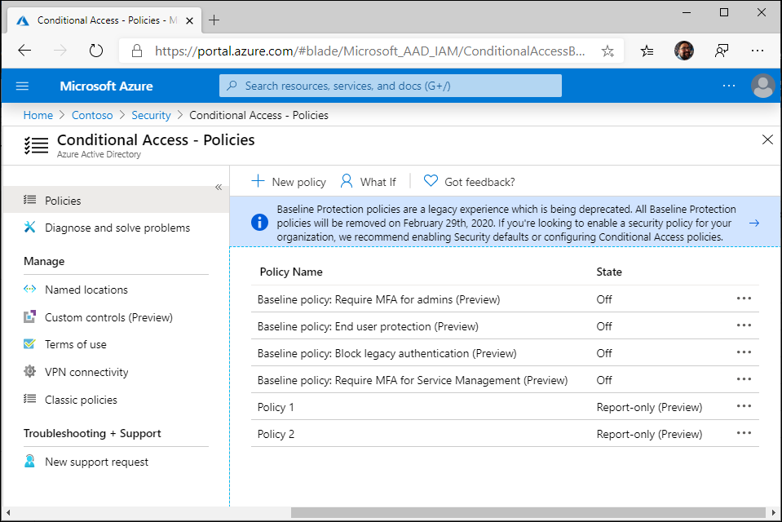

There are four baseline policies:

* Require MFA for admins (preview)
* End user protection (preview)
* Block legacy authentication (preview)
* Require MFA for service management (preview)

### Create and test alerts

1. In the Azure portal, select **Monitor** > **Alerts**.
2. Select **New alert rule** in the upper-left corner of the **Alerts** window.



The **Create rule** window appears.

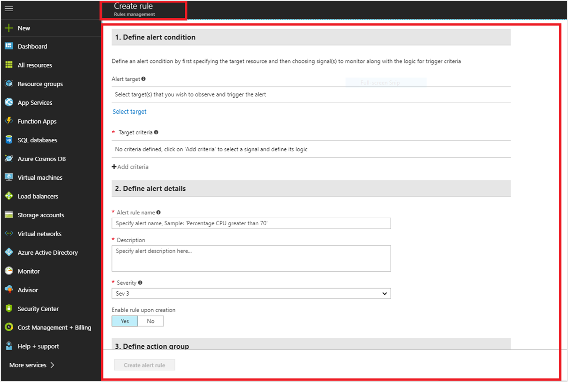

1. Under **Define alert condition**, provide the following information, and select **Done**:
   * **Alert target:** To view and select the target for the new alert, use **Filter by subscription** / **Filter by resource type**. Select the resource or resource group from the list displayed.

**Note**

You can select only [**Azure Resource Manager**](https://docs.microsoft.com/en-us/azure/azure-resource-manager/management/overview) tracked resource, resource group, or an entire subscription for an activity log signal.

**Alert target sample view**

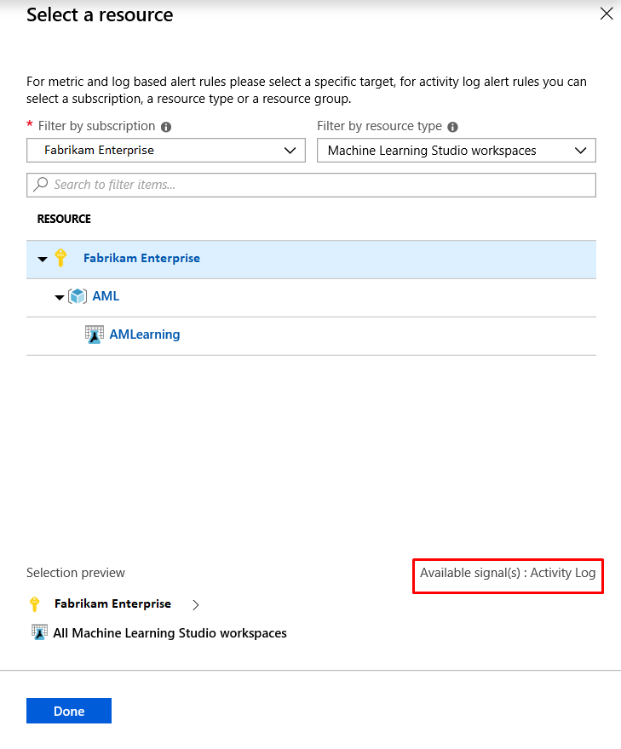

* + Under **Target criteria**, select **Add criteria**. All available signals for the target are displayed, which includes those from various categories of **Activity Log**. The category name is appended to the **Monitor Service** name.
  + Select the signal from the list displayed of various operations possible for the type **Activity Log**.

You can select the log history timeline and the corresponding alert logic for this target signal:

**Add criteria screen**

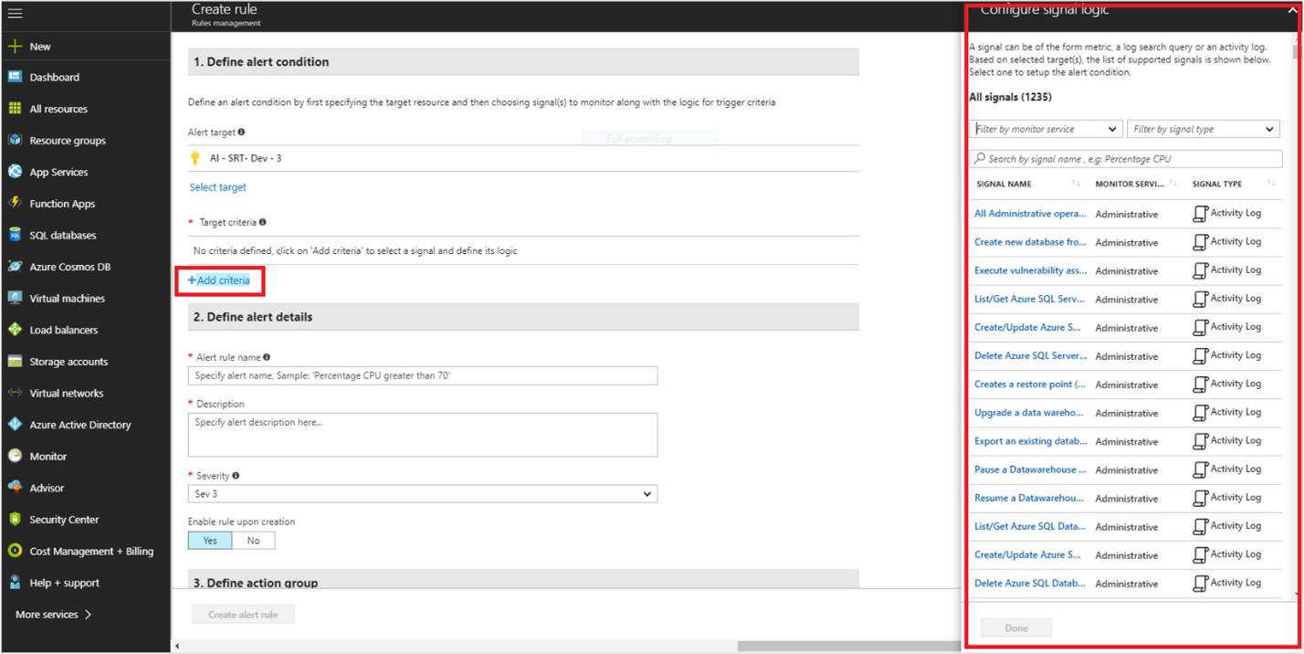

* + - **History time**: Events available for the selected operation can be plotted over the last 6, 12, or 24 hours or over the last week.
    - **Alert logic**:
      * **Event level**: The severity level of the event: Verbose, Informational, Warning, Error, or Critical.
      * **Status**: The status of the event: Started, Failed, or Succeeded.
      * **Event initiated by**: Also known as the caller. The email address or Azure Active Directory identifier of the user who performed the operation.

This sample signal graph has the alert logic applied:

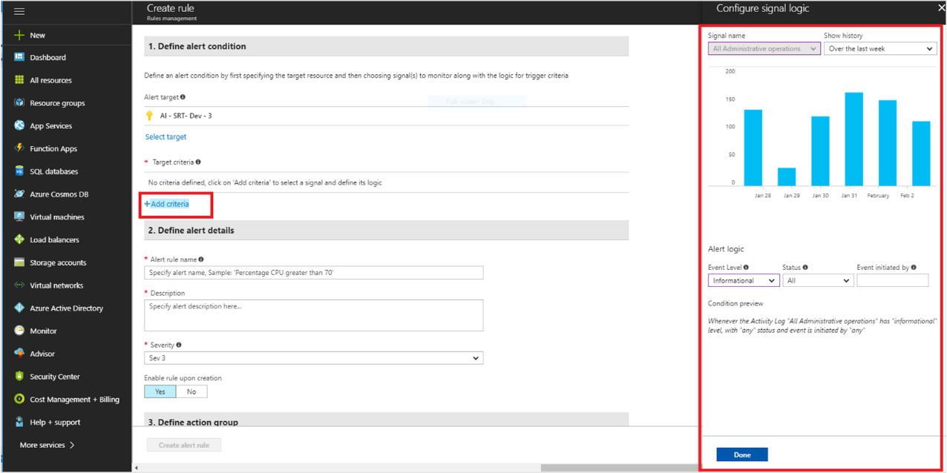

1. Under **Define alert details**, provide the following details:
   * **Alert rule name**: The name for the new alert rule.
   * **Description**: The description for the new alert rule.
   * **Save alert to resource group**: Select the resource group where you want to save this new rule.
2. Under **Action group**, from the drop-down menu, specify the action group that you want to assign to this new alert rule. Or, [create a new action group](https://docs.microsoft.com/en-us/azure/azure-monitor/platform/action-groups) and assign it to the new rule. To create a new group, select **+ New group**.
3. To enable the rules after you create them, select **Yes** for the **Enable rule upon creation** option.
4. Select **Create alert rule**.

### Analyze alerts across subscription

1. In Azure portal, navigate to **Monitor**
2. Click on **Alerts** and **Manage rules**
3. In the **Manage rules** blade, you can view all your alert rules across subscriptions. You can further filter the rules using **Resource group**, **Resource type**, and **Resource**. If you want to see only metric alerts, select **Signal type** as Metrics.
4. Click on the name of the metric alert rule you want to edit
5. In the Edit Rule, click on the **Alert criteria** you want to edit. You can change the metric, threshold condition and other fields as required
6. Click **Done** to save your edits.

### Analyze metrics across subscription

**Step 1 –**In Azure portal, click on Monitor. The Monitor blade consolidates all your monitoring settings and data in one view.

**Step 2 –**Click Alerts then click + New alert rule.

**Step 3 –**Click Select target, in the context pane that loads, select a target resource that we want to alert on. Use Subscription and Resource type drop-downs to find the resource we wish to monitor. We can also use the search bar to find the resource.

**Step 4 –**If the selected resource has metrics we can create alerts on, Available signals on the bottom right will include metrics.

**Step 5 –**Once we have selected a target resource, click on Add condition.

**Step 6 –**We will see a list of signals supported for the resource, select the metric we want to create an alert on.

**Step 7 –**Optionally, refine the metric by adjusting Period and Aggregation. If the metric has dimensions, we will see Dimensions table presented.

**Step 8 –**Select one or more values per dimension. The metric alert will run evaluate the condition for all combinations of values selected.

**Step 9 –**We will see a chart for the metric for the last 6 hours. Then define the alert parameters – Condition Type, Frequency, Operator and Threshold or Sensitivity, this will determine the logic which the metric alert rule will evaluate.

**Step 10 –**Now if we are using a static threshold, the metric chart can help determine what might be a reasonable threshold. If we are using a Dynamic Thresholds, the metric chart will display the calculated thresholds based on recent data.

**Step 11-**Click Done

### Create action groups and action rules

Action rules help you define or suppress actions at any Azure Resource Manager scope (Azure subscription, resource group, or target resource). They have various filters that help you narrow down the specific subset of alert instances that you want to act on.

**Scenarios**

Suppress the notifications during a planned maintenance window

Suppress the notifications during non-business hours

Action rules help you define alert suppression at scale with the ability to flexibly configure the period of suppression.

By defining actions at scale, an action group can be triggered for any alert that's generated on the configured scope.

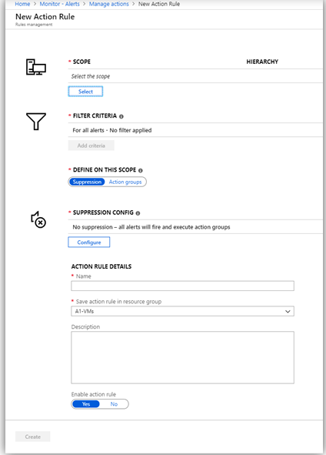

### Monitor for unused resources

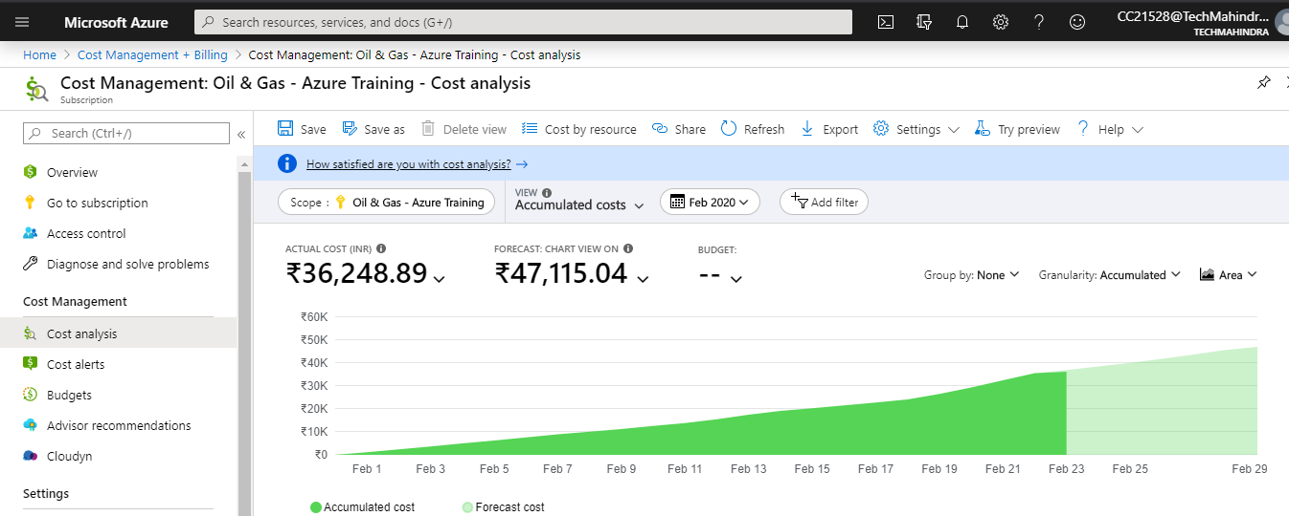

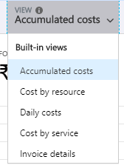

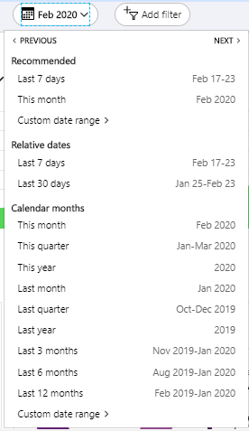

### Monitor spend

Use Cost Management alerts to monitor your Azure usage and spending.

**Budget alerts**: Budgets are defined by cost or by consumption usage. Budget alerts support both cost-based and usage-based budgets. Budget alerts are generated automatically whenever the budget alert conditions are met.

**Credit alerts**: Credit alerts notify you when your Azure credit monetary commitments are consumed. Credit alerts are generated automatically at 90% and at 100% of your Azure credit balance.

**Quota alerts**: quota alerts notify you when department spending reaches a fixed threshold of the quota. Whenever a threshold is met it generates an email to department owners and is shown in cost alerts.

| **Alert type** | **Enterprise Agreement** | **Microsoft Customer Agreement** | **Web direct/Pay-As-You-Go** |
| --- | --- | --- | --- |
| Budget | ✔ | ✔ | ✔ |
| Credit | ✔ | ✘ | ✘ |
| Department spending quota | ✔ | ✘ | ✘ |

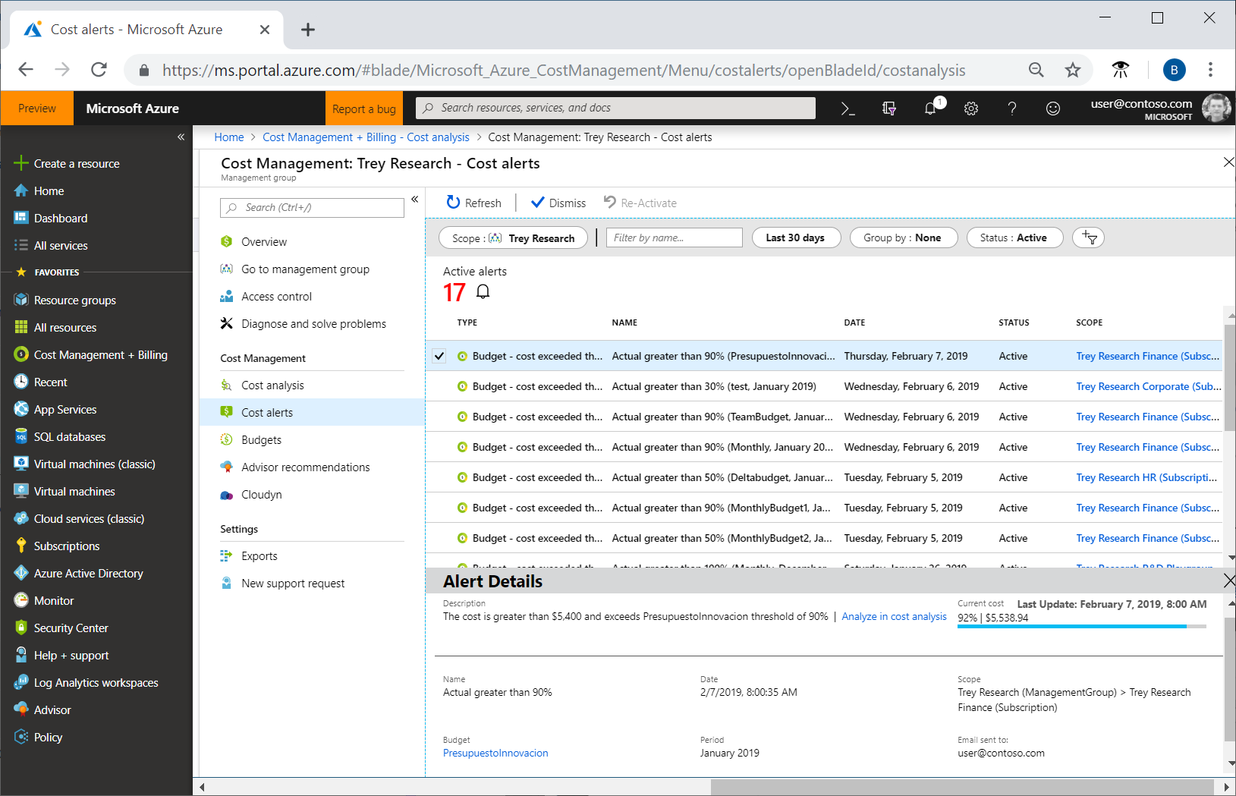

### Report on spend

Search for Cost Management + **Billing**. Depending on your access, you might need to select a **Billing** account or **Billing** profile. In the left menu, select Invoices under **Billing**. In the invoice grid, **find** the row of the **billing** period corresponding to the **usage** you want to download.

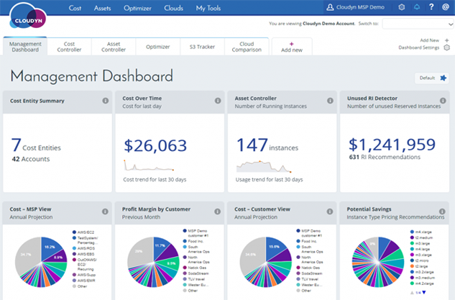

### Utilize log queries in Azure Monitory

Azure Monitor Logs is based on [Azure Data Explorer](https://docs.microsoft.com/en-us/azure/data-explorer), and log queries are written using Kusto query language (KQL). This query language is case-sensitive.

**Table-based queries**

Azure Monitor organizes log data in tables, each composed of multiple columns. All tables and columns are shown on the schema pane in Log Analytics in the Analytics portal.

*SecurityEvent | take 10*

The query shown above returns 10 results from the SecurityEvent table, in no specific order.

**Search queries**

Search queries are less structured, and generally more suited for finding records that include a specific value in any of their columns

*search in (SecurityEvent) "Cryptographic" | take 10*

This query searches the SecurityEvent table for records that contain the phrase "Cryptographic". Of those records, 10 records will be returned and displayed.

**Sort and top**

To get an ordered view, you could **sort** by the preferred column

*SecurityEvent | sort by TimeGenerated desc*

The above query sorts the entire SecurityEvent table by the TimeGenerated column.

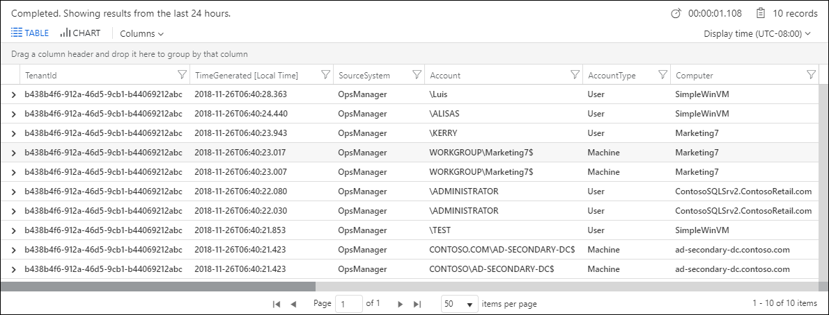

To add a filter to a query, use the **where** operator followed by one or more conditions.

*SecurityEvent | where Level == 8*

*SecurityEvent | where Level == 8 and EventID == 4672*

*SecurityEvent | where Level == 8 | where EventID == 4672*

**Specify a time range**

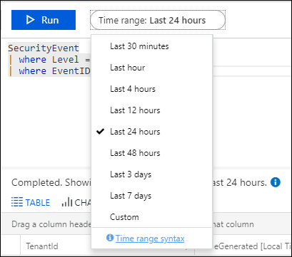

### Time filter in query

*SecurityEvent | where TimeGenerated > ago(30m) | where toint(Level) >= 10*

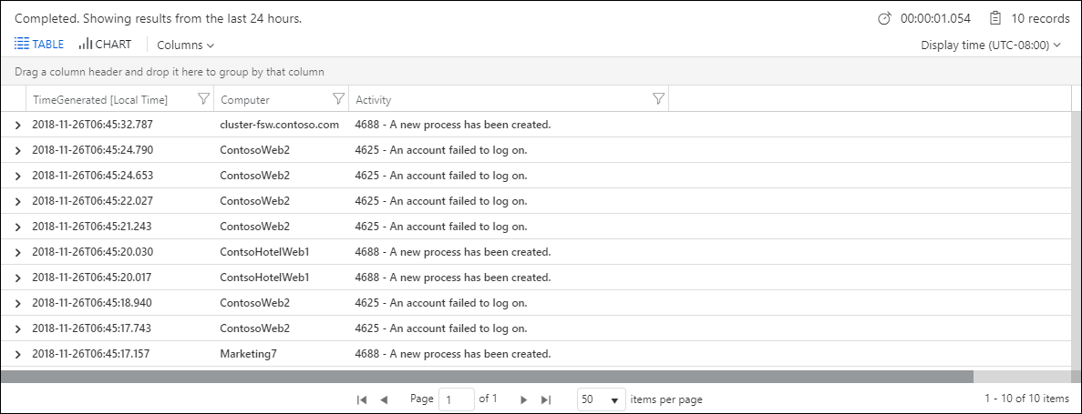

**Summarize: aggregate groups of rows**

The following query reviews all Perf records from the last hour, groups them by ObjectName, and counts the records in each group

*Perf | where TimeGenerated > ago(1h) | summarize count() by ObjectName*

 In Azure Monitor you will use queries in the following scenarios apart from interactively working with log queries

* **Alert rules.** [Alert rules](https://docs.microsoft.com/en-us/azure/azure-monitor/platform/alerts-overview) proactively identify issues from data in your workspace. Each alert rule is based on a log search that is automatically run at regular intervals.
* **Dashboards.** You can pin the results of any query into an [Azure dashboard](https://docs.microsoft.com/en-us/azure/azure-monitor/learn/tutorial-logs-dashboards) which allow you to visualize log and metric data together and optionally share with other Azure users.
* **Views.** You can create visualizations of data to be included in user dashboards with [View Designer](https://docs.microsoft.com/en-us/azure/azure-monitor/platform/view-designer). Log queries provide the data used by [tiles](https://docs.microsoft.com/en-us/azure/azure-monitor/platform/view-designer-tiles) and [visualization parts](https://docs.microsoft.com/en-us/azure/azure-monitor/platform/view-designer-parts) in each view.
* **Export.** When you import log data from Azure Monitor into Excel or [Power BI](https://docs.microsoft.com/en-us/azure/azure-monitor/platform/powerbi), you create a log query to define the data to export.
* **PowerShell.** You can run a PowerShell script from a command line or an Azure Automation runbook that uses [Get-AzOperationalInsightsSearchResults](https://docs.microsoft.com/en-us/powershell/module/az.operationalinsights/get-azoperationalinsightssearchresult) to retrieve log data from Azure Monitor. This cmdlet requires a query to determine the data to retrieve.
* **Azure Monitor Logs API.** The [Azure Monitor Logs API](https://dev.loganalytics.io/) allows any REST API client to retrieve log data from the workspace. The API request includes a query that is run against Azure Monitor to determine the data to retrieve.

### View alerts in Azure Monitor

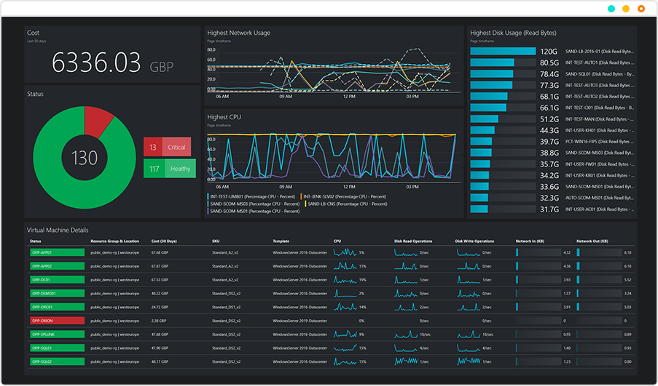

1. In Azure portal, navigate to **Monitor**
2. Click on **Alerts** and **Manage rules**
3. In the **Manage rules** blade, you can view all your alert rules across subscriptions. You can further filter the rules using **Resource group**, **Resource type**, and **Resource**. If you want to see only metric alerts, select **Signal type** as Metrics.
4. Click on the name of the metric alert rule you want to edit
5. In the Edit Rule, click on the **Alert criteria** you want to edit. You can change the metric, threshold condition and other fields as required
6. Click **Done** to save your edits.

## Manage resource groups

Azure Resources Groups are logical collections of related resources for an application / environment

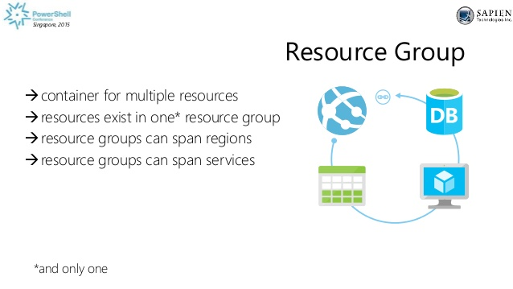

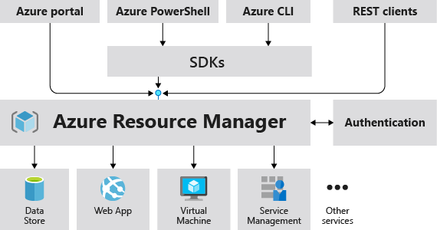

The benefits of using Resource Manager

* Manage your infrastructure through declarative templates rather than scripts.
* Deploy, manage, and monitor all the resources for your solution as a group, rather than handling these resources individually.
* Redeploy your solution throughout the development lifecycle and have confidence your resources are deployed in a consistent state.
* Define the dependencies between resources so they're deployed in the correct order.
* Apply access control to all services in your resource group because Role-Based Access Control (RBAC) is natively integrated into the management platform.
* Apply tags to resources to logically organize all the resources in your subscription.
* Clarify your organization's billing by viewing costs for a group of resources sharing the same tag.

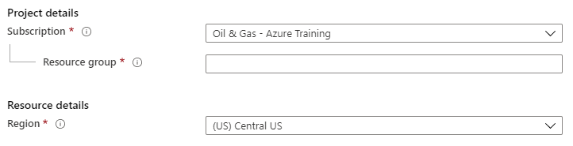

Three resource groups created

1. Client
2. Vendor
3. DevTest
4. Tags are appended to all three resource groups

**Resource Tags**

Resource tags help to logically organize Azure resources into a taxonomy. Each tag consists of a name and a value pair. Tags enable you to retrieve related resources from different resource groups.

### Use Azure policies for resource groups

Azure Policy is a service in Azure that you use to create, assign, and manage policies. These policies enforce different rules and effects over your resources, so those resources stay compliant with your corporate standards and service level agreements.

[**Azure Policies**](https://docs.microsoft.com/en-us/azure/governance/policy/overview?WT.mc_id=ITOPSTALK-blog-abartolo) focus on resource properties during deployment and for already existing resources.

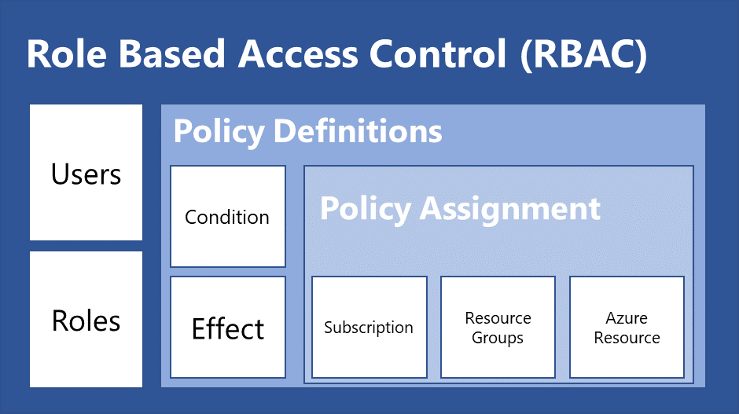

### Configure resource locks

Administrators can set locks on your Azure resources to prevent other users from deleting the resource or making any changes to it. You can set two different lock levels on your subscriptions, resource groups, or resources:

* **CanNotDelete**: This level prevents authorized users from deleting the resource. They can still read and modify the resource.
* **ReadOnly**: Within this level, authorized users can read a resource, but they cannot delete or update it. This level is similar to assigning all authorized users to the reader role using RBAC.

To apply a lock on your resource group, you have to perform the following steps:

1. Navigate to the Azure portal by opening [https://portal.azure.com](https://portal.azure.com/).
2. In the left-hand menu, select **Resource groups**. Select the resource group that we created in the previous demonstration.
3. In the **Resource Group** overview blade, under **Settings**, select **Locks**:

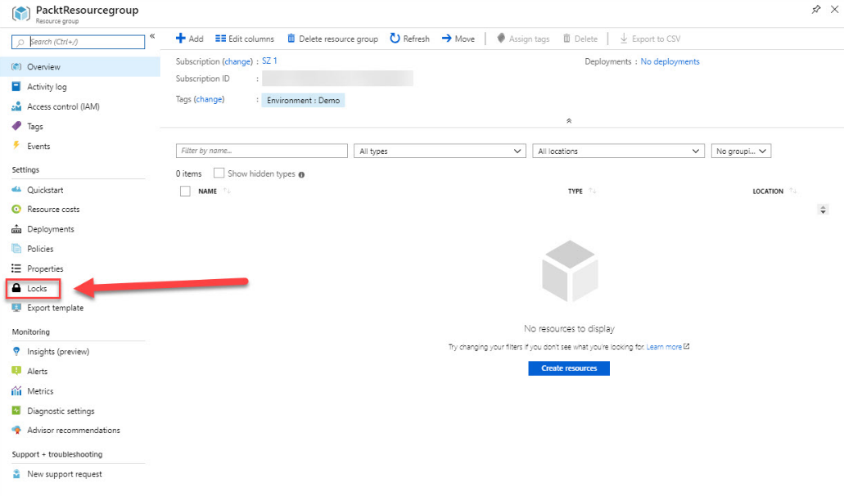

Resource group overview

1. On the next screen, click **Add** in the top menu to create a new lock for this resource.
2. Add the following values:
   * **Name**: No-Deletion
   * **Lock type**: **Delete**:

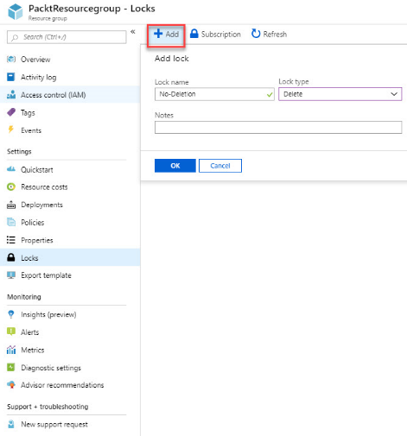

Creating a lock

1. Click on **OK** to create the lock.

We have created a lock for this resource group to prevent authorized users from deleting it. In the next section, we are going to look at how we can move resources across different resource groups.

### Configure resource policies

Resource policies are JSON based rules that define what can and can’t be created inside either a subscription or a resource group. Resource policies can be be applied to most resource types, however there are some that do not yet support it. Generally if a resource supports tags and locations then it will support resource policies.

**Default Stance**

The default stance with policy rights is the opposite to RBAC. In RBAC rights, by default you are denied everything and then explicitly allowed certain roles. In Resource Policies you are by default allowed to do anything in a subscription or RG, and you need to explicitly deny things in a policy.

**Required Rights**

To be able to apply policies to resource groups or subscriptions you need the “Microsoft.Authorization/policyassignments/write” permission on the required subscription or RG. To be able to create custom policies you also need the “Microsoft.Authorization/policydefinitions/write” permission.

**Built In Policies**

Azure provides some ready made policies out of the box. hese built in policies are:

* Allowed locations
* Allowed resource types
* Allowed storage account SKUs
* Allowed virtual machine SKUs
* Apply tag and default value
* Enforce tag and value
* Not allowed resource types
* Require SQL Server version 12.0
* Require storage account encryption

 There are both “Allowed” and “Not Allowed ” rules. This is helpful if you are looking to whitelist or blacklist, you have the choice to do either.

### Implement and set tagging on resource groups

You can apply tags to all of your Azure resources. This way, you add extra metadata to the resource group, which can be used to logically organize them into a taxonomy. Each tag consists of a name and a value pair.

For instance, you can set the name to Environment and the value to Demo, or you can set the name to Maintenance Window and the value to Saturday 9 AM. After applying these tags, you can easily retrieve all the resources with the same tag name and value.

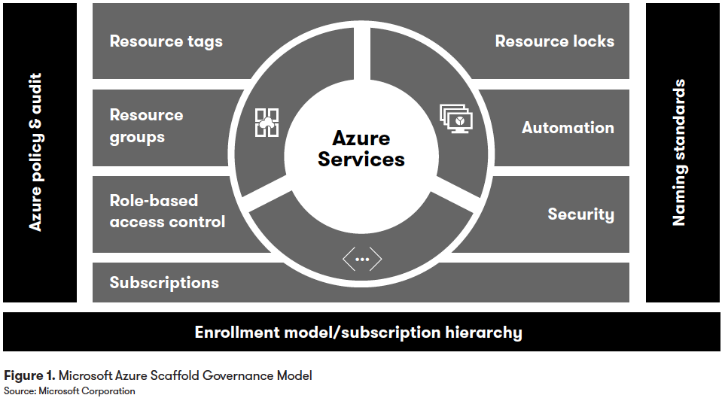

<https://cloudacademy.com/course/managing-azure-subscriptions-resource-groups/implement-set-tagging/>

### Move resources across resource groups

Azure Resource Group is a container that holds the related resources together. Moving the resources between the resource groups involves a very few steps as shown below.

* Log in to the Azure portal.
* Search and Filter the resource that needs to be moved to the different resource group.
* On Overview page of the resource, select Move - Move to another Resource Group.
* Select the Target Resource group.
* Accept the terms and click OK.
* Initially, Azure will validate the selected resource and configuration to verify the movement feasibility.
* On successful validation, the movement of the selected resource will be initiated.

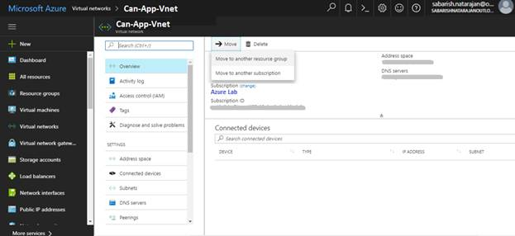

### Remove resource groups

When you delete a resource group, Resource Manager determines the order to delete resources. It uses the following order:

1. All the child (nested) resources are deleted.
2. Resources that manage other resources are deleted next. A resource can have the managedBy property set to indicate that a different resource manages it. When this property is set, the resource that manages the other resource is deleted before the other resources.
3. The remaining resources are deleted after the previous two categories.

After the order is determined, Resource Manager issues a DELETE operation for each resource. It waits for any dependencies to finish before proceeding.

## Managed role based access control (RBAC)

Access management for cloud resources is a critical function for any organization that is using the cloud. Role-based access control (RBAC) helps you manage who has access to Azure resources, what they can do with those resources, and what areas they have access to.

**What can I do with RBAC?**

Here are some examples of what you can do with RBAC:

* Allow one user to manage virtual machines in a subscription and another user to manage virtual networks
* Allow a DBA group to manage SQL databases in a subscription
* Allow a user to manage all resources in a resource group, such as virtual machines, websites, and subnets
* Allow an application to access all resources in a resource group.

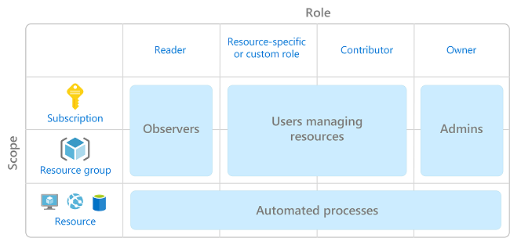

Policies on the other hand play a slightly different role in governance. [**Azure Policies**](https://docs.microsoft.com/en-us/azure/governance/policy/overview?WT.mc_id=ITOPSTALK-blog-abartolo) focus on resource properties during deployment and for already existing resources.  As an example, a policy can be issued to ensure users can only deploy DS series VMs within a specified resource should the user have the permission to deploy the VMs.  In an existing resource, a policy could be implemented to add or append tags to resources that do not currently have tags to make reporting on costs easier and provide a better way to assign resources to business cost centers.

**Permissions**

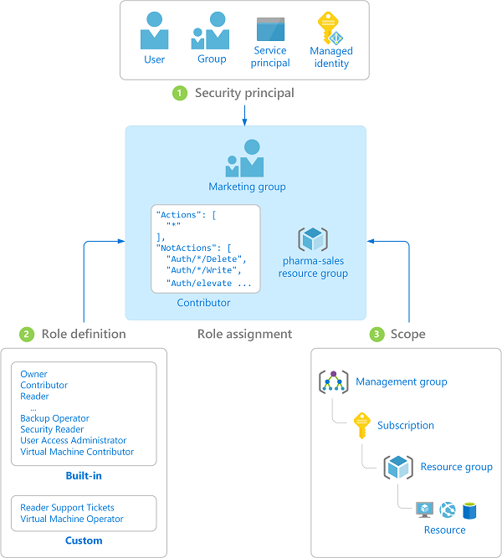

List all roles

Follow these steps to list all roles in the Azure portal.

1. In the Azure portal, click **All services** and then select any scope. For example, you can select **Management groups**, **Subscriptions**, **Resource groups**, or a resource.
2. Click the specific resource.
3. Click **Access control (IAM)**.
4. Click the **Roles** tab to see a list of all the built-in and custom roles.

**Built-in Roles for Azure Resources**

<https://docs.microsoft.com/en-us/azure/role-based-access-control/built-in-roles>

**Role Definition**

A role definition is a collection of permissions. It's typically just called a role. A role definition lists the operations that can be performed, such as read, write, and delete. Roles can be high-level, like owner, or specific, like virtual machine reader.

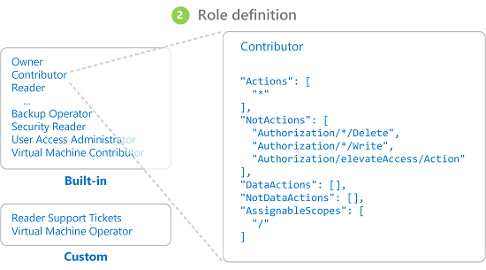

### Create a custom role

1. Sign in to the [Azure AD admin center](https://aad.portal.azure.com/) with Privileged role administrator or Global administrator permissions in the Azure AD organization.
2. Select **Azure Active Directory** > **Roles and administrators** > **New custom role**.

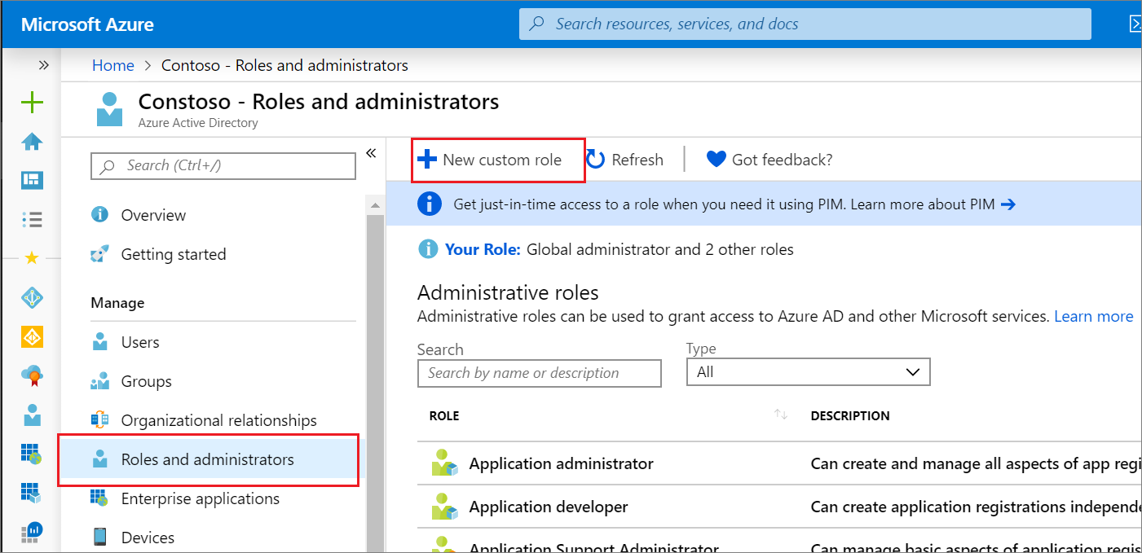

1. On the **Basics** tab, provide a name and description for the role and then click **Next**.

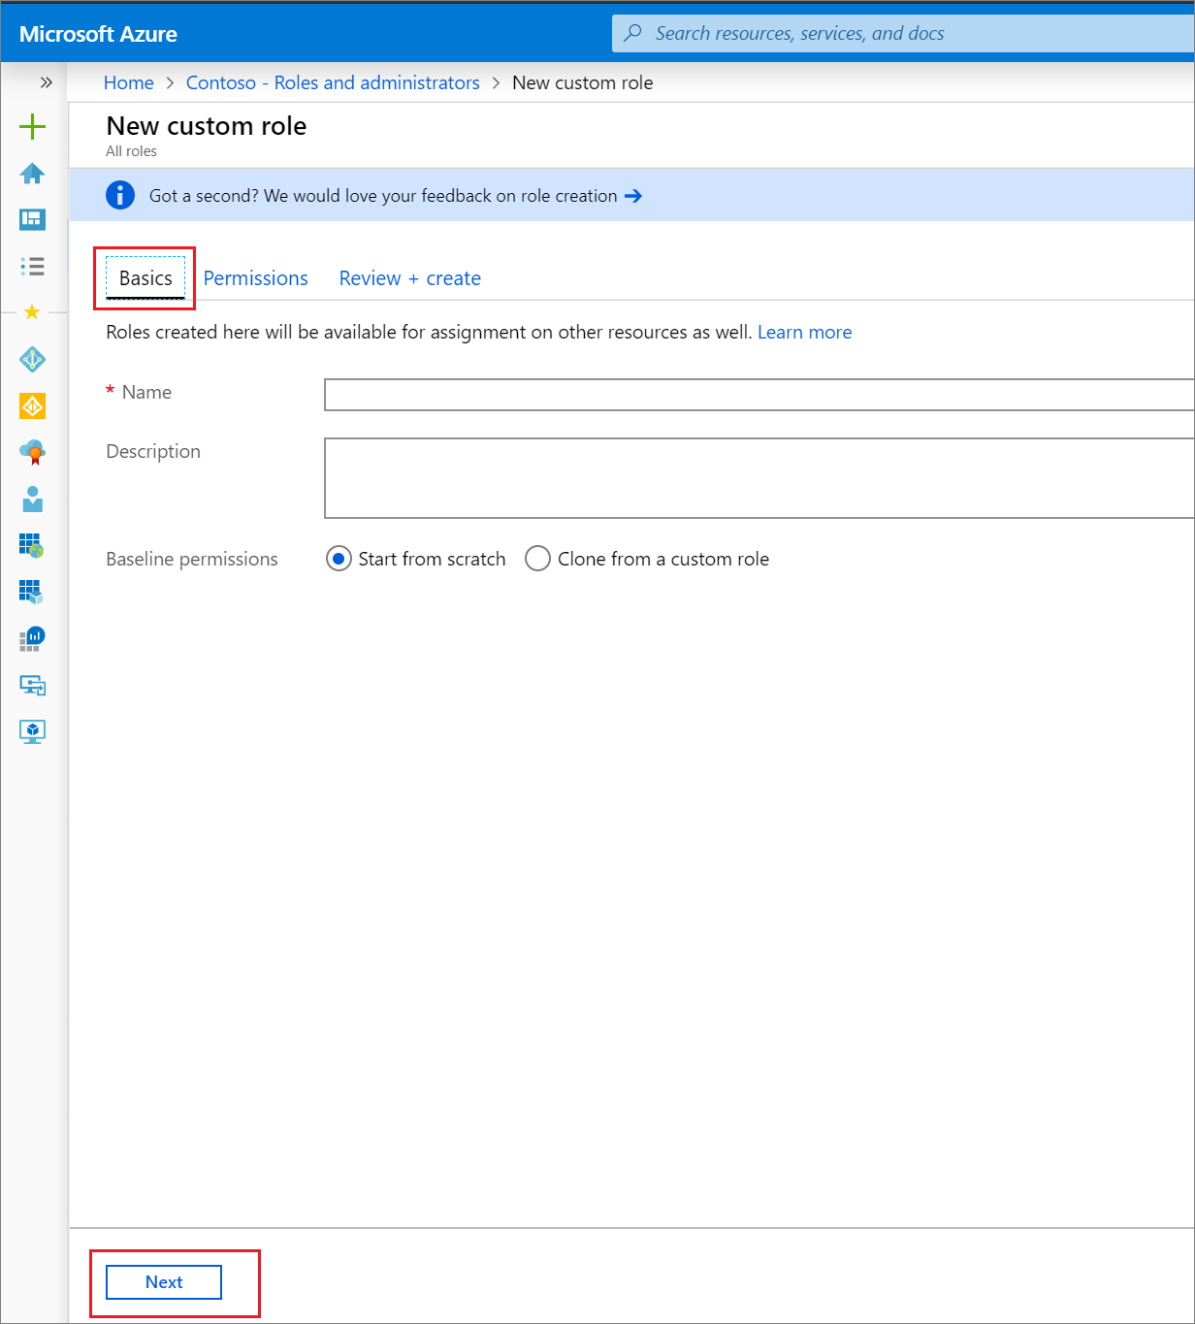

1. On the **Permissions** tab, select the permissions necessary to manage basic properties and credential properties of app registrations. For a detailed description of each permission, see [Application registration subtypes and permissions in Azure Active Directory](https://docs.microsoft.com/en-us/azure/active-directory/users-groups-roles/roles-custom-available-permissions).
   1. First, enter "credentials" in the search bar and select the microsoft.directory/applications/credentials/update permission.

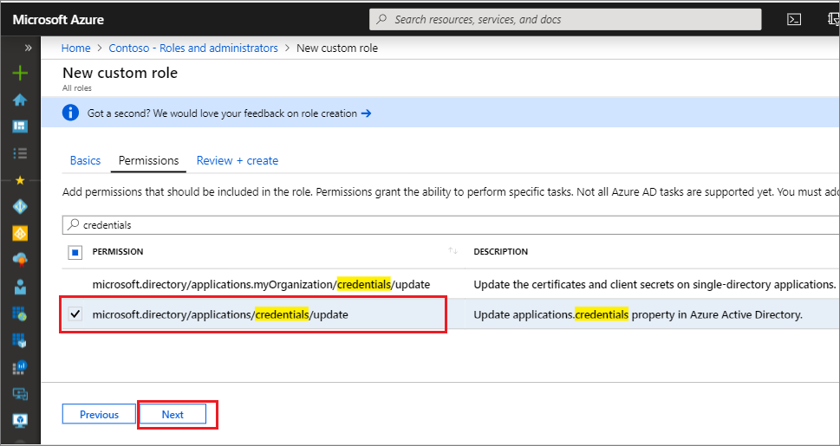

* 1. Next, enter "basic" in the search bar, select the microsoft.directory/applications/basic/update permission, and then click **Next**.

1. On the **Review + create** tab, review the permissions and select **Create**.

Your custom role will show up in the list of available roles to assign.

### Configure access to Azure resources by assigning roles

To add or remove role assignments, you must have:

* Microsoft.Authorization/roleAssignments/write and Microsoft.Authorization/roleAssignments/delete permissions, such as [User Access Administrator](https://docs.microsoft.com/en-us/azure/role-based-access-control/built-in-roles#user-access-administrator) or [Owner](https://docs.microsoft.com/en-us/azure/role-based-access-control/built-in-roles#owner)
* In the Azure portal, click **All services** and then select the scope that you want to grant access to. For example, you can select **Management groups**, **Subscriptions**, **Resource groups**, or a resource.
* Click the specific resource for that scope.
* Click **Access control (IAM)**.
* Click the **Role assignments** tab to view the role assignments at this scope.



* Click **Add** > **Add role assignment**.

If you don't have permissions to assign roles, the Add role assignment option will be disabled.



The Add role assignment pane opens.



* In the **Role** drop-down list, select a role such as **Virtual Machine Contributor**.
* In the **Select** list, select a user, group, service principal, or managed identity. If you don't see the security principal in the list, you can type in the **Select** box to search the directory for display names, email addresses, and object identifiers.
* Click **Save** to assign the role.

After a few moments, the security principal is assigned the role at the selected scope.

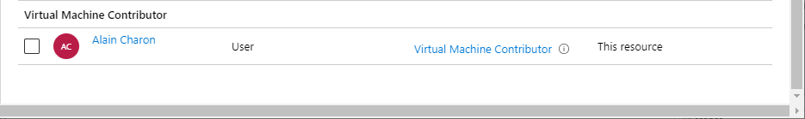

### Configure management access to Azure

If you are a Global Administrator, there might be times when you want to do the following:

* Regain access to an Azure subscription or management group when a user has lost access
* Grant another user or yourself access to an Azure subscription or management group
* See all Azure subscriptions or management groups in an organization
* Allow an automation app (such as an invoicing or auditing app) to access all Azure subscriptions or management groups

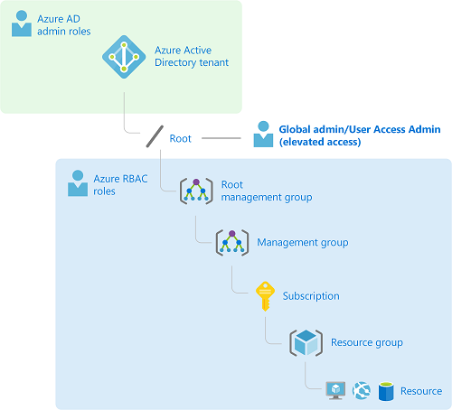

1. Sign in to the [Azure portal](https://portal.azure.com/) or the [Azure Active Directory admin center](https://aad.portal.azure.com/) as a Global Administrator.
2. Search for and select **Azure Active Directory**.

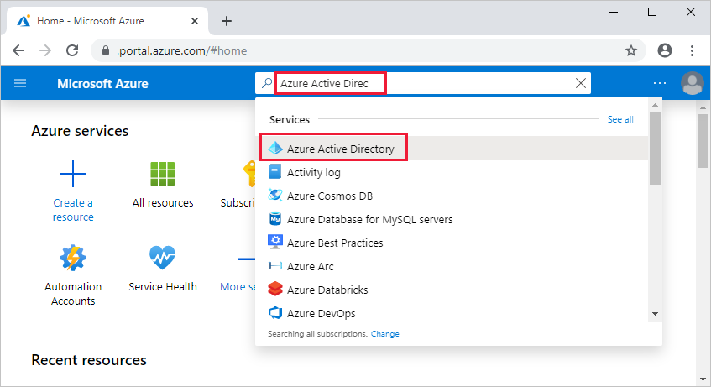

1. Under **Manage**, select **Properties**.

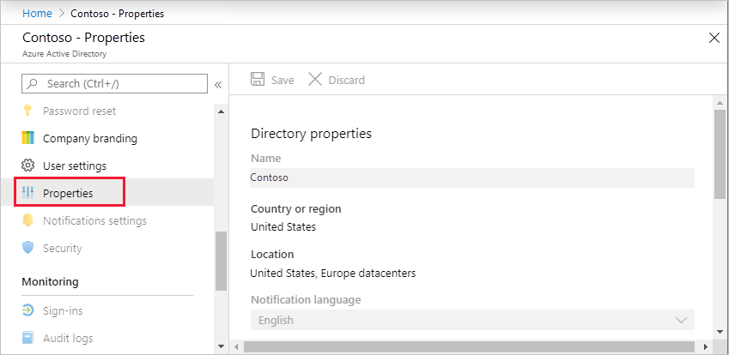

1. Under **Access management for Azure resources**, set the toggle to **Yes**.

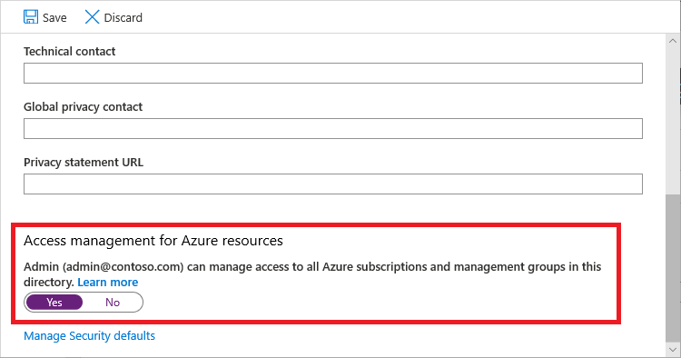

1. Click **Save** to save your setting.

This setting is not a global property and applies only to the currently signed in user. You can't elevate access for all members of the Global Administrator role.

1. Sign out and sign back in to refresh your access.

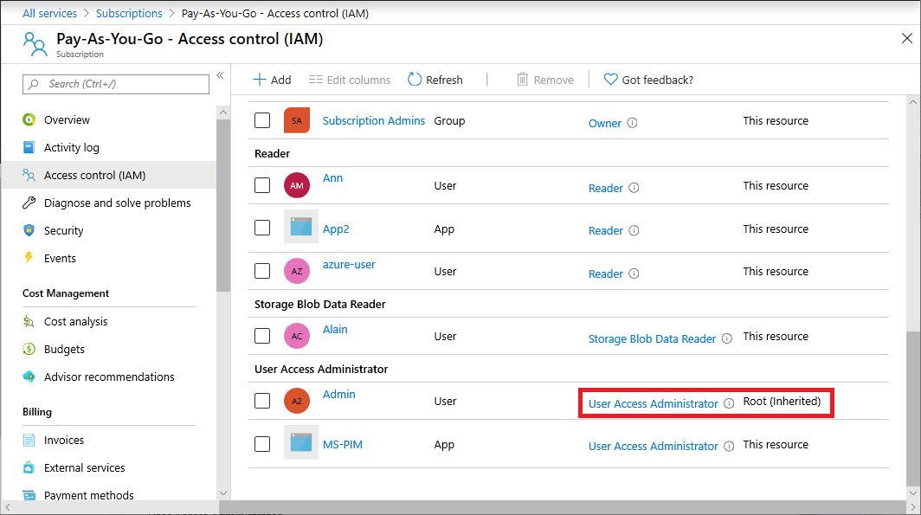

### Troubleshoot RBAC

**Problems with RBAC role assignments**

If the Add > Add role assignment option is disabled, then check that you are currently signed in with a user that is assigned a role that has the Microsoft.Authorization/roleAssignments/write permission such as Owner or User Access Administrator at the scope you are trying to assign the role.

If you receive error message "No more role assignments can be created (code: RoleAssignmentLimitExceeded)" then please understand that you are trying to exceed the role assignment limit.

Azure supports up to 2000 role assignments per subscription. This role assignments limit is fixed and cannot be increased.

**Problems with custom roles**

If you are unable to update an existing custom role, check that you are currently signed in withpermission such as Owner or User Access Administrator.

If you get the error message "There are existing role assignments referencing role", then there are role assignments still using the custom role. Remove those role assignments and try to delete the custom role again.

If you get the error message "Role definition limit exceeded", the reason is Azure supports up to 5000 custom roles in a tenant and not more than that.

**Recover RBAC when subscriptions are moved across tenants**

If you transfer a subscription to a different Azure AD tenant, all role assignments are permanently deleted from the source Azure AD tenant and are not migrated to the target Azure AD tenant. You must re-create your role assignments in the target tenant.

If you are an Azure AD Global Administrator and you don't have access to a subscription after it was moved between tenants, use the Access management for Azure resources toggle to temporarily elevate your access to get access to the subscription.

**Role assignments with Unknown security principal**

If you assign a role to a security principal (user, group, service principal, or managed identity) and then you later delete that security principal without removing the role assignment, the security principal type for the role assignment will be listed as Unknown.

**RBAC changes are not being detected**

Azure Resource Manager sometimes caches configurations and data to improve performance. When creating or deleting role assignments, it can take up to 30 minutes for changes to take effect.

**Few other issues are**

Web app features that require write access

Web app resources that require write access

Virtual machine features that require write access

Azure Functions and write access

### Implement RBAC policies

Whilst RBAC’s role is to grant the rights to your users to implement and manage the top-level Azure resources, they do not restrict users within the resource types. For example, RBAC controls whether a user can create VMs, but it doesn't stop them creating over-spec'd machines. This is where Azure Policies are used.

### Assign RBAC Roles

Please refer to “Configure access to Azure resources by assigning roles”.

# Implement and manage storage

## Create and configure storage accounts

An Azure storage account contains all of the Azure Storage data objects: blobs, files, queues, tables, and disks. The storage account provides a unique namespace for your Azure Storage data that is accessible from anywhere in the world over HTTP or HTTPS.

* [Azure Blobs](https://docs.microsoft.com/en-us/azure/storage/blobs/storage-blobs-introduction): A massively scalable object store for text and binary data.
* [Azure Files](https://docs.microsoft.com/en-us/azure/storage/files/storage-files-introduction): Managed file shares for cloud or on-premises deployments.
* [Azure Queues](https://docs.microsoft.com/en-us/azure/storage/queues/storage-queues-introduction): A messaging store for reliable messaging between application components.
* [Azure Tables](https://docs.microsoft.com/en-us/azure/storage/tables/table-storage-overview): A NoSQL store for schemaless storage of structured data.
* Append Blobs: Append Blob is optimized for fast append operations, making it ideal for scenarios where the data must be added to an existing blob without modifying the existing contents of that blob

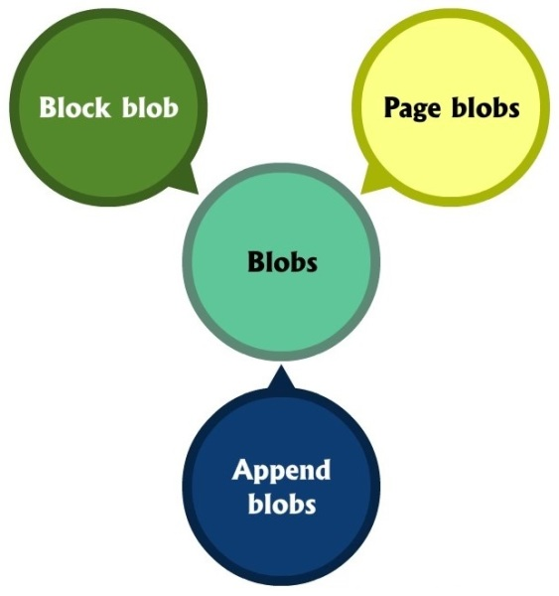

**Append Blobs**

An append blob is comprised of blocks and is optimized for append operations. When you modify an append blob, blocks are added to the end of the blob only, via the Append Block operation. Updating or deleting of existing blocks is not supported. Unlike a block blob, an append blob does not expose its block IDs. Each block in an append blob can be a different size, up to a maximum of 4 MB, and an append blob can include up to 50,000 blocks. The maximum size of an append blob is therefore slightly more than 195 GB (4 MB X 50,000 blocks).

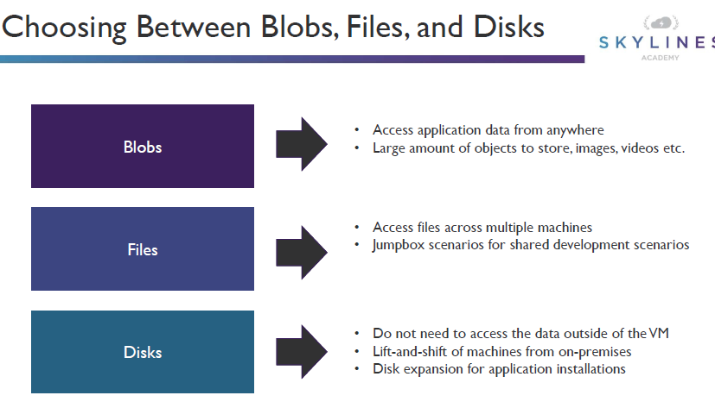

| **Storage account type** | **Supported services** | **Supported performance tiers** | **Supported access tiers** | **Replication options** | **Deployment model**  **1** | **Encryption**  **2** |
| --- | --- | --- | --- | --- | --- | --- |
| General-purpose V2 | Blob, File, Queue, Table, Disk, and Data Lake Gen2  6 | Standard, Premium  5 | Hot, Cool, Archive  3 | LRS, GRS, RA-GRS, ZRS, GZRS (preview), RA-GZRS (preview)  4 | Resource Manager | Encrypted |
| General-purpose V1 | Blob, File, Queue, Table, and Disk | Standard, Premium  5 | N/A | LRS, GRS, RA-GRS | Resource Manager, Classic | Encrypted |
| BlockBlobStorage | Blob (block blobs and append blobs only) | Premium | N/A | LRS, ZRS  4 | Resource Manager | Encrypted |
| FileStorage | File only | Premium | N/A | LRS, ZRS  4 | Resource Manager | Encrypted |
| BlobStorage | Blob (block blobs and append blobs only) | Standard | Hot, Cool, Archive  3 | LRS, GRS, RA-GRS | Resource Manager | Encrypted |

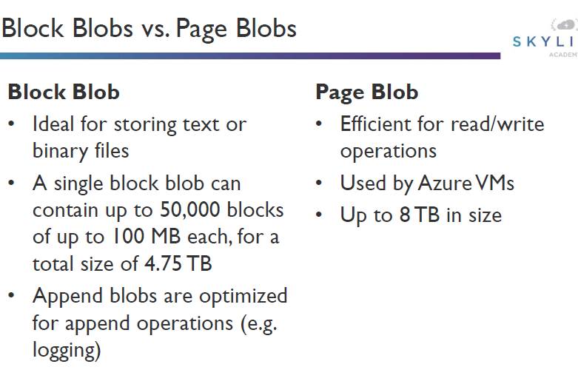

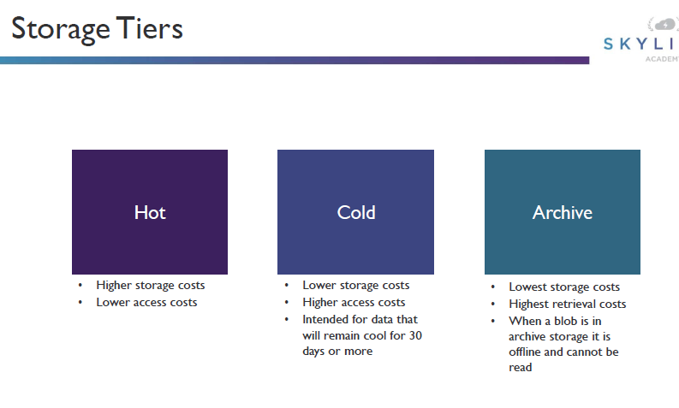

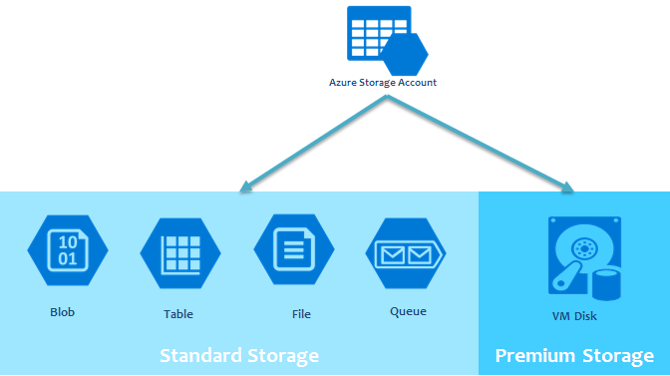

**Basics Mandatory Fields**

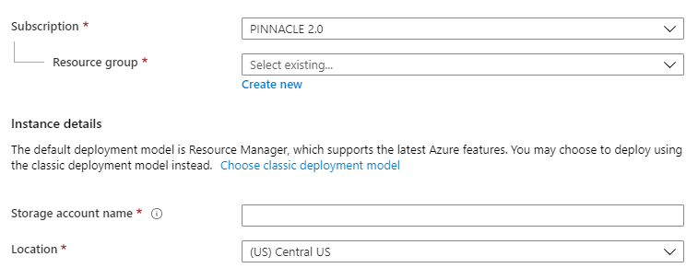

**Networking Mandatory Fields**

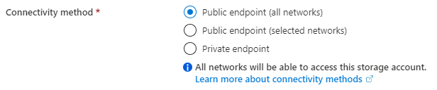

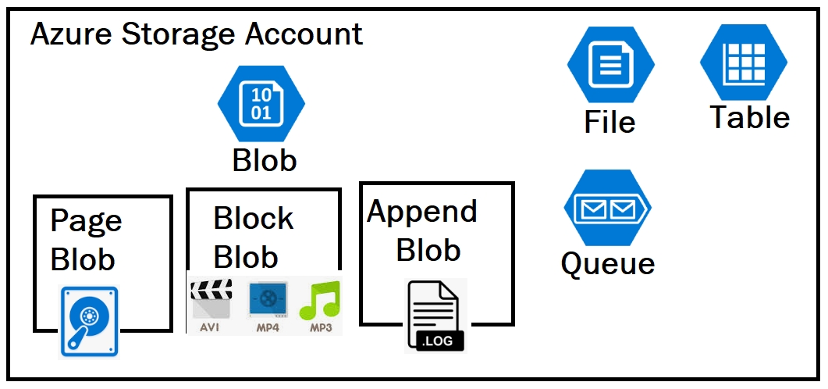

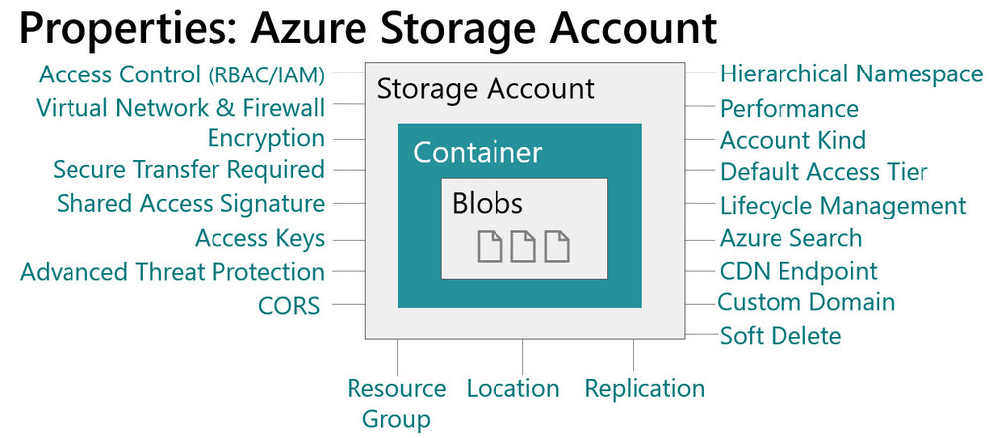

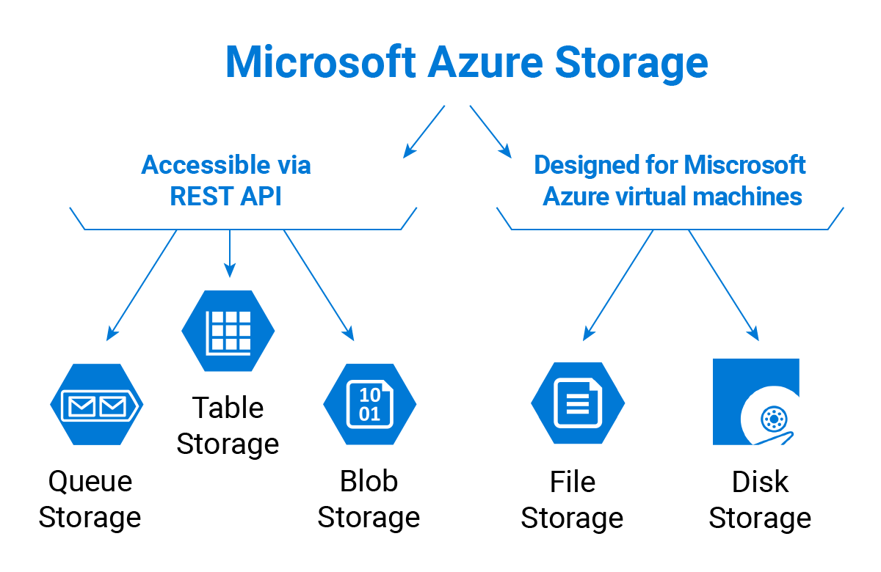

### Configure network access to the storage account

1. Go to the storage account you want to secure.
2. Click on the settings menu called **Firewalls and virtual networks**.
3. To deny access by default, choose to allow access from **Selected networks**. To allow traffic from all networks, choose to allow access from **All networks**.
4. Click **Save** to apply your changes.

### Create and configure storage account

1. On the Azure portal menu, select **All services**. In the list of resources, type **Storage Accounts**. As you begin typing, the list filters based on your input. Select **Storage Accounts**.
2. On the **Storage Accounts** window that appears, choose **Add**.
3. Select the subscription in which to create the storage account.
4. Under the **Resource group** field, select **Create new**. Enter a name for your new resource group, as shown in the following image.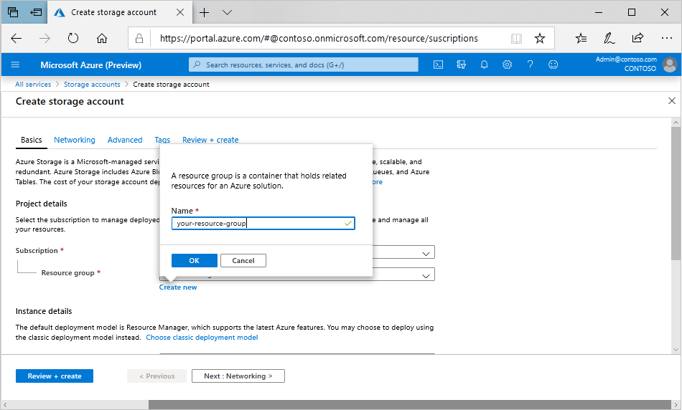
5. Next, enter a name for your storage account. The name you choose must be unique across Azure. The name also must be between 3 and 24 characters in length, and can include numbers and lowercase letters only.
6. Select a location for your storage account, or use the default location.
7. Leave these fields set to their default values:

| **Field** | **Value** |
| --- | --- |
| Deployment model | Resource Manager |
| Performance | Standard |
| Account kind | StorageV2 (general-purpose v2) |
| Replication | Read-access geo-redundant storage (RA-GRS) |
| Access tier | Hot |

1. If you plan to use [Azure Data Lake Storage](https://azure.microsoft.com/services/storage/data-lake-storage/), choose the **Advanced** tab, and then set **Hierarchical namespace** to **Enabled**.
2. Select **Review + Create** to review your storage account settings and create the account.
3. Select **Create**.

### Generate shared access signature

A shared access signature (SAS) provides secure delegated access to resources in your storage account without compromising the security of your data.

Azure Storage supports three types of shared access signatures:

* **User delegation SAS.** A user delegation SAS is secured with Azure Active Directory (Azure AD) credentials and also by the permissions specified for the SAS. A user delegation SAS applies to Blob storage only.
* **Service SAS.** A service SAS is secured with the storage account key. A service SAS delegates access to a resource in only one of the Azure Storage services: Blob storage, Queue storage, Table storage, or Azure Files.
* **Account SAS.** An account SAS is secured with the storage account key. An account SAS delegates access to resources in one or more of the storage services. All of the operations available via a service or user delegation SAS are also available via an account SAS.

A lightweight service authenticates the client as needed and then generates a SAS. Once the client application receives the SAS, they can access storage account resources directly with the permissions defined by the SAS and for the interval allowed by the SAS. The SAS mitigates the need for routing all data through the front-end proxy service.

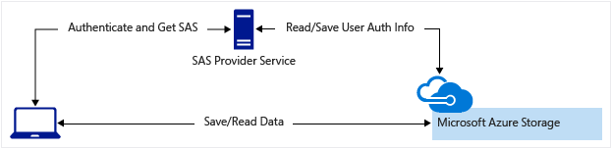

### Install and use Azure Storage Explorer

Microsoft Azure Storage Explorer is a standalone app that makes it easy to work with Azure Storage data on Windows, macOS, and Linux.

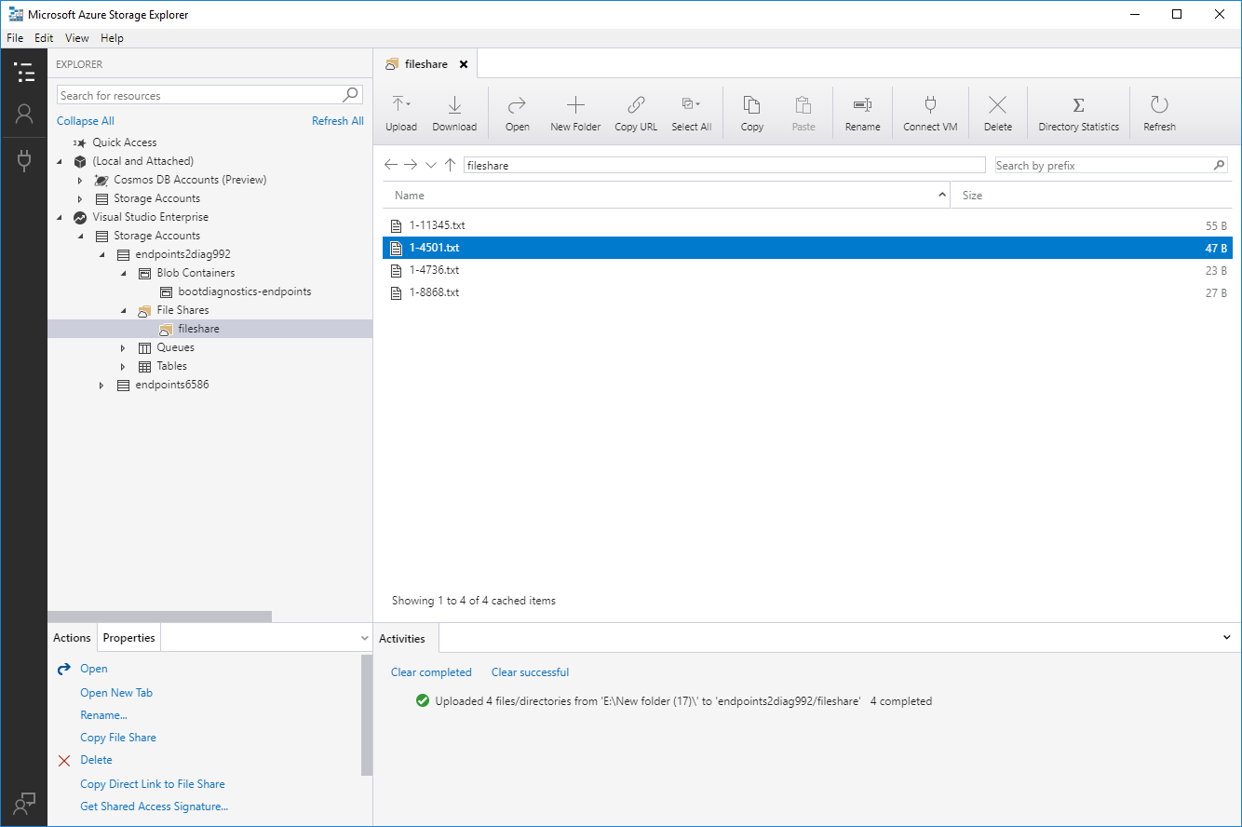

* 1. Download and install
  2. Connect to a storage account or service
     1. Sign in to Azure to access your subscriptions and their resources
     2. Attach a specific Storage or CosmosDB resource

1. In Storage Explorer, select **View** > **Account Management** or select the **Manage Accounts** button.
2. **ACCOUNT MANAGEMENT** now displays all the Azure accounts you've signed in to. To connect to another account, select **Add an account**.
3. In **Connect to Azure Storage**, select an Azure cloud from **Azure environment** to sign in to a national cloud or an Azure Stack. After you choose your environment, select **Next**.
4. After you successfully sign in with an Azure account, the account and the Azure subscriptions associated with that account appear under **ACCOUNT MANAGEMENT**. Select **All subscriptions** to toggle your selection between all or none of the listed Azure subscriptions. Select the Azure subscriptions that you want to work with, and then select **Apply**.

**EXPLORER** displays the storage accounts associated with the selected Azure subscriptions.

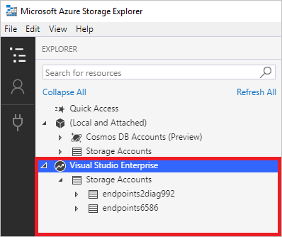

### Manage access keys

1. Navigate to the [Azure portal](https://portal.azure.com/).
2. Locate your storage account.
3. In the **Settings** section of the storage account overview, select **Access keys**. Your account access keys appear, as well as the complete connection string for each key.
4. Find the **Key** value under **key1**, and click the **Copy** button to copy the account key.
5. Alternately, you can copy the entire connection string. Find the **Connection string** value under **key1**, and click the **Copy** button to copy the connection string.

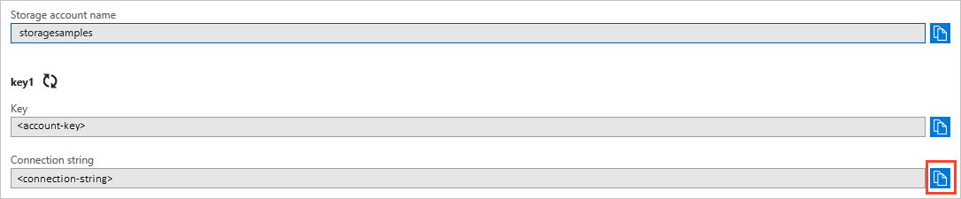

You can use either key to access Azure Storage, but in general it's a good practice to use the first key, and reserve the use of the second key for when you are rotating keys.

### Monitor activity log by using Monitor Logs

1. Sign in to the [Azure portal](https://portal.azure.com/).
2. Select **Azure Active Directory**, and then select **Logs** from the **Monitoring** section to open your Log Analytics workspace. The workspace will open with a default query.

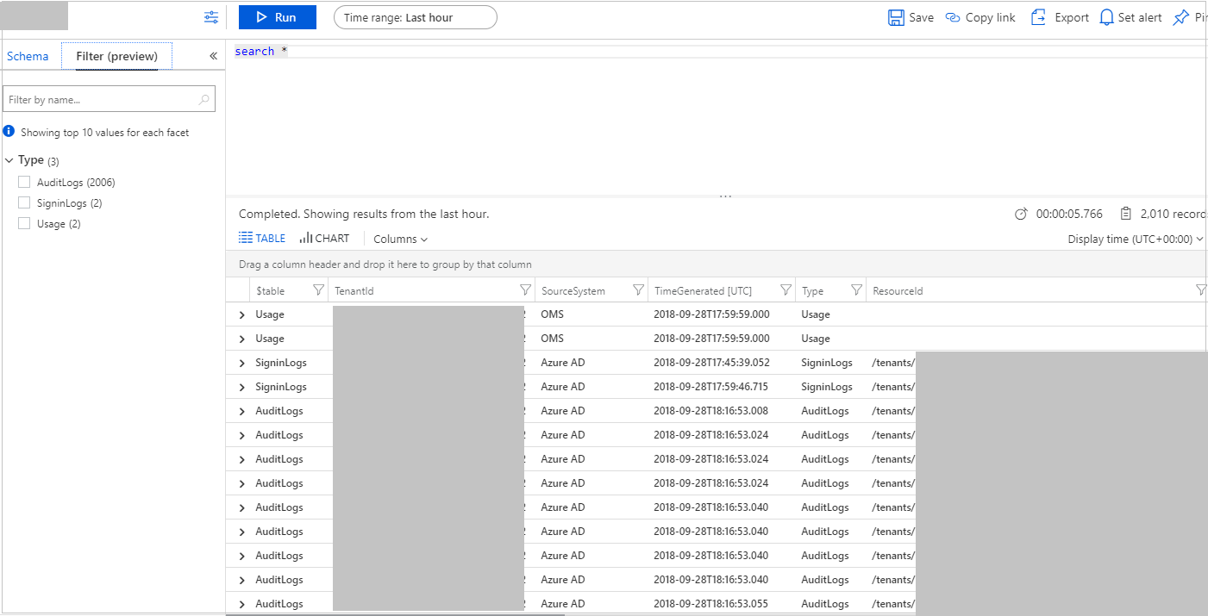

**View the schema for Azure AD activity logs**

The logs are pushed to the **AuditLogs** and **SigninLogs** tables in the workspace. To view the schema for these tables:

1. From the default query view in the previous section, select **Schema** and expand the workspace.
2. Expand the **Log Management** section and then expand either **AuditLogs** or **SignInLogs** to view the log schema.

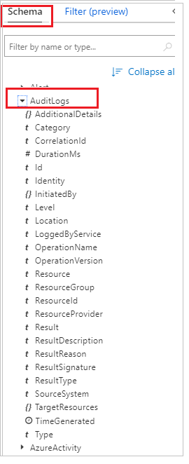 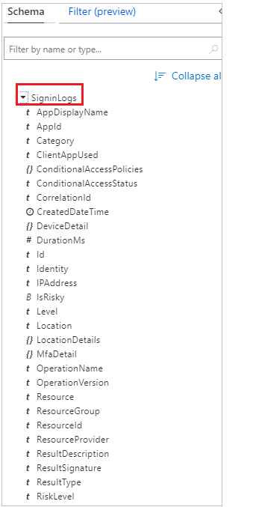

**Query the Azure AD activity logs**

Now that you have the logs in your workspace, you can now run queries against them. For example, to get the top applications used in the last week, replace the default query with the following and select **Run**

To get the top audit events over the last week, use the following query:

AuditLogs

| where TimeGenerated >= ago(7d)

| summarize auditCount = count() by OperationName

| sort by auditCount desc

**Alert on Azure AD activity log data**

You can also set up alerts on your query. For example, to configure an alert when more than 10 applications have been used in the last week:

1. From the workspace, select **Set alert** to open the **Create rule** page.

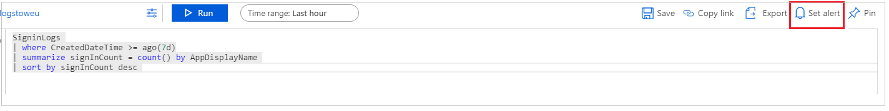

1. Select the default **alert criteria** created in the alert and update the **Threshold** in the default metric to 10.

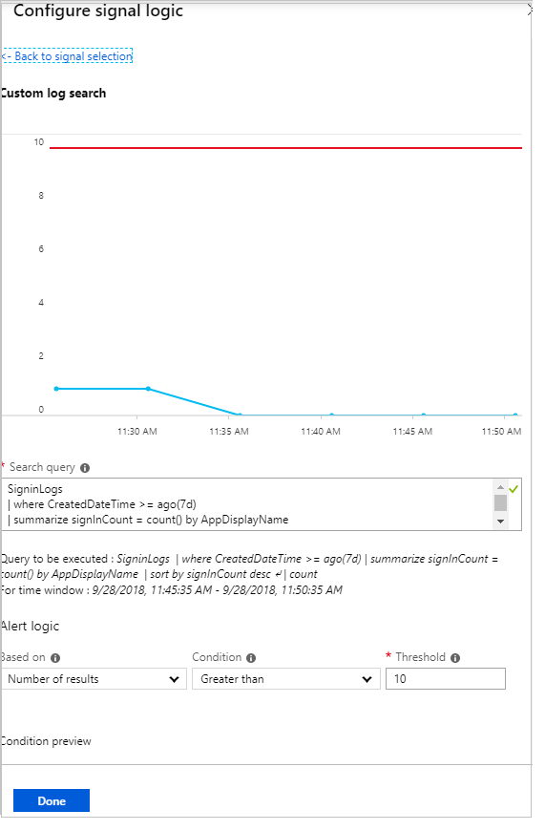

1. Enter a name and description for the alert, and choose the severity level. For our example, we could set it to **Informational**.
2. Select the **Action Group** that will be alerted when the signal occurs. You can choose to notify your team via email or text message, or you could automate the action using webhooks, Azure functions or logic apps. Learn more about [creating and managing alert groups in the Azure portal](https://docs.microsoft.com/azure/monitoring-and-diagnostics/monitoring-action-groups).
3. Once you have configured the alert, select **Create alert** to enable it.

### Implement Azure storage replication

Alongside the data access tiers (Hot, Cool, and Archive) and data services (Blob, File, Queue, and Table), Azure also has options around the data redundancy.

**LRS (LOCALLY REDUNDANT STORAGE)**

LRS ensure your data is replicated three times within a single data centre. These datastores are updated using synchronous writes to guarantee all three copies are kept up to date.

**ZRS (ZONE REDUNDANT STORAGE)**

Two or three availability zones contain copies of the data. The increased resilience removes the issues of a single data centre outage causing data access issues.

**GRS (GEO-REDUNDANT STORAGE)**

Geo-redundant storage (GRS) brings additional redundancy to the data storage over both LRS or ZRS. Along with the three copies of your data stored within a single region, a further three copies are stored in the twinned Azure region.

### Implement Azure AD Authentication

Azure AD Authentication for Azure Blobs and Queues is now available. With AAD authentication, customers can now use Azure's [role-based access control](https://docs.microsoft.com/en-us/azure/active-directory/role-based-access-control-what-is) framework to grant specific permissions to users, groups and applications down to the scope of an individual blob container or queue.

## Import and export data to Azure

This service is used to securely **import** large amounts of data to **Azure Blob storage** and **Azure** Files by shipping disk drives to an **Azure** datacenter. This service can also be used to transfer data from **Azure Blob storage** to disk drives and ship to your on-premises sites.

### Create export from Azure job

At a high level, an export job involves the following steps:

1. Determine the data to be exported, number of drives you need, source blobs or container paths of your data in Blob storage.
2. Create an export job in your source storage account in Azure portal.
3. Specify source blobs or container paths for the data to be exported.
4. Provide the return address and carrier account number for shipping the drives back to you.
5. Ship the disk drives to the shipping address provided during job creation.
6. Update the delivery tracking number in the export job details and submit the export job.
7. The drives are received and processed at the Azure data center.
8. The drives are encrypted with BitLocker and the keys are available via the Azure portal.
9. The drives are shipped using your carrier account to the return address provided in the import job.

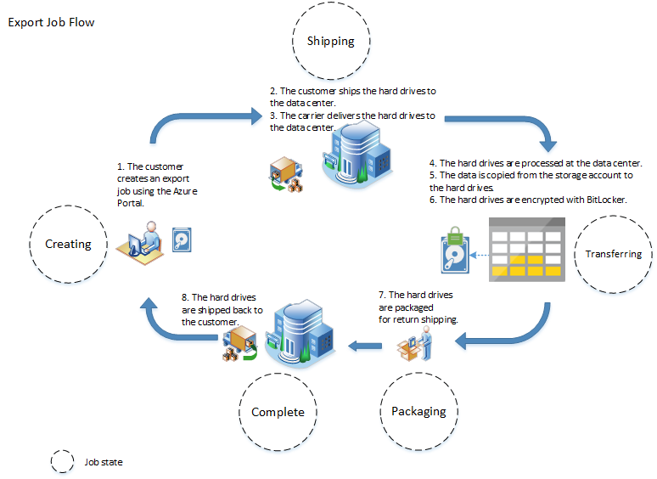

### Create import into Azure job

At a high level, an import job involves the following steps:

1. Determine data to be imported, number of drives you need, destination blob location for your data in Azure storage.
2. Use the WAImportExport tool to copy data to disk drives. Encrypt the disk drives with BitLocker.
3. Create an import job in your target storage account in Azure portal. Upload the drive journal files.
4. Provide the return address and carrier account number for shipping the drives back to you.
5. Ship the disk drives to the shipping address provided during job creation.
6. Update the delivery tracking number in the import job details and submit the import job.
7. The drives are received and processed at the Azure data center.
8. The drives are shipped using your carrier account to the return address provided in the import job.

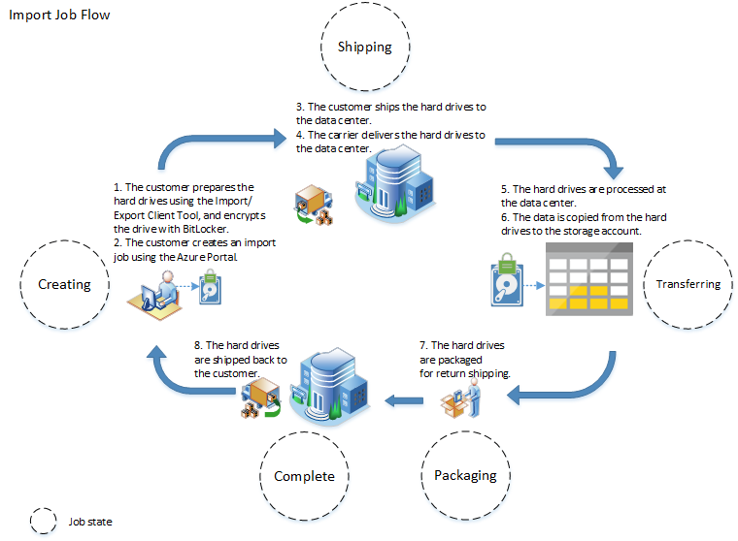

### Use Azure Data Box

Each storage device has a maximum usable storage capacity of 80 TB and is transported to your datacenter through a regional carrier. The device has a rugged casing to protect and secure data during the transit.

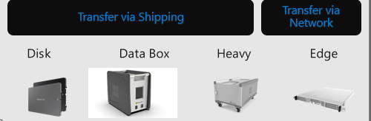

You can order the Data Box device via the Azure portal. Once the device is received, you can quickly set it up using the local web UI. Copy the data from your servers to the device and ship the device back to Azure.

In the Azure datacenter, your data is automatically uploaded from the device to Azure. The entire process is tracked end-to-end by the Data Box service in the Azure portal.

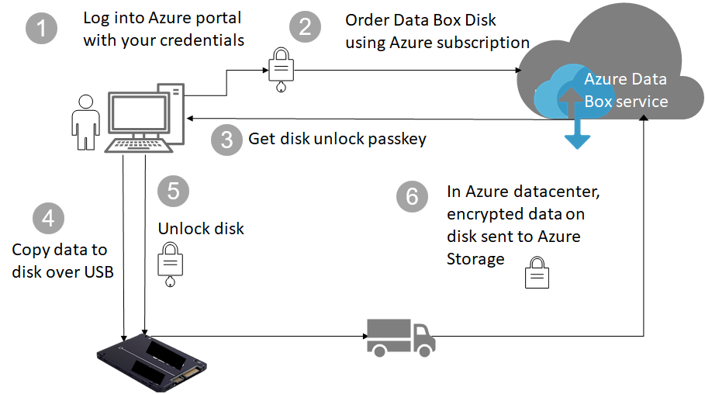

**Use cases**

* **One time migration** - when large amount of on-premises data is moved to Azure.
  + Moving a media library from offline tapes into Azure to create an online media library.
  + Migrating your VM farm, SQL server, and applications to Azure
  + Moving historical data to Azure for in-depth analysis and reporting using HDInsight
* **Initial bulk transfer** - when an initial bulk transfer is done using Data Box (seed) followed by incremental transfers over the network.
  + For example, backup solutions partners such as Commvault and Data Box are used to move initial large historical backup to Azure. Once complete, the incremental data is transferred via network to Azure storage.
* **Periodic uploads** - when large amount of data is generated periodically and needs to be moved to Azure. For example in energy exploration, where video content is generated on oil rigs and windmill farms.

**Benefits**

* **Speed** - Data Box uses 1 Gbps or 10 Gbps network interfaces to move up to 80 TB of data into Azure.
* **Secure** - Data Box has built-in security protections for the device, data, and the service.

### Configure and use Azure blob storage

**Create a container**

1. Navigate to your new storage account in the Azure portal.
2. In the left menu for the storage account, scroll to the **Blob service** section, then select **Containers**.
3. Select the **+ Container** button.
4. Type a name for your new container. The container name must be lowercase, must start with a letter or number, and can include only letters, numbers, and the dash (-) character. For more information about container and blob names, see [Naming and referencing containers, blobs, and metadata](https://docs.microsoft.com/rest/api/storageservices/naming-and-referencing-containers--blobs--and-metadata).
5. Set the level of public access to the container. The default level is **Private (no anonymous access)**.
6. Select **OK** to create the container.

**Upload a block blob**

1. In the Azure portal, navigate to the container you created in the previous section.
2. Select the container to show a list of blobs it contains. Since this container is new, it won't yet contain any blobs.
3. Select the **Upload** button to open the upload blade
4. Browse your local file system to find a file to upload as a block blob
5. Optionally, expand the advanced section to define other setting such as authentication type, access tier, or virtual folder path.
6. Select the **Upload** button to commit the upload
7. Upload as many blobs as you like in this way. You'll see that the new blobs are now listed within the container.

**Download a block blob**

1. Navigate to the list of blobs that you uploaded in the previous section.
2. Right-click the blob you want to download, and select **Download**.

**Clean up resources**

1. In the Azure portal, navigate to the list of containers in your storage account.
2. Select the container to delete.
3. Select the **More** button (**...**), and select **Delete**.
4. Confirm that you want to delete the container.

### Configure Azure content delivery network (CDN) endpoints

A content delivery network (CDN) is a distributed network of servers that can efficiently deliver web content to users. CDNs store cached content on edge servers in point-of-presence (POP) locations that are close to end users, to minimize latency.

Azure Content Delivery Network (CDN) offers developers a global solution for rapidly delivering high-bandwidth content to users by caching their content at strategically placed physical nodes across the world. Azure CDN can also accelerate dynamic content, which cannot be cached, by leveraging various network optimizations using CDN POPs. For example, route optimization to bypass Border Gateway Protocol (BGP).

The benefits of using Azure CDN to deliver web site assets include:

* Better performance and improved user experience for end users, especially when using applications in which multiple round-trips are required to load content.
* Large scaling to better handle instantaneous high loads, such as the start of a product launch event.
* Distribution of user requests and serving of content directly from edge servers so that less traffic is sent to the origin server.

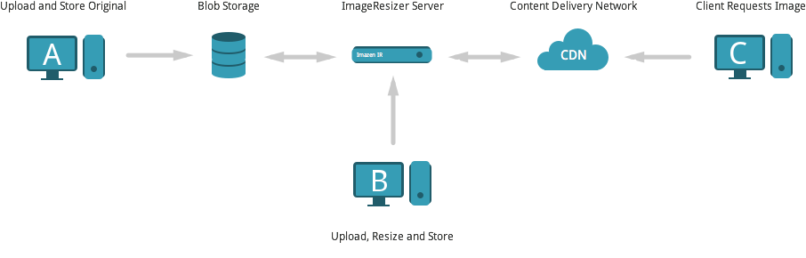

### Use Azure Data Factory to transfer data to Azure

Copy Activity in Azure Data Factory can be used to copy data from and to Azure Blob storage, and use Data Flow to transform data in Azure Blob storage.

1. Register an application entity in Azure Active Directory (Azure AD) by following [Register your application with an Azure AD tenant](https://docs.microsoft.com/en-us/azure/storage/common/storage-auth-aad-app#register-your-application-with-an-azure-ad-tenant). Make note of the following values, which you use to define the linked service:
   * Application ID
   * Application key
   * Tenant ID
2. Grant the service principal proper permission in Azure Blob storage. Refer to [Manage access rights to Azure Storage data with RBAC](https://docs.microsoft.com/en-us/azure/storage/common/storage-auth-aad-rbac) with more details on the roles.
   * **As source**, in Access control (IAM), grant at least **Storage Blob Data Reader** role.
   * **As sink**, in Access control (IAM), grant at least **Storage Blob Data Contributor** role.
3. [Retrieve data factory managed identity information](https://docs.microsoft.com/en-us/azure/data-factory/data-factory-service-identity#retrieve-managed-identity) by copying the value of **managed identity object ID** generated along with your factory.
4. Grant the managed identity proper permission in Azure Blob storage.

## Configure Azure files

### Create Azure file share

Azure File Share

Azure Files offers fully managed file shares in the cloud that are accessible via the industry standard [Server Message Block (SMB) protocol](https://msdn.microsoft.com/library/windows/desktop/aa365233.aspx).

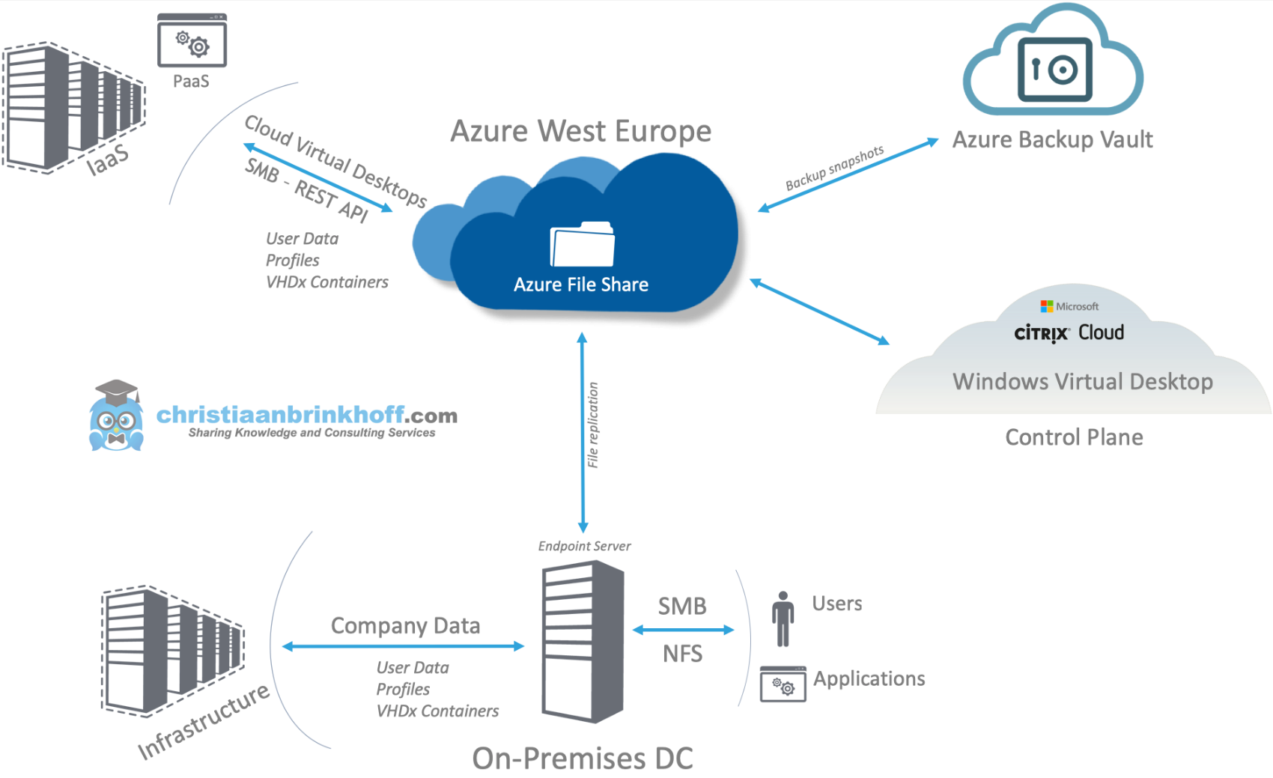

Key benefits

* **Shared access**. Azure file shares support the industry standard SMB protocol, meaning you can seamlessly replace your on-premises file shares with Azure file shares without worrying about application compatibility. Being able to share a file system across multiple machines, applications/instances is a significant advantage with Azure Files for applications that need shareability.
* **Fully managed**. Azure file shares can be created without the need to manage hardware or an OS. This means you don't have to deal with patching the server OS with critical security upgrades or replacing faulty hard disks.
* **Scripting and tooling**. PowerShell cmdlets and Azure CLI can be used to create, mount, and manage Azure file shares as part of the administration of Azure applications.You can create and manage Azure file shares using Azure portal and Azure Storage Explorer.
* **Resiliency**. Azure Files has been built from the ground up to be always available. Replacing on-premises file shares with Azure Files means you no longer have to wake up to deal with local power outages or network issues.
* **Familiar programmability**. Applications running in Azure can access data in the share via file [system I/O APIs](https://msdn.microsoft.com/library/system.io.file.aspx). Developers can therefore leverage their existing code and skills to migrate existing applications. In addition to System IO APIs, you can use [Azure Storage Client Libraries](https://msdn.microsoft.com/library/azure/dn261237.aspx) or the [Azure Storage REST API](https://docs.microsoft.com/en-us/rest/api/storageservices/file-service-rest-api).

### Create Azure File Sync service

An Azure file share in the same region that you want to deploy Azure File Sync. At least one supported instance of Windows Server or Windows Server cluster to sync with Azure File Sync.

1. Open Server Manager.
2. Click **Local Server**:  
   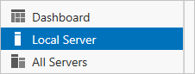
3. On the **Properties** subpane, select the link for **IE Enhanced Security Configuration**.  
   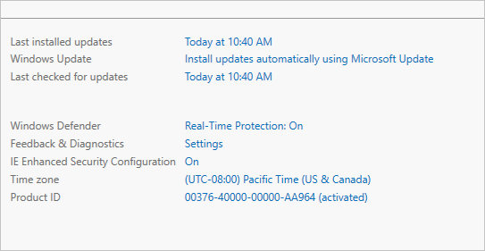
4. In the **Internet Explorer Enhanced Security Configuration** dialog box, select **Off** for **Administrators** and **Users**:  
   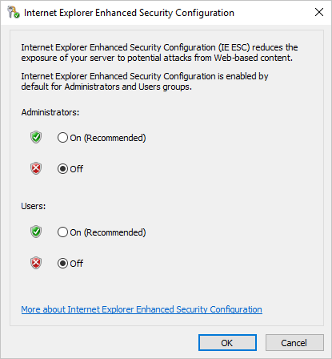

### Create Azure sync group

A sync group must contain one cloud endpoint, which represents an Azure file share and one or more server endpoints. A server endpoint represents a path on a registered server.

To create a sync group, in the [Azure portal](https://portal.azure.com/), go to your Storage Sync Service, and then select **+ Sync group**:

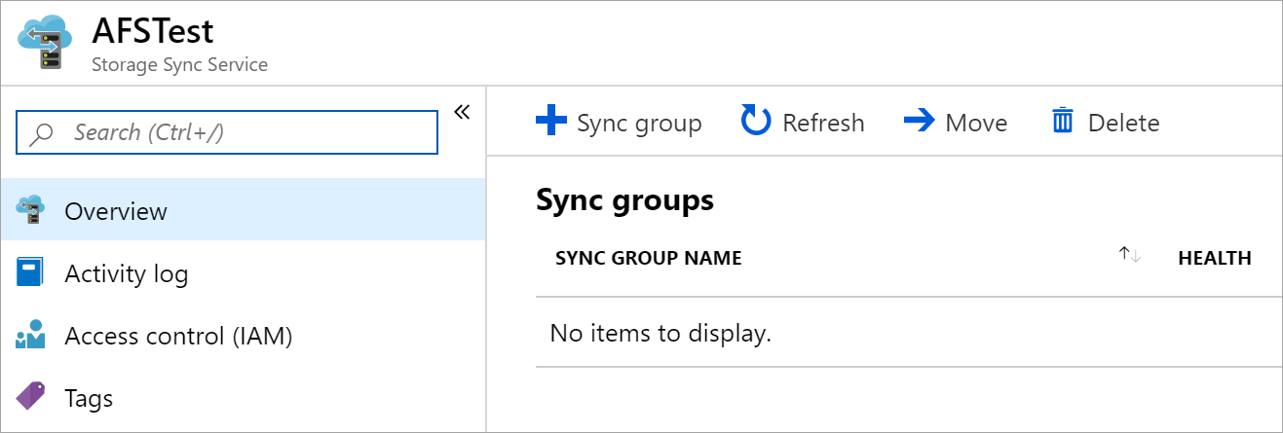

In the pane that opens, enter the following information to create a sync group with a cloud endpoint:

* **Sync group name**: The name of the sync group to be created. This name must be unique within the Storage Sync Service, but can be any name that is logical for you.
* **Subscription**: The subscription where you deployed the Storage Sync Service in [Deploy the Storage Sync Service](https://docs.microsoft.com/en-us/azure/storage/files/storage-sync-files-deployment-guide?tabs=azure-portal#deploy-the-storage-sync-service).
* **Storage account**: If you select **Select storage account**, another pane appears in which you can select the storage account that has the Azure file share that you want to sync with.
* **Azure file share**: The name of the Azure file share with which you want to sync.

### Troubleshoot Azure File Sync

**Troubleshoot agent installation failures**

If the Azure File Sync agent installation fails, at an elevated command prompt, run the following command to turn on logging during agent installation:

*StorageSyncAgent.msi /l*v AFSInstaller.log*

Review installer.log to determine the cause of the installation failure.

**Agent installation fails on Active Directory Domain Controller**

If you try to install the sync agent on an Active Directory domain controller where the PDC role owner is on a Windows Server 2008 R2 or below OS version, you may hit the issue where the sync agent will fail to install.

To resolve, transfer the PDC role to another domain controller running Windows Server 2012 R2 or more recent, then install sync.

**Accessing a volume on Windows Server 2012 R2 fails with error: The parameter is incorrect**

After creating a server endpoint on Windows Server 2012 R2, the following error occurs when accessing the volume:

driveletter:\ is not accessible. The parameter is incorrect.

To resolve, install the latest updates for Windows Server 2012 R2 and restart the server.

**Server Registration does not list all Azure Subscriptions**

When registering a server using ServerRegistration.exe, subscriptions are missing when you click the Azure Subscription drop-down.

This issue occurs because ServerRegistration.exe does not currently support multi-tenant environments. This issue will be fixed in a future Azure File Sync agent update.

To workaround this issue, use the following PowerShell commands to register the server:

Import-Module "C:\Program Files\Azure\StorageSyncAgent\StorageSync.Management.PowerShell.Cmdlets.dll"

Login-AzureRmStorageSync -SubscriptionID "<guid>" -TenantID "<guid>"

Register-AzureRmStorageSyncServer -SubscriptionId "<guid>" -ResourceGroupName "<string>" -StorageSyncServiceName "<string>"

**Server Registration displays the following message: "Pre-requisites are missing"**

This message appears if Az or AzureRM PowerShell module is not installed on PowerShell 5.1.

## Implement Azure backup

**Azure Backup** automatically allocates and manages **backup** storage, and it uses a pay-as-you-use model. So you only pay for the storage you consume

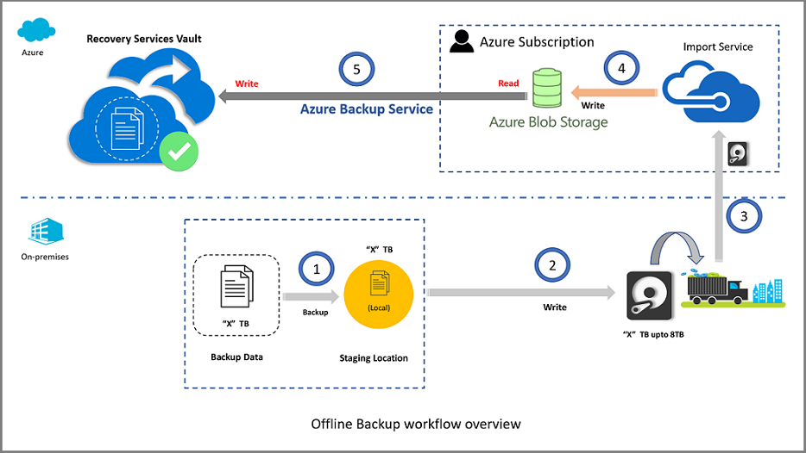

### Configure and review backup reports

A common requirement for backup admins is to obtain insights on backups, based on data spanning a long period of time.

1. **Create a Log Analytics (LA) workspace (or use an existing one):**

You need to set up one or more LA Workspaces to store your backup reporting data. By default, the data in an LA Workspace is retained for 30 days. To see data for a longer time horizon, change the retention period of the LA Workspace.

1. **Configure diagnostics settings for your vaults:**

In the monitoring section of your Recovery Services vault, select **Diagnostic settings** and specify the target for the Recovery Services vault's diagnostic data. [Learn more about using diagnostic events](https://docs.microsoft.com/azure/backup/backup-azure-diagnostic-events).

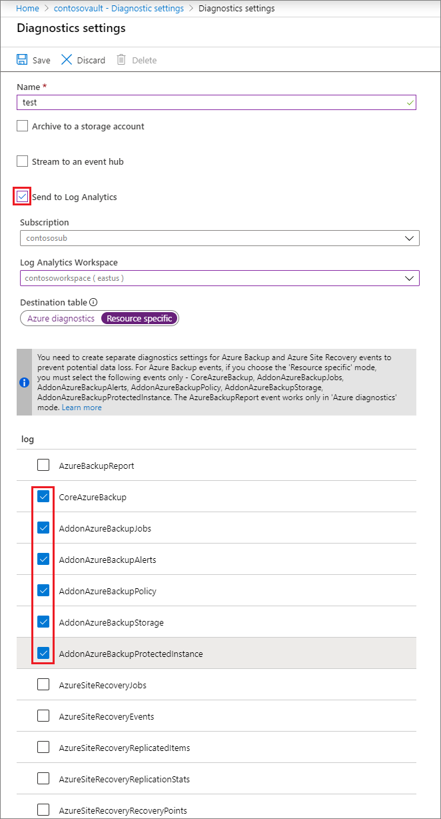

Azure Backup also provides a built-in Azure Policy, which automates the configuration of diagnostic settings for all vaults in a given scope.

1. **View reports on the Azure portal:**

Once you have configured your vaults to send data to LA, view your backup reports by navigating to any vault’s blade and clicking on the **Backup Reports** menu item.

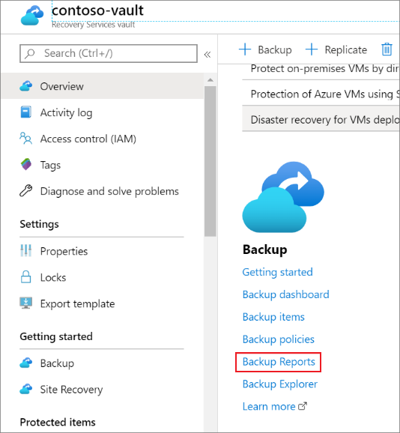

Clicking this link opens up the Backup Report Workbook.

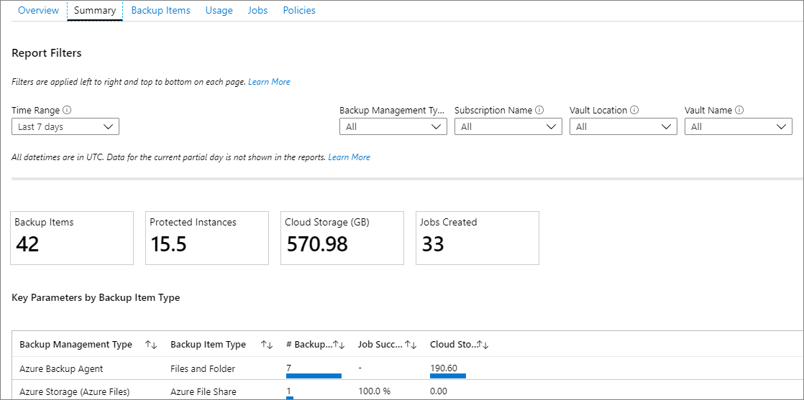

### Perform backup operation

he Azure Backup service provides simple, secure, and cost-effective solutions to back up your data and recover it from the Microsoft Azure cloud.

* **On-premises** - Back up files, folders, system state using the [Microsoft Azure Recovery Services (MARS) agent](https://docs.microsoft.com/en-us/azure/backup/backup-support-matrix-mars-agent). Or use the DPM or Azure Backup Server (MABS) agent to protect on-premises VMs ([Hyper-V](https://docs.microsoft.com/en-us/azure/backup/back-up-hyper-v-virtual-machines-mabs) and [VMWare](https://docs.microsoft.com/en-us/azure/backup/backup-azure-backup-server-vmware)) and other [on-premises workloads](https://docs.microsoft.com/en-us/azure/backup/backup-mabs-protection-matrix)
* **Azure VMs** - [Back up entire Windows/Linux VMs](https://docs.microsoft.com/en-us/azure/backup/backup-azure-vms-introduction) (using backup extensions) or back up files, folders, and system state using the [MARS agent](https://docs.microsoft.com/en-us/azure/backup/backup-azure-manage-mars).
* **Azure Files shares** - [Back up Azure File shares to a storage account](https://docs.microsoft.com/en-us/azure/backup/backup-afs)
* **SQL Server in Azure VMs** - [Back up SQL Server databases running on Azure VMs](https://docs.microsoft.com/en-us/azure/backup/backup-azure-sql-database)
* **SAP HANA databases in Azure VMs** - [Backup SAP HANA databases running on Azure VMs](https://docs.microsoft.com/en-us/azure/backup/backup-azure-sap-hana-database)

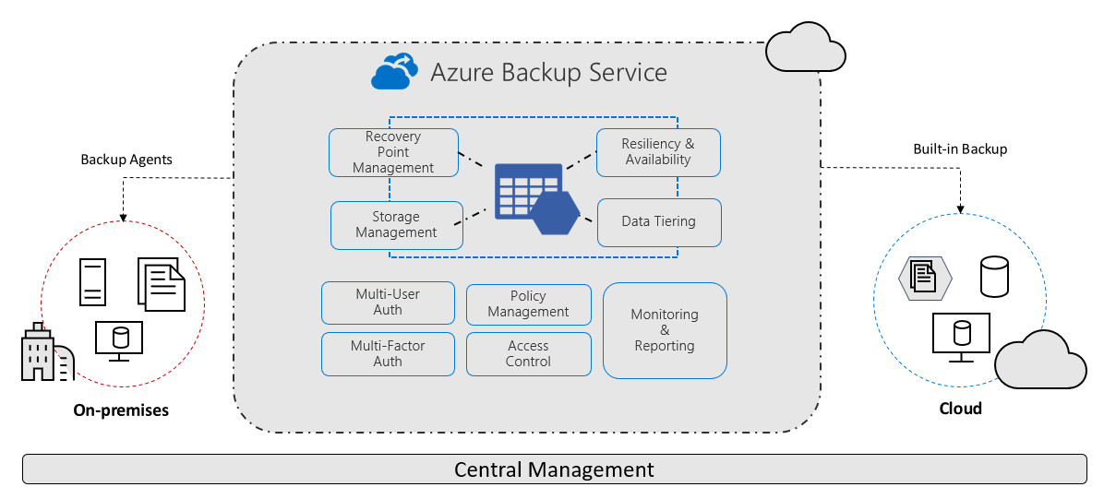

### Create Recovery Services Vault

A Recovery Services vault is an entity that stores the backups and recovery points created over time. The Recovery Services vault also contains the backup policies that are associated with the protected virtual machines.

To create a Recovery Services vault:

1. In the **All services** dialog box, enter **Recovery Services**. The list of resources filters according to your input. In the list of resources, select **Recovery Services vaults**.

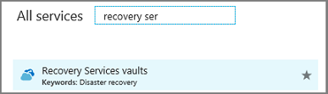

1. On the **Recovery Services vaults** dashboard, select **Add**.

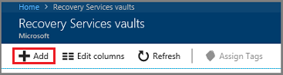

The **Recovery Services vault** dialog box opens. Provide values for the **Name**, **Subscription**, **Resource group**, and **Location**.

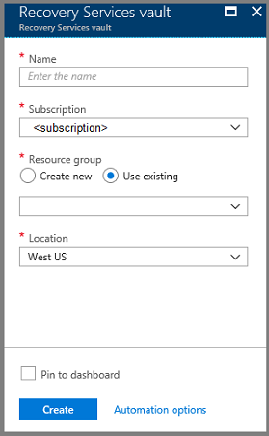

* + **Name**: Enter a friendly name to identify the vault.
  + **Subscription**: Choose the subscription to use.
  + **Resource group**: Use an existing resource group or create a new one.
  + **Location**: Select the geographic region for the vault.

1. When you're ready to create the Recovery Services vault, select **Create**.

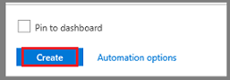 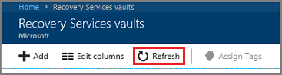

**Set storage redundancy**

Azure Backup automatically handles storage for the vault. You need to specify how that storage is replicated.

1. From the **Recovery Services vaults** blade, click the new vault. Under the **Settings** section, click **Properties**.
2. In **Properties**, under **Backup Configuration**, click **Update**.
3. Select the storage replication type, and click **Save**.

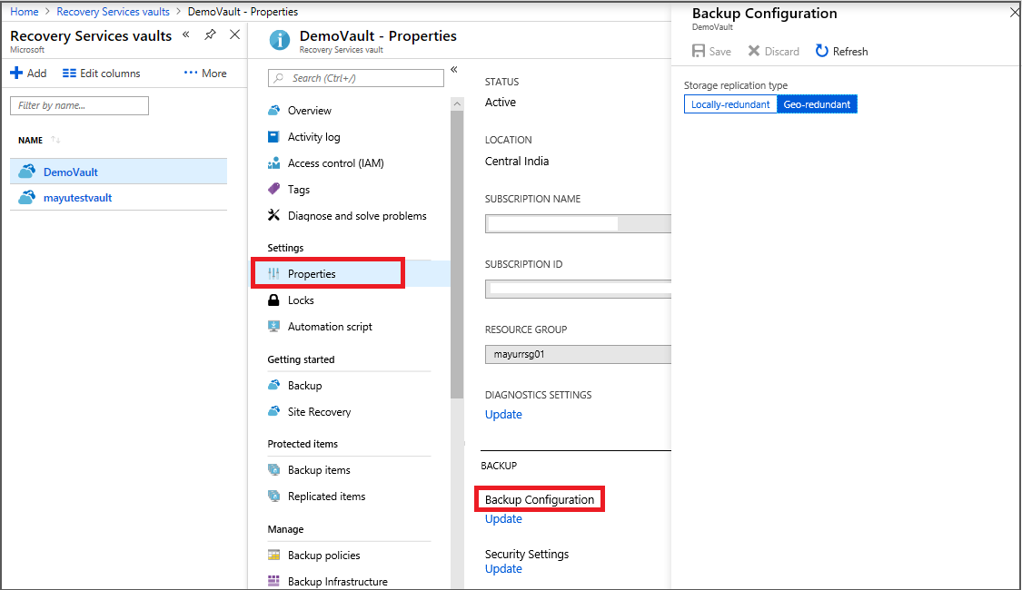

* + We recommend that if you're using Azure as a primary backup storage endpoint, continue to use the default **Geo-redundant** setting.
  + If you don't use Azure as a primary backup storage endpoint, then choose **Locally-redundant**, which reduces the Azure storage costs.

### Create and configure backup policy

* Open the vault in the portal, and select Backup in the Getting Started section.
* In Backup goal > Where is the workload running ? select Azure.
* In What do we want to back up? select Virtual machine > OK.
* In Backup policy > Choose backup policy, select the policy that we want to associate with the vault. Then click OK.
* A backup policy specifies when backups are taken, and how long they are stored – The details of the default policy are listed under the drop-down menu and in case we don’t want to use the default policy, select Create New, and create a custom policy.
* Choose the encrypted VMs you want to back up using the select policy, and select OK.
* In case we are using Azure Key Vault, on the vault page, we see a message that Azure Backup needs read-only access to the keys and secrets in the Key Vault.
* In case we are using Azure Key Vault, on the vault page, we see a message that Azure Backup needs read-only access to the keys and secrets in the Key Vault.
* Click Enable Backup to deploy the backup policy in the vault, and enable backup for the selected VMs.

|  |  |
| --- | --- |
| **SIZE OF EACH INSTANCE** | **AZURE BACKUP PRICE PER MONTH** |
| Instance < or = 50 GB | $5 + storage consumed |
| Instance is >50 but < or = 500 GB | $10 + storage consumed |
| Instance > 500 GB | $10 for each 500 GB increment + storage consumed |

|  |  |  |  |
| --- | --- | --- | --- |
| **omponent** | **Unit** | **Unit Charges** | **Total Cost** |
| Backup Instance charges | Instance > 500 GB | $ 10 for each 500 GB increment | $30 |
| Storage consumed | 840 GB for full backup + 84 GB for incremental | $ 0.024 per GB (LRS) | $22.18 |

### Perform a restore operation

1. Sign in to the [Azure portal](https://portal.azure.com/) and in the left pane, click **Virtual machines**. From the list of virtual machines, select the virtual machine to open that virtual machine's dashboard.
2. In the virtual machine's menu, click **Backup** to open the Backup dashboard.

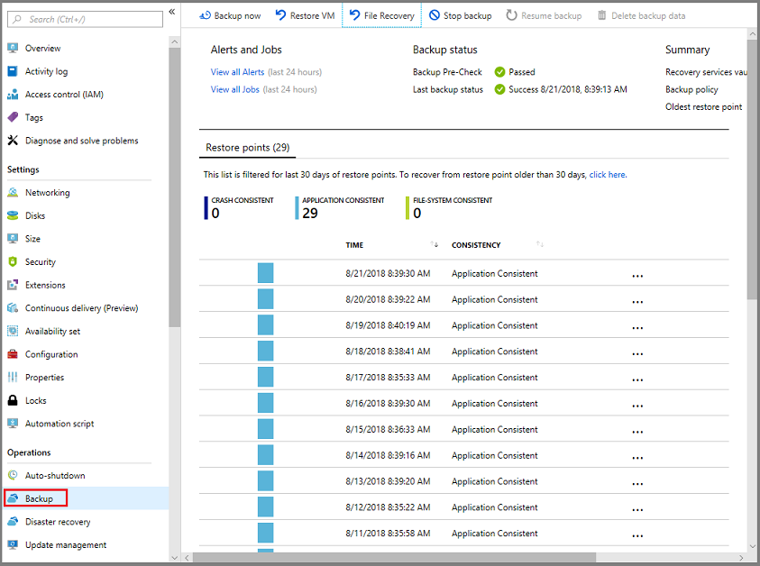

1. In the Backup dashboard menu, click **File Recovery**.

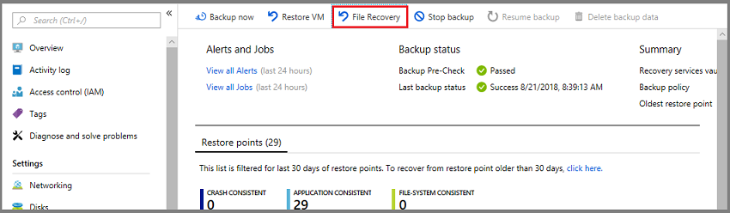

The **File Recovery** menu opens.

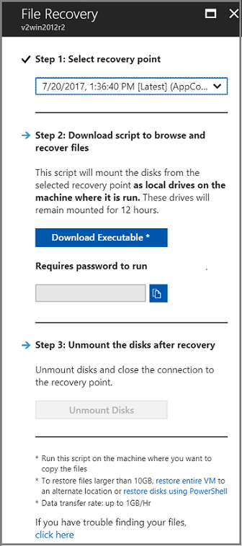

1. From the **Select recovery point** drop-down menu, select the recovery point that holds the files you want. By default, the latest recovery point is already selected.
2. To download the software used to copy files from the recovery point, click **Download Executable** (for Windows Azure VMs) or **Download Script** (for Linux Azure VMs, a python script is generated).

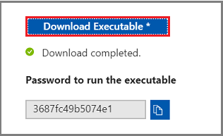

Azure downloads the executable or script to the local computer.



1. The executable or script is password protected and requires a password. In the **File Recovery** menu, click the copy button to load the password into memory.

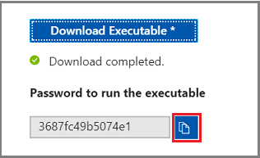

1. From the download location right-click the executable or script and run it with Administrator credentials. Once the valid password is entered, the script connects to the recovery point.

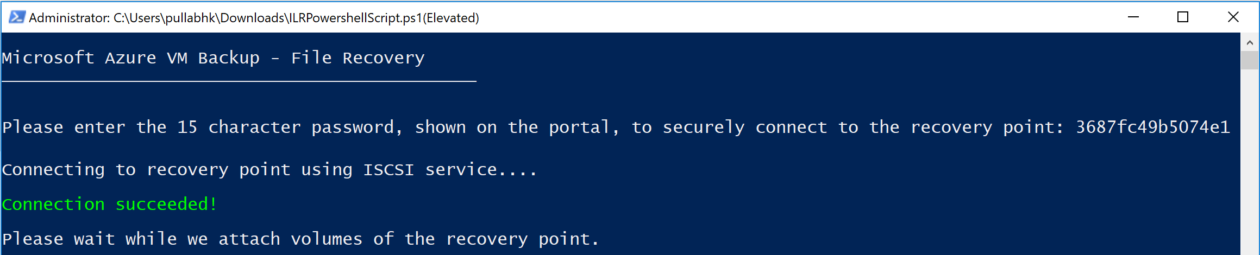

1. For Linux machines, a python script is generated. One needs to download the script and copy it to the relevant/compatible Linux server. You may have to modify the permissions to execute it with chmod +x <python file name>. Then run the python file with ./<python file name>.

# Deploy and manage virtual machines (VMs)

## Create and configure a VM for Windows and Linux

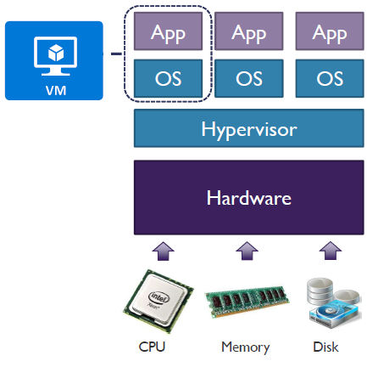

A **hypervisor**, also known as a virtual machine monitor, is a process that creates and runs virtual machines ([VMs](https://www.vmware.com/topics/glossary/content/virtual-machine)). A hypervisor allows one host computer to support multiple guest VMs by virtually sharing its resources, like memory and processing.

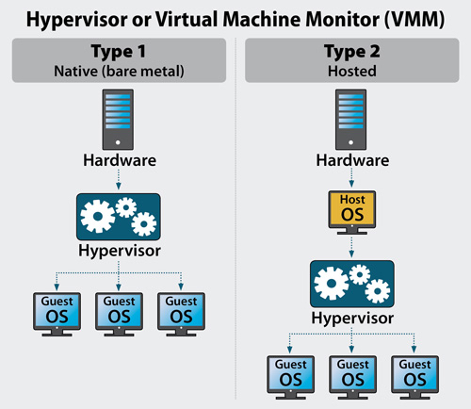

**VM Types**

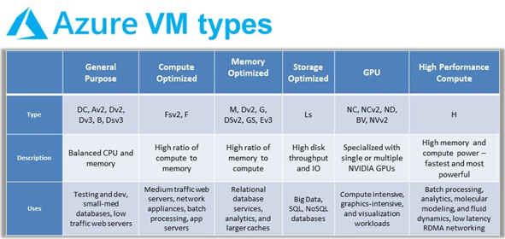

**VM Specializations**

A code is normally used in the name of a VM to denote a special feature in that VM size. Examples of such codes are:

* **S**: The VM supports Premium SSD disks. It also supports Standard HDD and Standard SSD disks. Note that the S variants are the same price as the non-S variants – it is your choice of disk tier that varies the pricing. Also note that in the more recent series of machines, Microsoft only provides the S variants because people started to standardize on them for easier disk tier switching.
* **M**: The size in question offers more memory (RAM) than usual.
* **R**: An additional Remote Direct Memory Access (RDMA) NIC is added to the VM. This offers high bandwidth, low latency, and low CPU impact data transfers.
* **I**: This indicates that the virtual machine is the only virtual machine (Isolated) on the host, thus having all the motherboard’s capacity.

**Azure Compute Units (ACU)**

The concept of the Azure Compute Unit (ACU) provides a way of comparing compute (CPU) performance across Azure SKUs. This will help you easily identify which SKU is most likely to satisfy your performance needs.

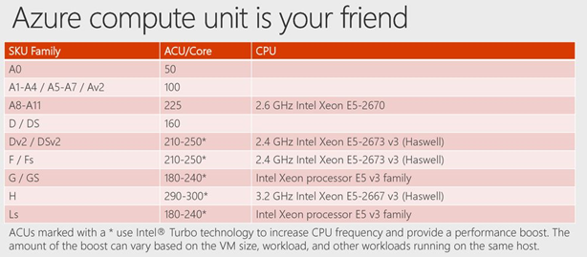

**Create and configure a VM for Windows and Linux**

Azure Virtual Machines (VM) is one of several types of [on-demand, scalable computing resources](https://docs.microsoft.com/en-us/azure/architecture/guide/technology-choices/compute-decision-tree). An Azure VM gives the flexibility of virtualization without having to buy and maintain the physical hardware that runs it

Windows capabilities

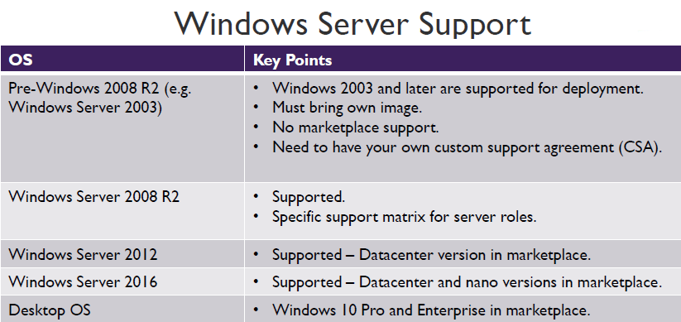

Linux capabilities

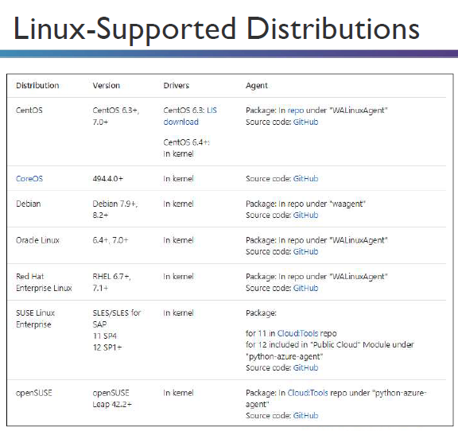

The following resources are created when a VM is created

1. Virtual Machine
2. Disk
3. Public IP Address (Optional)
4. Virtual Network
5. Network Interface Card
6. Network Security Group (optional)

1. Virtual Machine

**Basics Mandatory Fields**

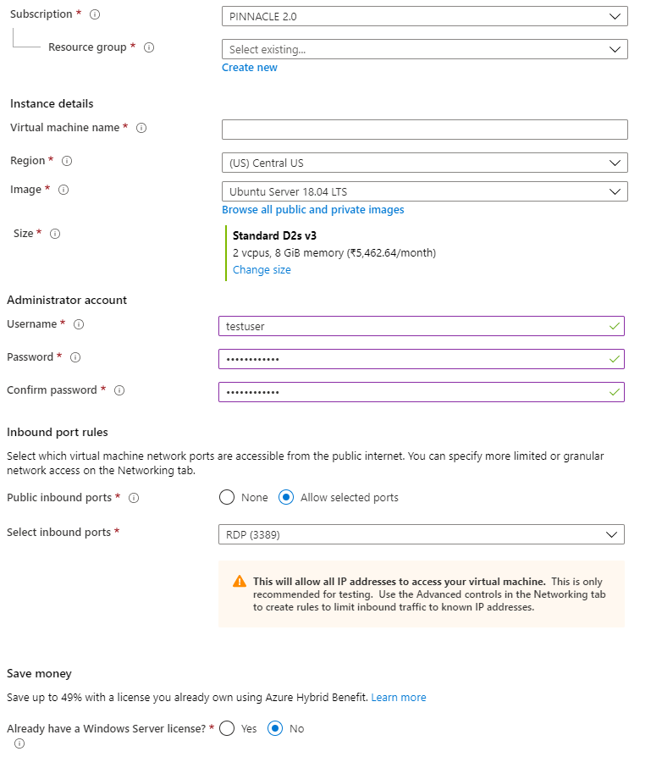

2.Disk



3. Public IP Address (Optional)

4. Virtual Network

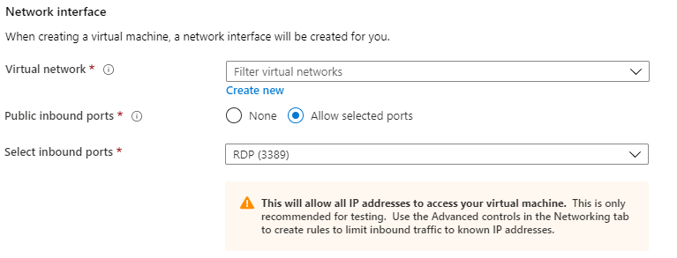

5. Network Interface Card

6. Network Security Group (optional)



### Configure high availability

Learn ways to set up and manage multiple virtual machines to ensure high availability for your Windows application in Azure.

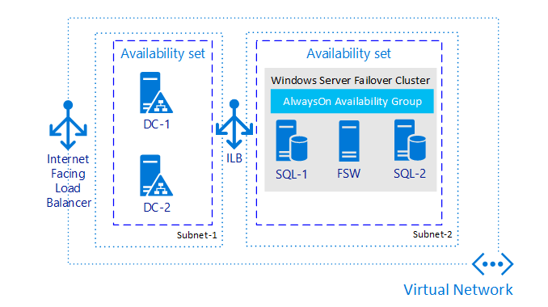

**High Availability Scenarios**

1. **Unplanned Hardware Maintenance Event**
2. **An Unexpected Downtime**
3. **Planned Maintenance events**

**Availability Set**

An Availability Set is a logical grouping capability for isolating VM resources from each other when they're deployed. Azure makes sure that the VMs you place within an Availability Set run across multiple physical servers, compute racks, storage units, and network switches. If a hardware or software failure happens, only a subset of your VMs are impacted and your overall solution stays operational. Availability Sets are essential for building reliable cloud solutions.

Each virtual machine in your availability set is assigned an **update domain** and a **fault domain** by the underlying Azure platform. For a given availability set, five non-user-configurable update domains are assigned by default to indicate groups of virtual machines and underlying physical hardware that can be rebooted at the same time.

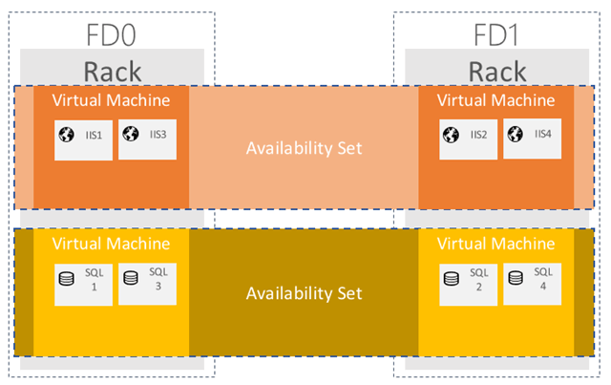

**Fault Domain**

A fault domain is factually a rack of the servers which consumes essentially subsystem like network, power, cooling etc. When you put VMs on an Availability Set then to protect VMs from failure Azure spread them on fault domain and update domain.

Two events Unplanned Hardware maintenance Event and Unexpected Downtime comes under fault domain.

**Update Domain**

When you created VMs on the IaaS service model then Microsoft is not responsible for automatic system updates. You have complete control over that. Planned maintenance event comes in this phase where we planned for server or virtual machine updating.

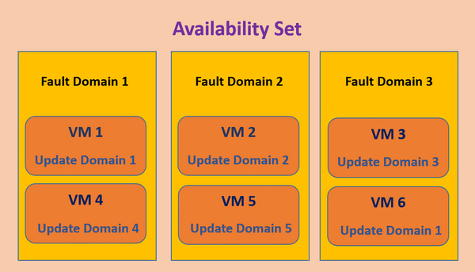

Sometimes we need to update some own software or some updates come from Microsoft due to performance, security etc. it is not automatically updated your virtual machine we need to plane it for updates. So how is that done without taking your service offline? Update Domains.

|  |  |  |
| --- | --- | --- |
| VM | Fault Domain (Unplanned) | Update Domain (Planned) |
| VM 0 | 0 | 0 |
| VM 1 | 1 | 1 |
| VM 2 | 0 | 2 |
| VM 3 | 1 | 3 |
| VM 4 | 0 | 4 |
| VM 5 | 1 | 0 |
| VM 6 | 0 | 1 |
| VM 7 | 1 | 2 |
| VM 8 | 0 | 3 |
| VM 9 | 1 | 4 |

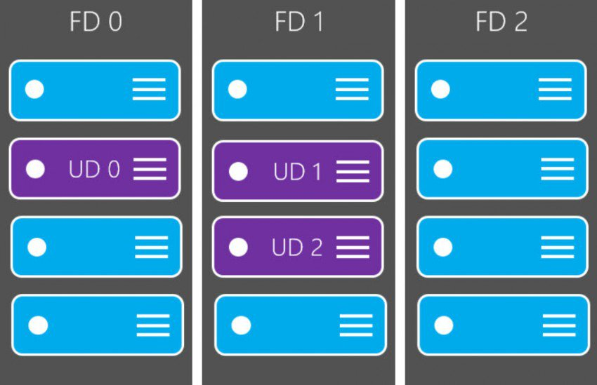

### Configure monitoring, networking, storage, and virtual machine size

**Disk Types**

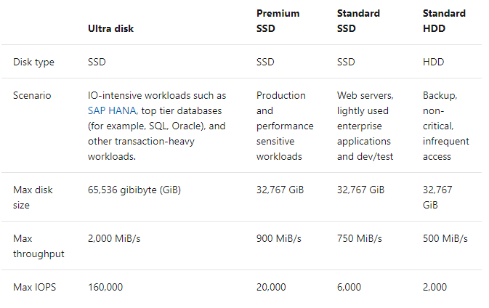

**Managed Disks**

Azure Managed Disks simplifies disk management for Azure IaaS VMs by managing the storage accounts associated with the VM disks. You only have to specify the type (Premium or Standard) and the size of disk you need, and Azure creates and manages the disk for you.

**Unmanaged Disks**

Microsoft Azure unmanaged disk is a Microsoft-managed cloud service that provides storage that is highly available, secure, durable, scalable, and redundant. Microsoft takes care of maintenance and handles critical problems for you.

Unmanaged disk consists of three data services: Blob storage, File storage, and Queue storage. In an unmanaged disk, you manage the storage accounts that you use to store the virtual hard disk (VHD) files that correspond to your VM disks. VHD files are stored as page blobs in Azure storage accounts.

|  |  |  |
| --- | --- | --- |
| **Category** | **Managed disks** | **Unmanaged disks** |
| **Management** | Is an ARM (Azure Resource Manager) object (resource) | Is not an ARM resource, but a file (.vhd) residing on a Azure Storage Account. The latter is an ARM  object |
| **Size** | The managed disks sizes are fixed (and can be resized). Which means that you cannot choose a custom size. You will need to pick up from a list. | You can choose the disk size during the provisioning (and can be resized) when using Standard Storage. |
| **Cost** | You will pay :  ·       Standard Storage :  o   A fixed price per disk size (Per month), whatever the disk usage is  o   Operations cost*  ·       Premium Storage  o   A fixed price per disk size whatever the disk usage is | You will pay :  ·       Standard Storage :  o   The GB / month disk usage. You pay only what you consume  o   Operations cost*  ·       Premium Storage  o   A fixed price per disk size whatever the disk usage is |
| **Performance** | A managed disk have a predictable performance, with Standard storage (500 IOPS) or Premium storage (Depends on the disk). | Only premium storage disks have a predictable performance (depends on the disk). Standard storage have a predictable performance (500 IOPS) unless they are impacted by the Storage Account performance limits (A maximum of 40 disks per standard storage account is recommended, otherwise disks can be throttled). |
| **Availability** | When placing VMs using managed disks under an Availability Set, disks are placed on different fault domains in order to achieve the better SLA (The Availability Set SLA is only for compute) | When placing VMs using unmanaged disks under an Availability Set, there is no guarantee that the disks are placed on different fault domains, even if they are on different Storage Accounts. |
| **Redundancy** | LRS | LRS, GRS |
| **Encryption** | ADE, SSE (Coming soon) | ADE, SSE |

### Deploy and configure scale sets

**VM Extensions**

Azure virtual machine (VM) extensions are small applications that provide post-deployment configuration and automation tasks on Azure VMs.

The Azure platform hosts many extensions that range from VM configuration, monitoring, security, and utility applications. Publishers take an application, then wrap it into an extension, and simplify the installation

**VM Extensions Scenarios**

* VM configuration, you can use Powershell DSC (Desired State Configuration), Chef, Puppet and Custom Script Extensions to install VM configuration agents and configure your VM.
* AV products, such as Symantec, ESET.
* VM vulnerability tool, such as Qualys, Rapid7, HPE.
* VM and App monitoring tooling, such as DynaTrace, Azure Network Watcher, Site24x7, and Stackify.

**PowerShell DSC Extension**

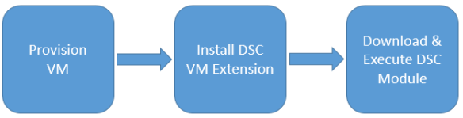

**Azure VM Antimalware Extension || Custom Script Extension**

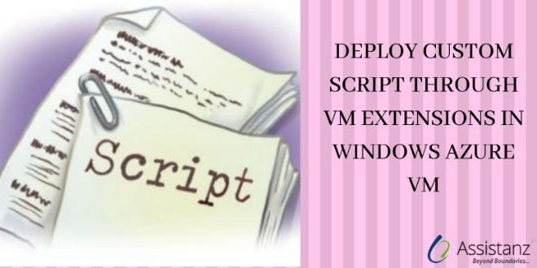

<https://www.starwindsoftware.com/blog/working-with-azure-vm-extensions>

**VM Scale Sets**

Azure virtual machine scale sets let you create and manage a group of identical, load balanced VMs. The number of VM instances can automatically increase or decrease in response to demand or a defined schedule. Scale sets provide high availability to your applications, and allow you to centrally manage, configure, and update a large number of VMs.

| **Scenario** | **Manual group of VMs** | **Virtual machine scale set** |
| --- | --- | --- |
| Add additional VM instances | Manual process to create, configure, and ensure compliance | Automatically create from central configuration |
| Traffic balancing and distribution | Manual process to create and configure Azure load balancer or Application Gateway | Can automatically create and integrate with Azure load balancer or Application Gateway |
| High availability and redundancy | Manually create Availability Set or distribute and track VMs across Availability Zones | Automatic distribution of VM instances across Availability Zones or Availability Sets |
| Scaling of VMs | Manual monitoring and Azure Automation | Autoscale based on host metrics, in-guest metrics, Application Insights, or schedule |

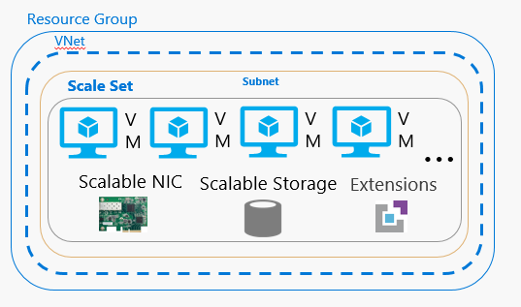

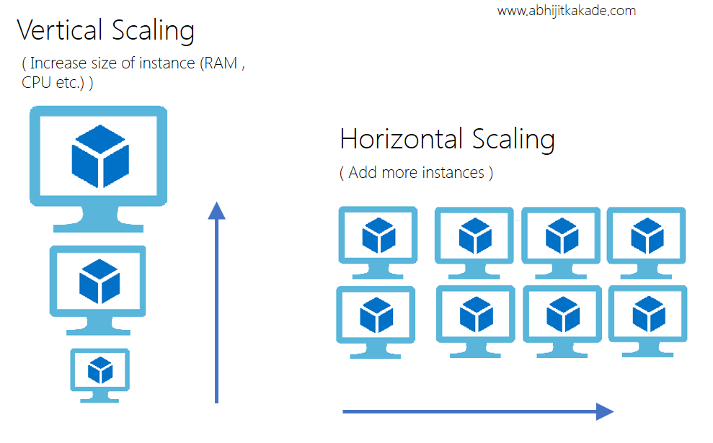

 There two type / workflow of Scaling:

* **Scale Up (Vertical Scaling)**

Make it bigger. Its means Get More size of CPU, Memory, Disk space etc. You scale up by changing the pricing tier of the App Service plan that your app belongs to.  Ex: Increase the RAM size from 2 TB to 10 TB.

* **Scale out (Horizontal Scaling)**

Add more Instances. It’s like upgrading the capacity of the app / server by creating/ adding more instances of same size. Using Load balancer, you can manage all request coming from end users. Suppose your Sever has 10 GB RAM, 200 TB HDD space, 10 core etc. so while scaling out this server you will create more instances of servers with same configuration.

## Automate deployment of VMs

### Modify Azure Resource Manager (ARM) template

you can automate deployments and use the practice of infrastructure as code. To implement infrastructure as code for your Azure solutions, use Azure Resource Manager templates. The template is a JavaScript Object Notation (JSON) file that defines the infrastructure and configuration for your project.

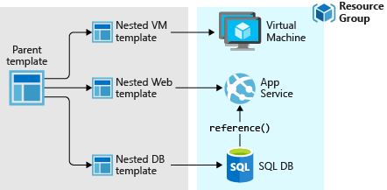

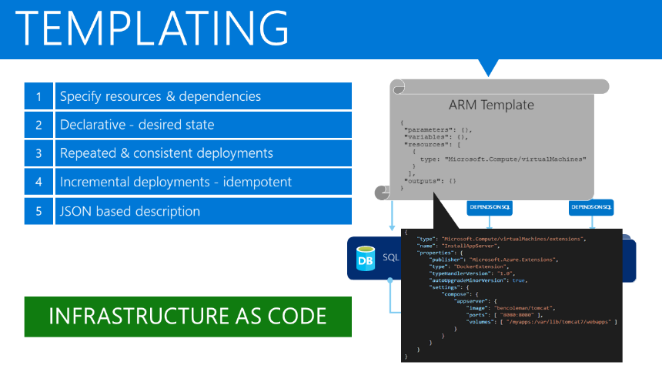

**Declarative syntax**: Resource Manager templates allow you to create and deploy an entire Azure infrastructure declaratively. For example, you can deploy not only virtual machines, but also the network infrastructure, storage systems and any other resources you may need.

**Repeatable results**: Repeatedly deploy your infrastructure throughout the development lifecycle and have confidence your resources are deployed in a consistent manner. Templates are idempotent, which means you can deploy the same template many times and get the same resource types in the same state.

**Orchestration**: Resource Manager orchestrates the deployment of interdependent resources so they're created in the correct order. When possible, Resource Manager deploys resources in parallel so your deployments finish faster than serial deployments. You deploy the template through one command, rather than through multiple imperative commands.

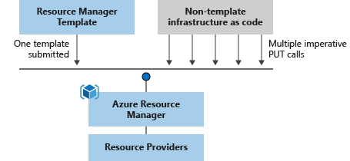

**Template. JSON format**

{

"$schema": "https://schema.management.azure.com/schemas/2015-01-01/deploymentTemplate.json#",

"contentVersion": "",

"apiProfile": "",

"parameters": { },

"variables": { },

"functions": [ ],

"resources": [ ],

"outputs": { }

}

| **Element name** | **Required** | **Description** |
| --- | --- | --- |
| $schema | Yes | Location of the JSON schema file that describes the version of the template language.  For resource group deployments, use: https://schema.management.azure.com/schemas/2015-01-01/deploymentTemplate.json#  For subscription deployments, use: https://schema.management.azure.com/schemas/2018-05-01/subscriptionDeploymentTemplate.json# |
| contentVersion | Yes | Version of the template (such as 1.0.0.0). You can provide any value for this element. Use this value to document significant changes in your template. When deploying resources using the template, this value can be used to make sure that the right template is being used. |
| apiProfile | No | An API version that serves as a collection of API versions for resource types. Use this value to avoid having to specify API versions for each resource in the template. When you specify an API profile version and don't specify an API version for the resource type, Resource Manager uses the API version for that resource type that is defined in the profile.  The API profile property is especially helpful when deploying a template to different environments, such as Azure Stack and global Azure. Use the API profile version to make sure your template automatically uses versions that are supported in both environments. For a list of the current API profile versions and the resources API versions defined in the profile, see [API Profile](https://github.com/Azure/azure-rest-api-specs/tree/master/profile).  For more information, see [Track versions using API profiles](https://docs.microsoft.com/en-us/azure/azure-resource-manager/templates/templates-cloud-consistency#track-versions-using-api-profiles). |
| [parameters](https://docs.microsoft.com/en-us/azure/azure-resource-manager/templates/template-syntax#parameters) | No | Values that are provided when deployment is executed to customize resource deployment. |
| [variables](https://docs.microsoft.com/en-us/azure/azure-resource-manager/templates/template-syntax#variables) | No | Values that are used as JSON fragments in the template to simplify template language expressions. |
| [functions](https://docs.microsoft.com/en-us/azure/azure-resource-manager/templates/template-syntax#functions) | No | User-defined functions that are available within the template. |
| [resources](https://docs.microsoft.com/en-us/azure/azure-resource-manager/templates/template-syntax#resources) | Yes | Resource types that are deployed or updated in a resource group or subscription. |
| [outputs](https://docs.microsoft.com/en-us/azure/azure-resource-manager/templates/template-syntax#outputs) | No | Values that are returned after deployment. |

**Parameters.JSON**

"parameters": {

"<parameter-name>" : {

"type" : "<type-of-parameter-value>",

"defaultValue": "<default-value-of-parameter>",

"allowedValues": [ "<array-of-allowed-values>" ],

"minValue": <minimum-value-for-int>,

"maxValue": <maximum-value-for-int>,

"minLength": <minimum-length-for-string-or-array>,

"maxLength": <maximum-length-for-string-or-array-parameters>,

"metadata": {

"description": "<description-of-the parameter>"

}

}

}

| **Element name** | **Required** | **Description** |
| --- | --- | --- |
| parameter-name | Yes | Name of the parameter. Must be a valid JavaScript identifier. |
| type | Yes | Type of the parameter value. The allowed types and values are **string**, **securestring**, **int**, **bool**, **object**, **secureObject**, and **array**. See [Data types](https://docs.microsoft.com/en-us/azure/azure-resource-manager/templates/template-syntax#data-types). |
| defaultValue | No | Default value for the parameter, if no value is provided for the parameter. |
| allowedValues | No | Array of allowed values for the parameter to make sure that the right value is provided. |
| minValue | No | The minimum value for int type parameters, this value is inclusive. |
| maxValue | No | The maximum value for int type parameters, this value is inclusive. |
| minLength | No | The minimum length for string, secure string, and array type parameters, this value is inclusive. |
| maxLength | No | The maximum length for string, secure string, and array type parameters, this value is inclusive. |
| description | No | Description of the parameter that is displayed to users through the portal. For more information, see [Comments in templates](https://docs.microsoft.com/en-us/azure/azure-resource-manager/templates/template-syntax#comments). |

### **Configure location of new VMs**

Azure has some special regions that you may wish to use when building out your applications for compliance or legal purposes. These special regions include:

* **US Gov Virginia** and **US Gov Iowa**
  + A physical and logical network-isolated instance of Azure for US government agencies and partners, operated by screened US persons. Includes additional compliance certifications such as [FedRAMP](https://www.microsoft.com/en-us/TrustCenter/Compliance/FedRAMP) and [DISA](https://www.microsoft.com/en-us/TrustCenter/Compliance/DISA). Read more about [Azure Government](https://azure.microsoft.com/features/gov/).
* **China East** and **China North**
  + These regions are available through a unique partnership between Microsoft and 21Vianet, whereby Microsoft does not directly maintain the datacenters. See more about [Azure China 21Vianet](https://www.windowsazure.cn/).
* **Germany Central** and **Germany Northeast**
  + These regions are available via a data trustee model whereby customer data remains in Germany under control of T-Systems, a Deutsche Telekom company, acting as the German data trustee.

**Region pairs**

Each Azure region is paired with another region within the same geography

| **eography** | **Paired regions** |  |
| --- | --- | --- |
| Asia | East Asia | Southeast Asia |
| Australia | Australia East | Australia Southeast |
| Australia | Australia Central | Australia Central 2 |
| Brazil | Brazil South | South Central US |
| Canada | Canada Central | Canada East |
| China | China North | China East |
| China | China North 2 | China East 2 |
| Europe | North Europe (Ireland) | West Europe (Netherlands) |
| France | France Central | France South |
| Germany | Germany Central | Germany Northeast |
| India | Central India | South India |
| India | West India | South India |
| Japan | Japan East | Japan West |
| Korea | Korea Central | Korea South |
| North America | East US | West US |
| North America | East US 2 | Central US |
| North America | North Central US | South Central US |
| North America | West US 2 | West Central US |
| South Africa | South Africa North | South Africa West |
| UK | UK West | UK South |
| United Arab Emirates | UAE North | UAE Central |
| US Department of Defense | US DoD East | US DoD Central |
| US Government | US Gov Arizona | US Gov Texas |
| US Government | US Gov Iowa | US Gov Virginia |
| US Government | US Gov Virginia | US Gov Texas |

### **Configure VHD template**

A virtual hard disk is conceptually similar to a physical hard disk. You can use a VHD to host the operating system and run a virtual machine. A VHD can also hold databases and other user-defined folders, files, and data. A VHD can hold anything that you can store on a physical hard disk.

A virtual machine can contain multiple VHDs. Typically, a virtual machine has an *operating system VHD* on which the operating system is installed. It also has one or more *data VHDs* that contain the applications and other user-specific data used by the virtual machine.

The difference between a VHD and a physical hard disk is that a VHD is stored as a virtual file in Azure. It isn't a piece of physical hardware.

**VHD Template**

Azure Resource Manager template defines a new Azure virtual machine (VM) instance, created from local virtual hard disk (VHD). This template is called VHD template.

### **Deploy from template**

1. Open Visual Studio Code with the Resource Manager Tools extension installed.
2. From the **File** menu, select **New File** to create a new file.
3. From the **File** menu, select **Save as**.
4. Name the file **azuredeploy** and select the **JSON** file extension. The complete name of the file **azuredeploy.json**.
5. Save the file to your workstation. Select a path that is easy to remember because you'll provide that path later when deploying the template.
6. Copy and paste the following JSON into the file:

{

"$schema": "https://schema.management.azure.com/schemas/2015-01-01/deploymentTemplate.json#",

"contentVersion": "1.0.0.0",

"resources": []

}

Here's what your VS Code environment looks like:

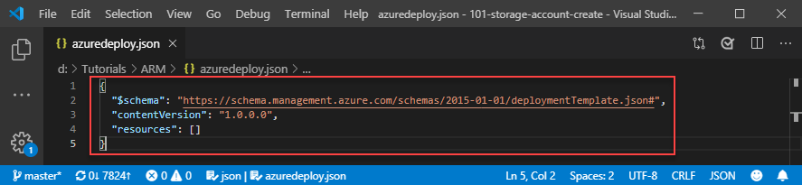

This template doesn't deploy any resources. We're starting with a blank template

### **Save a deployment as an ARM template**



### **Deploy Windows and Linux VMs**

To deploy the template, use either Azure CLI or Azure PowerShell. Use the resource group you created.

*$templateFile = "{provide-the-path-to-the-template-file}"*

*New-AzResourceGroupDeployment `*

*-Name blanktemplate `*

*-ResourceGroupName myResourceGroup `*

*-TemplateFile $templateFile*

**Verify deployment**

1. Sign in to the [Azure portal](https://portal.azure.com/).
2. From the left menu, select **Resource groups**.
3. Select the resource group deploy in the last procedure. The default name is **myResourceGroup**. You shall see no resource deployed within the resource group.
4. Notice in the upper right of the overview, the status of the deployment is displayed. Select **1 Succeeded**.

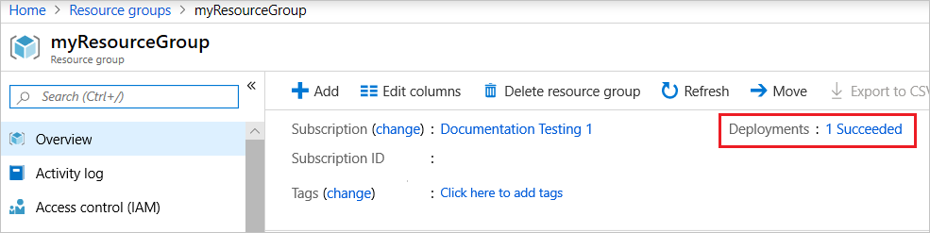

1. You see a history of deployment for the resource group. Select **blanktemplate**.

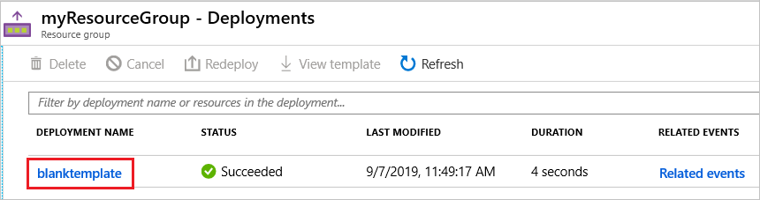

1. You see a summary of the deployment.

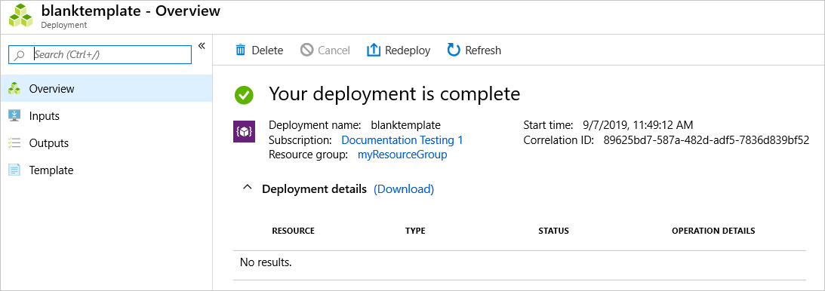

## Manage Azure VM

### **Add data discs**

1. Go to the [Azure portal](https://portal.azure.com/) to add a data disk. Search for and select **Virtual machines**.
2. Select a virtual machine from the list.
3. On the **Virtual machine** page, select **Disks**.
4. On the **Disks** page, select **Add data disk**.
5. In the drop-down for the new disk, select **Create disk**.
6. In the **Create managed disk** page, type in a name for the disk and adjust the other settings as necessary. When you're done, select **Create**.
7. In the **Disks** page, select **Save** to save the new disk configuration for the VM.
8. After Azure creates the disk and attaches it to the virtual machine, the new disk is listed in the virtual machine's disk settings under **Data disks**.

### **Add network interfaces**

1. Sign in to the Azure portal.
2. In the search box at the top of the portal, type the name of the VM to which you want to add the network interface, or browse for the VM by selecting **All services**, and then **Virtual machines**. After you've found the VM, select it. The VM must support the number of network interfaces you want to add. To find out how many network interfaces each VM size supports, see [Sizes for Linux virtual machines in Azure](https://docs.microsoft.com/en-us/azure/virtual-machines/linux/sizes?toc=%2fazure%2fvirtual-network%2ftoc.json) or [Sizes for Windows virtual machines in Azure](https://docs.microsoft.com/en-us/azure/virtual-machines/virtual-machines-windows-sizes?toc=%2fazure%2fvirtual-network%2ftoc.json).
3. Select **Overview**, under **SETTINGS**. Select **Stop**, and then wait until the **Status** of the VM changes to **Stopped (deallocated)**.
4. Select **Networking**, under **SETTINGS**.
5. Select **Attach network interface**. From the list of network interfaces that aren't currently attached to another VM, select the one you'd like to attach.

If you don't have an existing network interface, you must first create one.

1. Select **OK**.
2. Select **Overview**, under **SETTINGS**, and then **Start** to start the virtual machine.
3. Configure the VM operating system to use multiple network interfaces properly. Learn how to configure [Linux](https://docs.microsoft.com/en-us/azure/virtual-machines/linux/multiple-nics?toc=%2fazure%2fvirtual-network%2ftoc.json#configure-guest-os-for-multiple-nics) or [Windows](https://docs.microsoft.com/en-us/azure/virtual-machines/windows/multiple-nics?toc=%2fazure%2fvirtual-network%2ftoc.json#configure-guest-os-for-multiple-nics) for multiple network interfaces.

### **Automate configuration management by using PowerShell Desired State Configuration (DSC) and VM Agent by using custom script extensions**

The Azure DSC extension can use DSC configuration documents to directly configure Azure VMs during deployment.

The following example shows a simple example of a configuration. Save the configuration locally as iisInstall.ps1.

The following commands place the iisInstall.ps1 script on the specified VM. The commands also execute the configuration, and then report back on status.

$resourceGroup = 'dscVmDemo'

$vmName = 'myVM'

$storageName = 'demostorage'

#Publish the configuration script to user storage

Publish-AzVMDscConfiguration -ConfigurationPath .\iisInstall.ps1 -ResourceGroupName $resourceGroup -StorageAccountName $storageName -force

#Set the VM to run the DSC configuration

Set-AzVMDscExtension -Version '2.76' -ResourceGroupName $resourceGroup -VMName $vmName -ArchiveStorageAccountName $storageName -ArchiveBlobName 'iisInstall.ps1.zip' -AutoUpdate -ConfigurationName 'IISInstall'

### **Manage VM sizes**



### **Move VMs from one resource group to another**

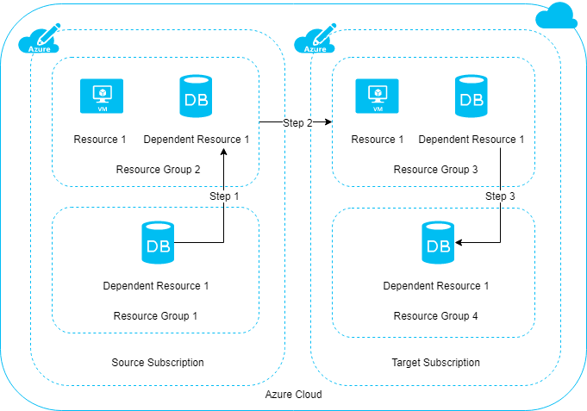

**Checklist before moving resources**

1. The resources you want to move must support the move operation. For a list of which resources support move, see [Move operation support for resources](https://docs.microsoft.com/en-us/azure/azure-resource-manager/management/move-support-resources).
2. Some services have specific limitations or requirements when moving resources. If you've moving any of the following services, check that guidance before moving.
   * [App Services move guidance](https://docs.microsoft.com/en-us/azure/azure-resource-manager/management/move-limitations/app-service-move-limitations)
   * [Azure DevOps Services move guidance](https://docs.microsoft.com/en-us/azure/devops/organizations/billing/change-azure-subscription?toc=/azure/azure-resource-manager/toc.json)
   * [Classic deployment model move guidance](https://docs.microsoft.com/en-us/azure/azure-resource-manager/management/move-limitations/classic-model-move-limitations) - Classic Compute, Classic Storage, Classic Virtual Networks, and Cloud Services
   * [Networking move guidance](https://docs.microsoft.com/en-us/azure/azure-resource-manager/management/move-limitations/networking-move-limitations)
   * [Recovery Services move guidance](https://docs.microsoft.com/en-us/azure/backup/backup-azure-move-recovery-services-vault?toc=/azure/azure-resource-manager/toc.json)
   * [Virtual Machines move guidance](https://docs.microsoft.com/en-us/azure/azure-resource-manager/management/move-limitations/virtual-machines-move-limitations)
3. The source and destination subscriptions must be active.
4. The source and destination subscriptions must exist within the same [Azure Active Directory tenant](https://docs.microsoft.com/en-us/azure/active-directory/develop/quickstart-create-new-tenant).

If the tenant IDs for the source and destination subscriptions aren't the same, use the following methods to reconcile the tenant IDs:

* + [Transfer ownership of an Azure subscription to another account](https://docs.microsoft.com/en-us/azure/billing/billing-subscription-transfer)
  + [How to associate or add an Azure subscription to Azure Active Directory](https://docs.microsoft.com/en-us/azure/active-directory/fundamentals/active-directory-how-subscriptions-associated-directory)

1. The destination subscription must be registered for the resource provider of the resource being moved.
2. The account moving the resources must have at least the following permissions:
   * **Microsoft.Resources/subscriptions/resourceGroups/moveResources/action** on the source resource group.
   * **Microsoft.Resources/subscriptions/resourceGroups/write** on the destination resource group.
3. If moving the resources means the subscription will exceed its limits, you need to review whether you can request an increase in the quota.
4. **For a move across subscriptions, the resource and its dependent resources must be located in the same resource group and they must be moved together.**

**How to Move Resources**

* Step 1: If dependent resources are distributed across different resource groups, first move them into one resource group.
* Step 2: Move the resource and dependent resources together from the source subscription to the target subscription.
* Step 3: Optionally, redistribute the dependent resources to different resource groups within the target subscription.

**Validate move**

The [validate move operation](https://docs.microsoft.com/en-us/rest/api/resources/resources/validatemoveresources) lets you test your move scenario without actually moving the resources. To run this operation, you need the:

* name of the source resource group
* resource ID of the target resource group
* resource ID of each resource to move
* the [access token](https://docs.microsoft.com/en-us/rest/api/azure/#acquire-an-access-token) for your account

Send the following request:

HTTPCopy

POST https://management.azure.com/subscriptions/<subscription-id>/resourceGroups/<source-group>/validateMoveResources?api-version=2019-05-10

Authorization: Bearer <access-token>

Content-type: application/json

With a request body:

JSONCopy

{

"resources": ["<resource-id-1>", "<resource-id-2>"],

"targetResourceGroup": "/subscriptions/<subscription-id>/resourceGroups/<target-group>"

}

If the request is formatted correctly, the operation returns:

HTTPCopy

Response Code: 202

cache-control: no-cache

pragma: no-cache

expires: -1

location: https://management.azure.com/subscriptions/<subscription-id>/operationresults/<operation-id>?api-version=2018-02-01

retry-after: 15

...

The 202 status code indicates the validation request was accepted,

### **Redeploy VMs**

1. Select the VM you wish to redeploy, then select the *Redeploy* button in the *Settings* blade. You may need to scroll down to see the **Support and Troubleshooting** section that contains the 'Redeploy' button as in the following example:
2. To confirm the operation, select the *Redeploy* button:
3. The **Status** of the VM changes to *Updating* as the VM prepares to redeploy, as shown in the following example:

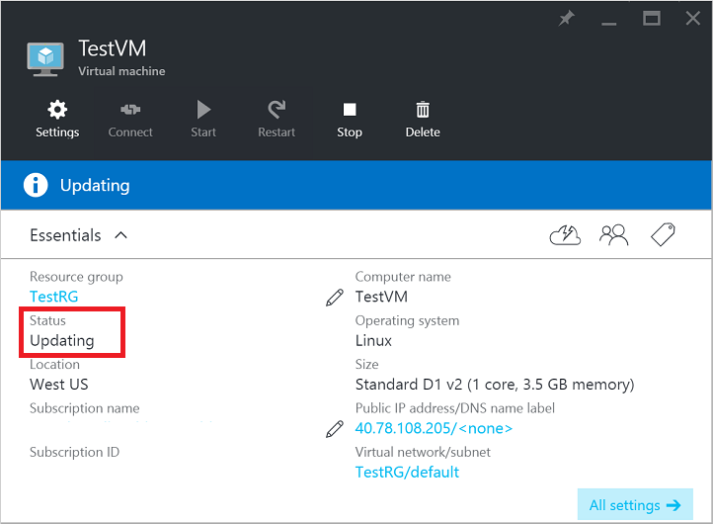

1. The **Status** then changes to *Starting* as the VM boots up on a new Azure host, as shown in the following example:

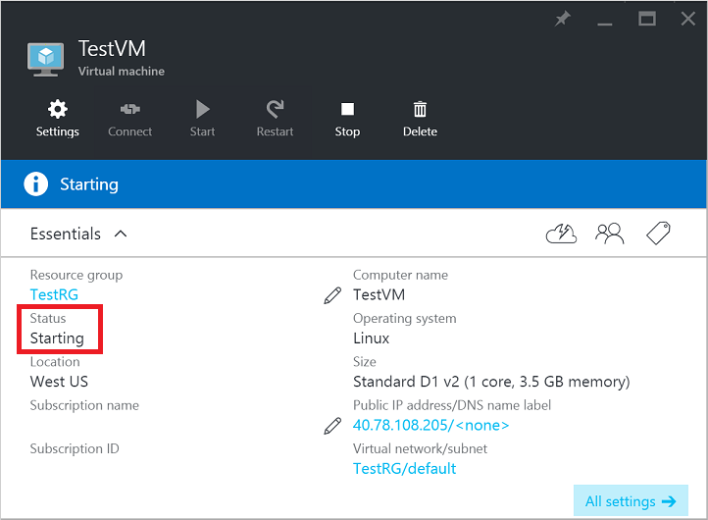

1. After the VM finishes the boot process, the **Status** then returns to *Running*, indicating the VM has been successfully redeployed:

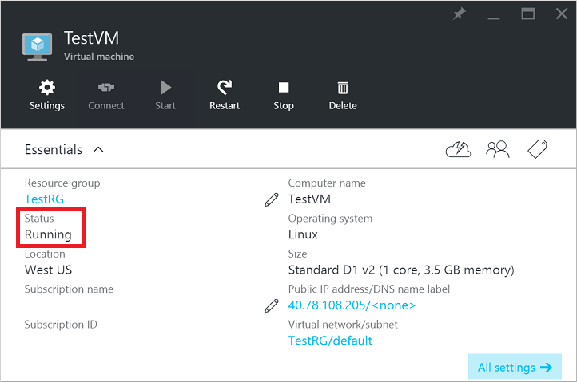

### **Soft delete for Azure VMs**

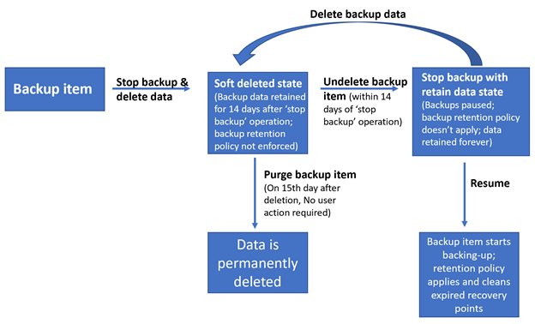

1. In the Azure portal, go to your recovery services vault, right-click on the backup item and choose **Stop backup**.
2. In the following window, If you choose **Delete backup data and then Stop backup**, the VM backup will not be permanently deleted. Rather, the backup data will be retained for 14 days in the soft deleted state.
3. During those 14 days, in the Recovery Services Vault, the soft deleted VM will appear with a red “soft-delete” icon next to it.
4. To restore the soft-deleted VM, it must first be undeleted. To undelete, choose the soft-deleted VM, and then select the option **Undelete**.
5. After the undelete process is completed, the status will return to “Stop backup with retain data” and then you can choose **Resume backup**. The **Resume backup** operation brings back the backup item in the active state, associated with a backup policy selected by the user defining the backup and retention schedules.

## Manage VM backups

### **Configure VM backup; define backup policies; implement backup policies; perform VM restore; Azure Site Recovery**

As an organization you need to adopt a business continuity and disaster recovery (BCDR) strategy

**Site Recovery service**: Site Recovery helps ensure business continuity by keeping business apps and workloads running during outages. Site Recovery replicates workloads running on physical and virtual machines (VMs) from a primary site to a secondary location.

**Backup service**: The [Azure Backup](https://docs.microsoft.com/azure/backup/) service keeps your data safe and recoverable by backing it up to Azure.

Site Recovery can manage replication for:

* Azure VMs replicating between Azure regions.
* On-premises VMs, Azure Stack VMs and physical servers.

# Configure and manage virtual networks

## Create connectivity between virtual networks

* [**Connectivity services**](https://docs.microsoft.com/en-us/azure/networking/networking-overview#connect): Connect Azure resources and on-premises resources using any or a combination of these networking services in Azure - Virtual Network (VNet), Virtual WAN, ExpressRoute, VPN Gateway, Azure DNS, or Azure Bastion.
* [**Application protection services**](https://docs.microsoft.com/en-us/azure/networking/networking-overview#protect) Protect your applications using any or a combination of these networking services in Azure - DDoS protection, Firewall, Network Security Groups, Web Application Firewall, or Virtual Network Endpoints.
* [**Application delivery services**](https://docs.microsoft.com/en-us/azure/networking/networking-overview#deliver) Deliver applications in the Azure network using any or a combination of these networking services in Azure - Content Delivery Network (CDN), Azure Front Door Service, Traffic Manager, Application Gateway, or Load Balancer.
* [**Network monitoring**](https://docs.microsoft.com/en-us/azure/networking/networking-overview#monitor) – Monitor your network resources using any or a combination of these networking services in Azure - Network Watcher, ExpressRoute Monitor, Azure Monitor, or VNet Terminal Access Point (TAP).

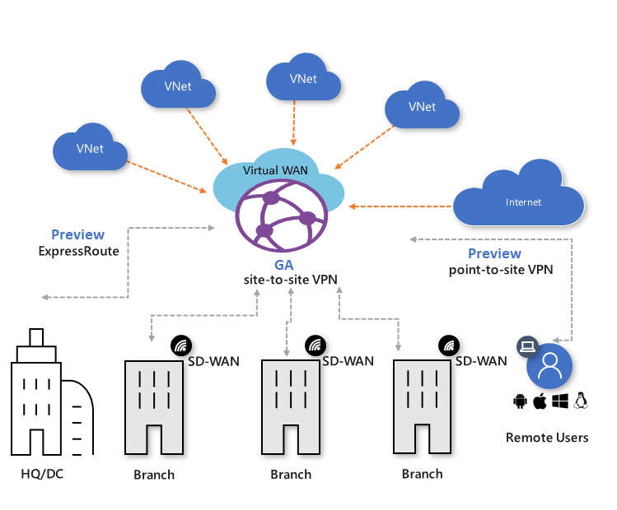

**DDoS Threat**

A distributed denial-of-service (**DDoS**) attack occurs when multiple systems flood the bandwidth or resources of a targeted system, usually one or more web servers. Such an attack is often the result of multiple compromised systems (for example, a botnet) flooding the targeted system with traffic.

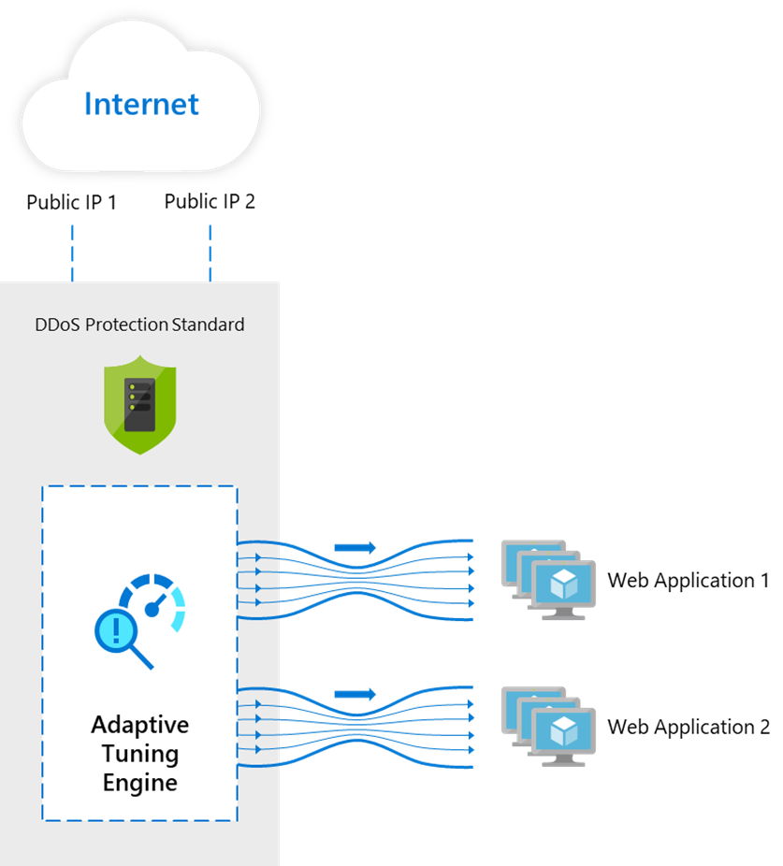

Web Application Firewall (WAF)

Azure Web Application Firewall (WAF) provides protection to your web applications from common web exploits and vulnerabilities such as SQL injection, and cross site scripting. Azure WAF provides out of box protection from OWASP top 10 vulnerabilities via managed rules.

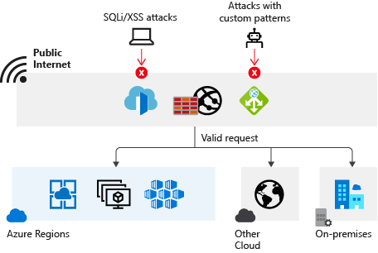

An Azure Virtual Network (VNet) is a representation of your own network in the cloud. Each VNet you create has its own CIDR block and can be linked to other VNets and on-premises networks as long as the CIDR blocks do not overlap

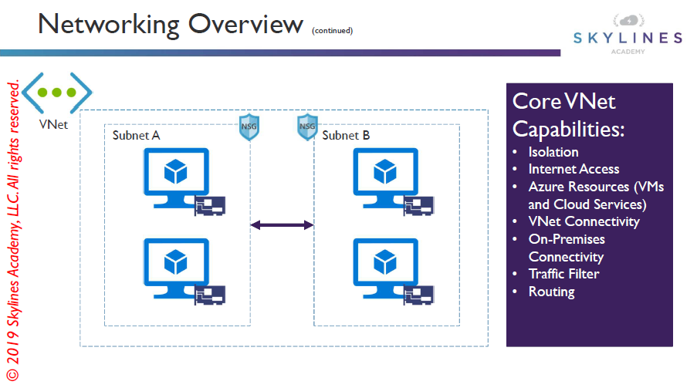

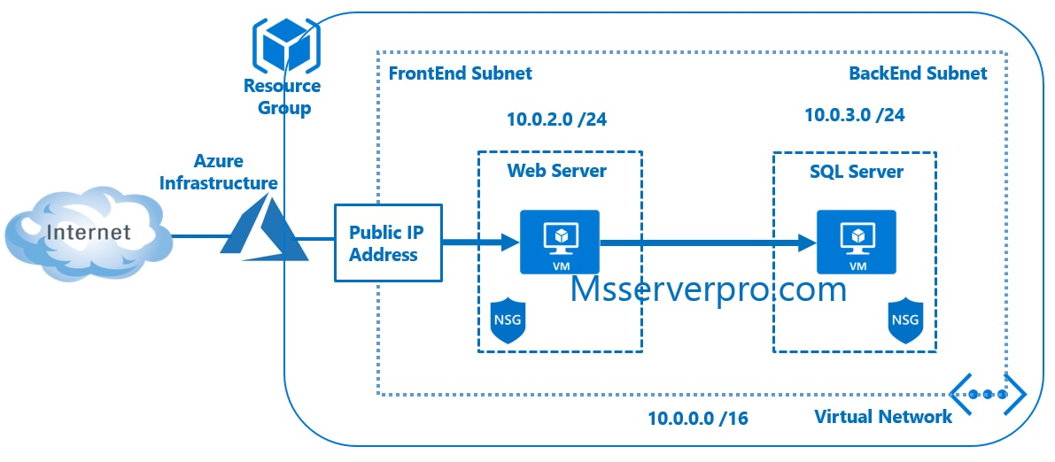

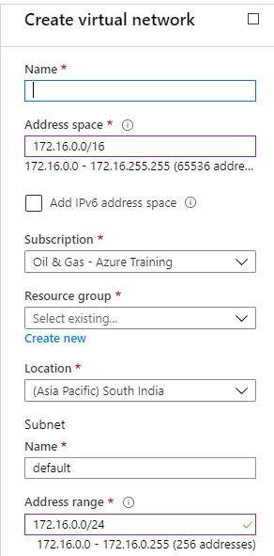

**IP Address**

An IP address is interpreted as composed of two parts: a network-identifying prefix followed by a [host](https://en.wikipedia.org/wiki/Host_(network)) identifier within that network.

**CIDR**

Classless Inter-Domain Routing (CIDR) is a method for allocating [IP addresses](https://en.wikipedia.org/wiki/IP_address) and [IP routing](https://en.wikipedia.org/wiki/IP_routing).

**CIDR** **Notation**

CIDR notation is a compact representation of an IP address and its associated routing prefix. The notation is constructed from an IP address, a [slash](https://en.wikipedia.org/wiki/Slash_(punctuation)) ('/') character, and an integer. The integer is the count of leading *1* bits in the [subnet mask](https://en.wikipedia.org/wiki/Subnet_mask). Larger values here indicate smaller networks.

IPV4

IPV4 is the fourth version of the [Internet Protocol](https://en.wikipedia.org/wiki/Internet_Protocol) (IP).

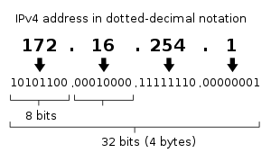

**IPV4 CIDR Examples**

|  |
| --- |
|  |
| **Address format** | **Difference to last address** | **Mask** | **Addresses** | | **Example**  **Address Format** | **Allotted**  **IP Addresses** |
| **IP Address**  **Count** | **2*n*** |
| *a.b.c.d/32* | +*0.0.0.0* | *255.255.255.255* | 1 | 20 | 172.16.0.0/32 | 172.16.0.0 |
| *a.b.c.d/31* | +*0.0.0.1* | *255.255.255.254* | 2 | 21 | 172.16.0.0/31 | 172.16.0.0  172.16.0.1 |
| *a.b.c.d/30* | +*0.0.0.3* | *255.255.255.252* | 4 | 22 | 172.16.0.0/30 | 172.16.0.0  172.16.0.1  172.16.0.2  172.16.0.3 |
| *a.b.c.d/29* | +*0.0.0.7* | *255.255.255.248* | 8 | 23 | 172.16.0.0/29 | 172.16.0.0  172.16.0.1  172.16.0.2  172.16.0.3  172.16.0.4  172.16.0.5  172.16.0.6  172.16.0.7 |
| Addresses continue until 232 *=* 4,294,967,296 | | | | | | |

**IPV6**

IPV6  is the most recent version of the [Internet Protocol](https://en.wikipedia.org/wiki/Internet_Protocol) (IP), the [communications protocol](https://en.wikipedia.org/wiki/Communication_protocol) that provides an identification and location system for computers on networks and routes traffic across the [Internet](https://en.wikipedia.org/wiki/Internet). IPv6 addresses are represented as eight groups, separated by colons, of four [hexadecimal](https://en.wikipedia.org/wiki/Hexadecimal) digits. The full representation may be simplified by several methods of notation;

**IPV4 to IPV6**

|  |  |
| --- | --- |
| **IPV4** | 172.16.0.0 |
| **IPV6 Compressed:** | ::ffff:ac10:0 |
| **IPV6 Expanded (Shortened):** | 0:0:0:0:0:ffff:ac10:0 |
| **IPV6 Expanded:** | 0000:0000:0000:0000:0000:ffff:ac10:0000 |

**DHCP**

The **Dynamic Host Configuration Protocol** (**DHCP**) is a [network management protocol](https://en.wikipedia.org/wiki/Network_protocol) used on [Internet Protocol](https://en.wikipedia.org/wiki/Internet_Protocol) networks whereby a DHCP server dynamically assigns an [IP address](https://en.wikipedia.org/wiki/IP_address) and other network configuration parameters to each device on a network so they can communicate with other IP networks.[[1]](https://en.wikipedia.org/wiki/Dynamic_Host_Configuration_Protocol#cite_note-TechTarget-1) A DHCP server enables computers to request IP addresses and networking parameters automatically from the [Internet service provider](https://en.wikipedia.org/wiki/Internet_service_provider) (ISP), reducing the need for a [network administrator](https://en.wikipedia.org/wiki/Network_administrator) or a user to manually assign IP addresses to all network devices.[[1]](https://en.wikipedia.org/wiki/Dynamic_Host_Configuration_Protocol#cite_note-TechTarget-1)

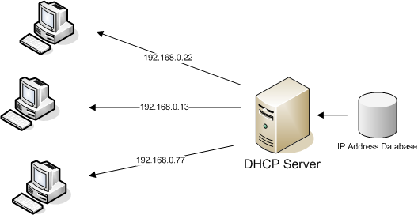

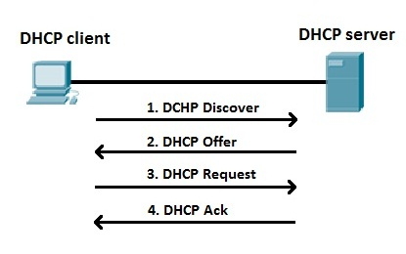

1: A DHCP client sends a broadcast packet (**DHCP Discover**) to discover DHCP servers on the LAN segment.

2: The DHCP servers receive the DHCP Discover packet and respond with **DHCP Offer** packets, offering IP addressing information.

3: If the client receives the DHCP Offer packets from multiple DHCP servers, the first DHCP Offer packet is accepted. The client responds by broadcasting a **DHCP Request** packet, requesting the network parameters from the server that responded first.

4: The DHCP server approves the lease with a **DHCP Acknowledgement** packet. The packet includes the lease duration and other configuration information.

Networking limits

Azure reserves 5 IP addresses within each subnet. These are x.x.x.0-x.x.x.3 and the last address of the subnet. x.x.x.1-x.x.x.3 is reserved in each subnet for Azure services.

* x.x.x.0: Network address
* x.x.x.1: Reserved by Azure for the default gateway
* x.x.x.2, x.x.x.3: Reserved by Azure to map the Azure DNS IPs to the VNet space
* x.x.x.255: Network broadcast address

|  |  |
| --- | --- |
| **Resource** | **Default/maximum limit** |
| Virtual networks | 1,000 |
| Subnets per virtual network | 3,000 |
| Virtual network peerings per virtual network | 500 |
| [Virtual network gateways (VPN gateways) per virtual network](https://docs.microsoft.com/en-us/azure/vpn-gateway/vpn-gateway-about-vpngateways#gwsku) | 1 |
| [Virtual network gateways (ExpressRoute gateways) per virtual network](https://docs.microsoft.com/en-us/azure/expressroute/expressroute-about-virtual-network-gateways#gwsku) | 1 |
| DNS servers per virtual network | 20 |
| Private IP addresses per virtual network | 65,536 |
| Private IP addresses per network interface | 256 |
| Private IP addresses per virtual machine | 256 |
| Public IP addresses per network interface | 256 |
| Public IP addresses per virtual machine | 256 |
| [Concurrent TCP or UDP flows per NIC of a virtual machine or role instance](https://docs.microsoft.com/en-us/azure/virtual-network/virtual-machine-network-throughput#flow-limits-and-recommendations) | 500,000 |
| Network interface cards | 65,536 |
| Network Security Groups | 5,000 |
| NSG rules per NSG | 1,000 |
| IP addresses and ranges specified for source or destination in a security group | 4,000 |
| Application security groups | 3,000 |
| Application security groups per IP configuration, per NIC | 20 |
| IP configurations per application security group | 4,000 |
| Application security groups that can be specified within all security rules of a network security group | 100 |
| User-defined route tables | 200 |
| User-defined routes per route table | 400 |
| Point-to-site root certificates per Azure VPN Gateway | 20 |
| Virtual network TAPs | 100 |
| Network interface TAP configurations per virtual network TAP | 100 |

**Create connectivity between virtual networks**

**Address space:** When creating a VNet, you must specify a custom private IP address space using public and private (RFC 1918) addresses. Azure assigns resources in a virtual network a private IP address from the address space that you assign.

**Subnets:** Subnets enable you to segment the virtual network into one or more sub-networks and allocate a portion of the virtual network's address space to each subnet.

**Gateway types**

When you create a virtual network gateway, you need to specify several settings. One of the required settings, '-GatewayType', specifies whether the gateway is used for **ExpressRoute, or VPN traffic**. The two gateway types are:

* **Vpn** - To send encrypted traffic across the **public Internet**, you use the gateway type 'Vpn'. This is also referred to as a VPN gateway. Site-to-Site, Point-to-Site, and VNet-to-VNet connections all use a VPN gateway.
* **ExpressRoute** - To send network traffic on a **private connection**, you use the gateway type 'ExpressRoute'. This is also referred to as an ExpressRoute gateway and is the type of gateway used when configuring ExpressRoute.

### Create and configure VNET peering

You can connect virtual networks to each other with virtual network peering. These **virtual networks** can be in the **same region or different regions** (also known as Global VNet peering). Once virtual networks are peered, resources in both virtual networks are able to communicate with each other, with the same latency and bandwidth as if the resources were in the same virtual network.

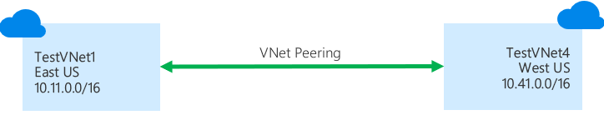

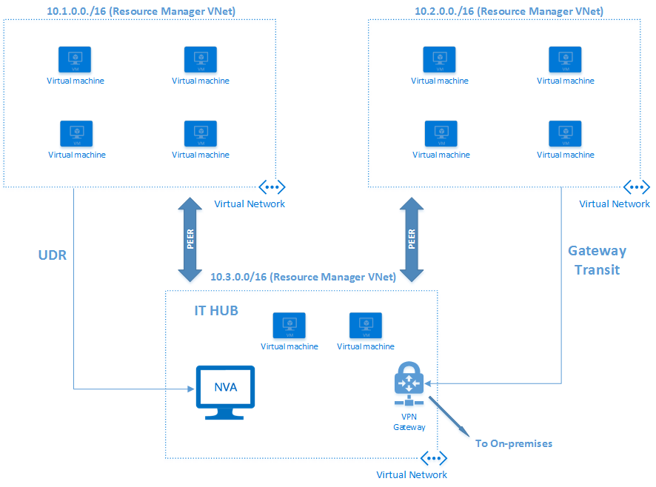

### Create and configure VNET to VNET connections

**VNet2VNet (Two or more network which are in Azure cloud can be connected)**

VNet2VNet connection type use a **VPN gateway** to provide a secure tunnel with IPsec/IKE. When you create a VNet-to-VNet connection, the **local network gateway** address space is automatically created and populated. If you update the address space for one VNet, the other VNet automatically routes to the updated address space. It's typically faster and easier to create a VNet-to-VNet connection

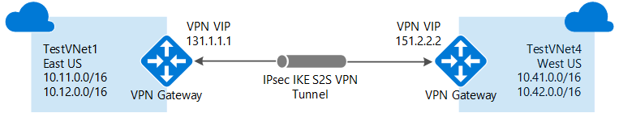

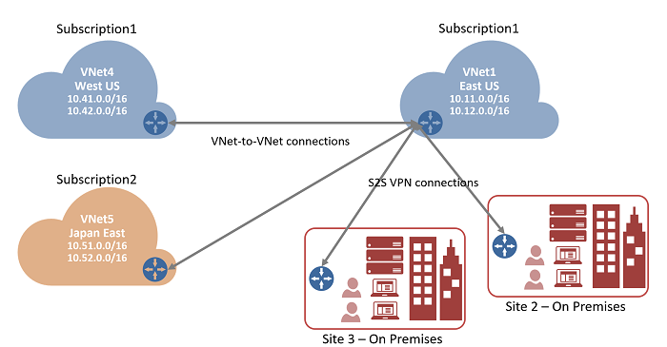

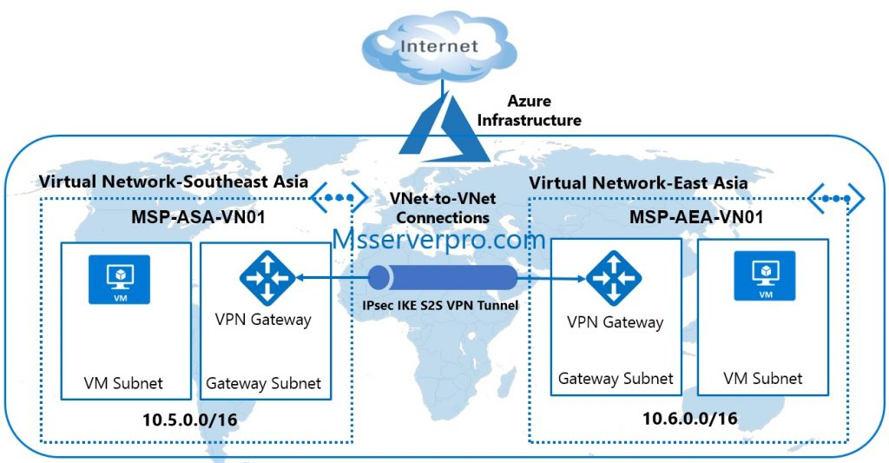

**VNet-to-VNet Vs VNet Peering scenarios**

**VNet Peering** provides a low latency, high bandwidth connection useful in scenarios such as cross-region data replication and database failover scenarios. Since traffic is completely private and remains on the Microsoft backbone, customers with strict data policies prefer to use VNet Peering as public internet is not involved. Since there is no gateway in the path, there are no extra hops, ensuring low latency connections.

**VPN Gateways** provide a limited bandwidth connection and is useful in scenarios where encryption is needed, but bandwidth restrictions are tolerable. In these scenarios, customers are also not as latency-sensitive.

### Verify virtual network connectivity

**verify virtual network connectivity**

|  |  |
| --- | --- |
| * **Virtual network settings**   + **Name**: Enter *TestVNet1*.   + **Address space**: Enter *10.11.0.0/16*.   + **Subscription**: Select the subscription you want to use.   + **Resource group**: Enter *TestRG1*.   + **Location**: Select **East US**.   + **Subnet**     - **Name**: Enter *FrontEnd*.     - **Address range**: Enter *10.11.0.0/24*.   + **Gateway subnet**:     - **Name**: *GatewaySubnet* is autofilled.     - **Address range**: Enter *10.11.255.0/27*. * **Virtual network gateway settings**   + **Name**: Enter *TestVNet1GW*.   + **Gateway type**: Select **VPN**.   + **VPN type**: Select **Route-based**.   + **SKU**: Select the gateway SKU you want to use.   + **Public IP address name**: Enter *TestVNet1GWIP*   + **Connection**     - **Name**: Enter *TestVNet1toTestVNet4*.     - **Shared key**: Enter *abc123*. You can create the shared key yourself. When you create the connection between the VNets, the values must match. | **Values for TestVNet4:**   * **Virtual network settings**   + **Name**: Enter *TestVNet4*.   + **Address space**: Enter *10.41.0.0/16*.   + **Subscription**: Select the subscription you want to use.   + **Resource group**: Enter *TestRG4*.   + **Location**: Select **West US**.   + **Subnet**     - **Name**: Enter *FrontEnd*.     - **Address range**: Enter *10.41.0.0/24*.   + **GatewaySubnet**     - **Name**: *GatewaySubnet* is autofilled.     - **Address range**: Enter *10.41.255.0/27*. * **Virtual network gateway settings**   + **Name**: Enter *TestVNet4GW*.   + **Gateway type**: Select **VPN**.   + **VPN type**: Select **Route-based**.   + **SKU**: Select the gateway SKU you want to use.   + **Public IP address name**: Enter *TestVNet4GWIP*.   + **Connection**     - **Name**: Enter *TestVNet4toTestVNet1*.     - **Shared key**: Enter *abc123*. You can create the shared key yourself. When you create the connection between the VNets, the values must match. |

### Create virtual network gateway

A virtual network gateway is composed of two or more VMs that are deployed to a specific subnet you create called the gateway subnet.

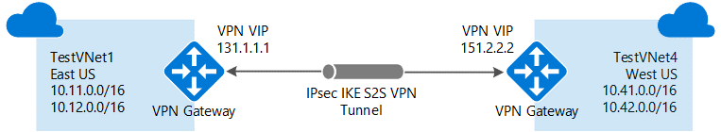

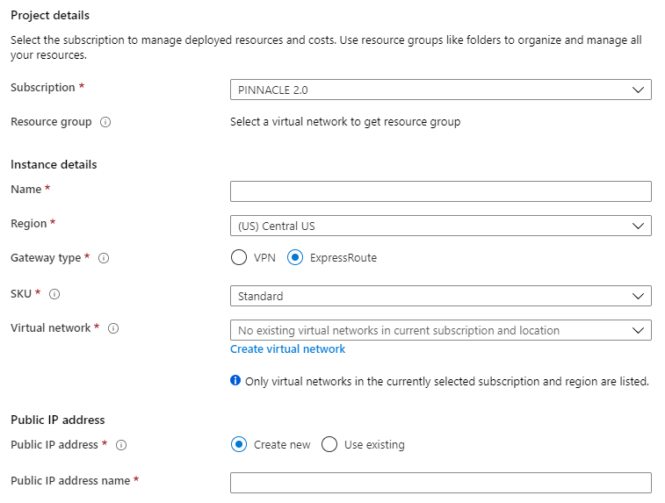

**Implement and manage virtual networking**

<https://github.com/MicrosoftLearning/20533-ImplementingMicrosoftAzureInfrastructureSolutions/blob/master/Instructions/20533E_LAB_02.md>

<https://docs.microsoft.com/en-us/azure/virtual-network/>

## Implement and manage virtual networking

### Configure private and public IP addresses, network routes, network interface, subnets, and virtual network

**configure private and public IP addresses, network routes, network interface, subnets, and virtual network**

* **Public IP addresses**: Used for communication with the Internet, including Azure public-facing services.

In Azure Resource Manager, a [public IP](https://docs.microsoft.com/en-us/azure/virtual-network/virtual-network-public-ip-address) address is a resource that has its own properties. Some of the resources you can associate a public IP address resource with are:

* Virtual machine network interfaces
* Internet-facing load balancers
* VPN gateways
* Application gateways
* Azure Firewall

## Configure name resolution

### Configure Azure DNS

You might need to allow the virtual machines (VMs), and other resources deployed in a virtual network to communicate with each other. Although you can enable communication by using IP addresses, it is much simpler to use names that can be easily remembered, and do not change.

When resources deployed in virtual networks need to resolve domain names to internal IP addresses, they can use one of two methods:

* [Azure-provided name resolution](https://docs.microsoft.com/en-us/azure/virtual-network/virtual-networks-name-resolution-for-vms-and-role-instances#azure-provided-name-resolution)

Along with resolution of public DNS names, Azure provides internal name resolution for VMs and role instances that reside within the same virtual network or cloud service. VMs and instances in a cloud service share the same DNS suffix, so the host name alone is sufficient.

* [Name resolution that uses your own DNS server](https://docs.microsoft.com/en-us/azure/virtual-network/virtual-networks-name-resolution-for-vms-and-role-instances#name-resolution-that-uses-your-own-dns-server) (which might forward queries to the Azure-provided DNS servers)

DNS servers within a virtual network can forward DNS queries to the recursive resolvers in Azure. This enables you to resolve host names within that virtual network. For example, a domain controller (DC) running in Azure can respond to DNS queries for its domains, and forward all other queries to Azure.

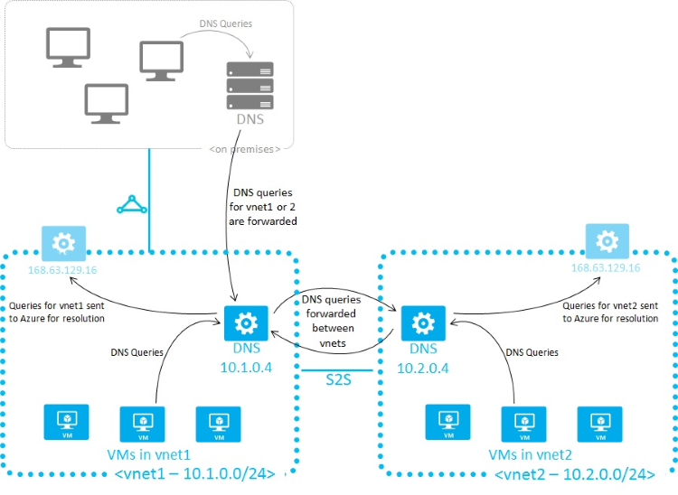

**• configure Azure DNS**

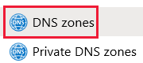

You can configure Azure DNS to resolve host names in your public domain. For example, if you purchased the contoso.xyz domain name from a domain name registrar, you can configure Azure DNS to host the contoso.xyz domain and resolve [*www.contoso.xyz*](http://www.contoso.xyz/) to the IP address of your web server or web app.

A DNS zone contains the DNS entries for a domain. To start hosting your domain in Azure DNS, you create a DNS zone for that domain name.

**Create a DNS Zone**

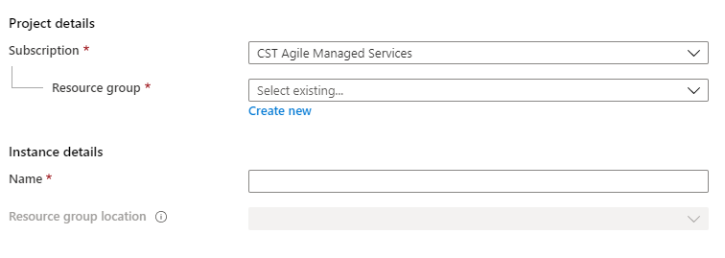

You create DNS entries or records for your domain inside the DNS zone. Create a new address record or 'A' record to resolve a host name to an IPv4 address.

**DNS Record Types**

The DNS record type contains the details related to domain name

CNAME: Specific Domain

*www.contoso.com*

A: Domain represent as IP address

*134.170.185.46*

A and CNAME records used to map a host name to one or more IP address in DNS. It is very important that you should understand the differences between these two records.

This article will help to understand difference between A and CNAME records.

A Record

A record is used to points a name to specific IP Address. For example, if you want to the name blog.looklinux.com to point to the server 104.27.129.39 you will need to configure like below.

blog.looklinux.com. A 104.27.129.39

CNAME Record

CNAME record is used to points a name to another name, instead of IP Addresss. The CNAME source represents an alias for the target name and inherits its entire resolution chain.

For example:

blog.looklinux.com. CNAME web.phpcommander.com.

web.phpcommander.com. CNAME blog.studentvergo.com.

blog.studentvergo.com. A 104.27.129.39

Above we used blog.looklinux.com as a CNAME of web.phpcommander.com, which in turns is itself a CNAME of blog.studentvergo.com, which is an A record pointing to 104.27.129.39. This means that blog.looklinux.com resolves to 104.27.129.39.

So, A record points a name to an IP address and CNAME record can point a name to another CNAME or an A record.

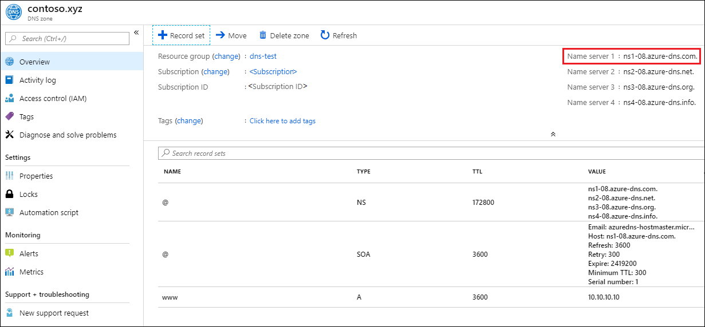

### Configure custom DNS settings

**Configure custom DNS settings**

**Public DNS**

When we purchase a web site from Azure ([www.newwebfromazure.com](http://www.newwebfromazure.com)). They will provide a FQDN. It connects over internet. We will configure that FQDN in Azure DNS zone. It is Azure provided public DNS zone.

When we purchase a web site from Other providers ([www.newwebfromgodaddy.com](http://www.newwebfromgodaddy.com)). They will provide a FQDN. We will configure that FQDN in Azure DNS zone. It connects over internet. It is Public DNS Zone

**Private DNS**

When we have a web site inside a virtual network and we do not want that to be accessed via internet, We will configure that FQDN in Azure DNS zone within the private network. It is Private DNS zone.

### Configure private and public DNS zones

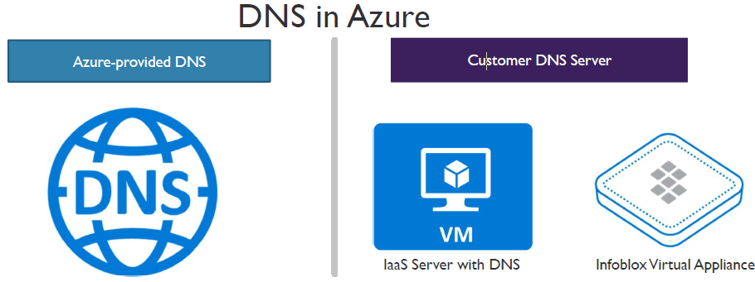

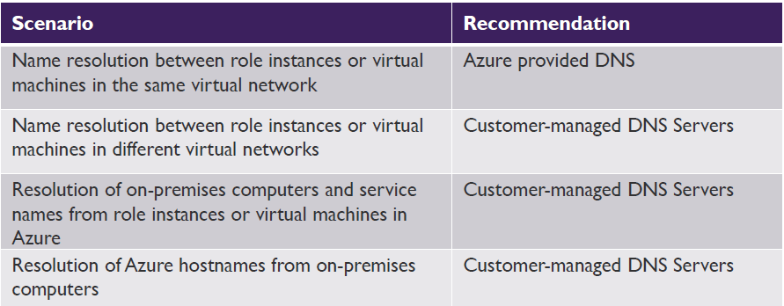

**configure private and public DNS zones**

**Private DNS Zone**

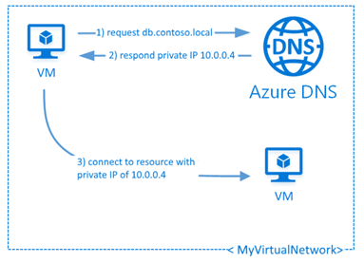

In addition to supporting internet-facing DNS domains, Azure DNS also supports private DNS zones.

Azure Private DNS provides a reliable, secure DNS service to manage and resolve domain names in a virtual network without the need to add a custom DNS solution. By using private DNS zones, you can use your own custom domain names rather than the Azure-provided names available today.

**Private DNS Zone Scenarios**

**scoped to a single virtual network**

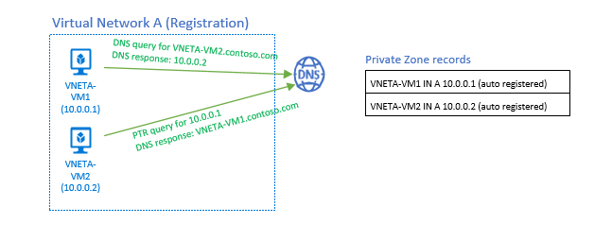

**across virtual networks**

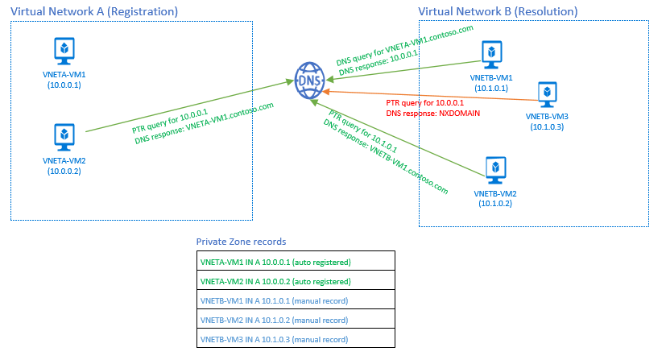

**Split-Horizon**

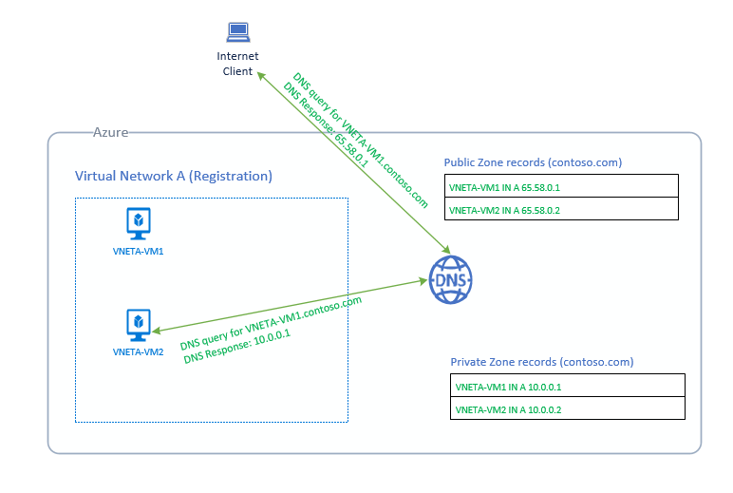

<https://docs.microsoft.com/en-us/azure/dns/dns-faq-private>

## Create and configure a Network Security Group (NSG)

**Network Security Group (NSG)**

You can filter network traffic to and from Azure resources in an Azure [virtual network](https://docs.microsoft.com/en-us/azure/virtual-network/virtual-networks-overview) with a network security group. A network security group contains [security rules](https://docs.microsoft.com/en-us/azure/virtual-network/security-overview#security-rules) that allow or deny inbound network traffic to, or outbound network traffic from, several types of Azure resources.

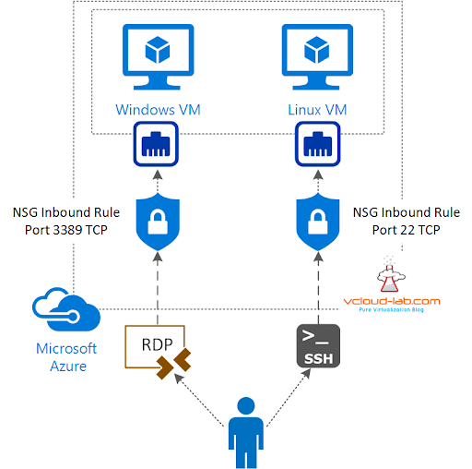

### Create security rules

Security rules in network security groups enable you to filter the type of network traffic that can flow in and out of virtual network subnets and network interfaces.

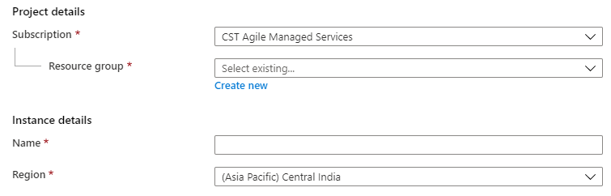

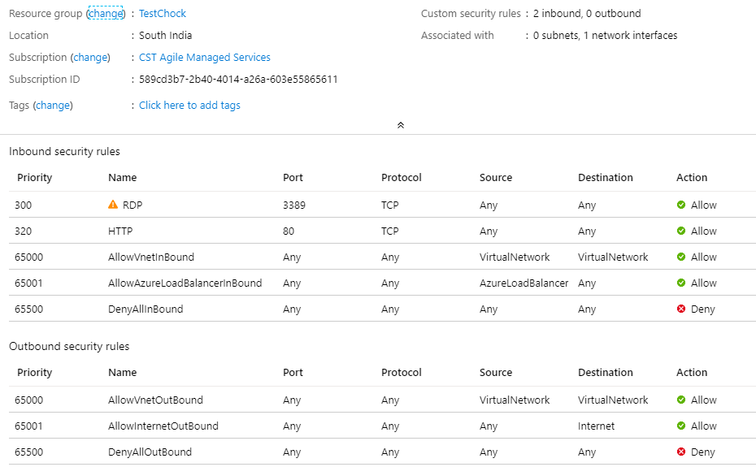

### Associate NSG to a subnet or network interface

A network security group (NSG) contains a list of security rules that allow or deny network traffic to resources connected to Azure Virtual Networks (VNet). NSGs can be associated to subnets, individual VMs (classic), or individual network interfaces (NIC) attached to VMs (Resource Manager).

When an NSG is associated to a subnet, the rules apply to all resources connected to the subnet. Traffic can further be restricted by also associating an NSG to a VM or NIC.

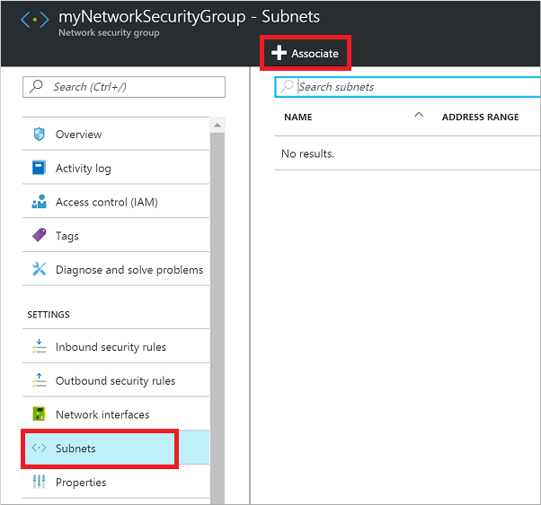

Security rules are applied to the traffic, by priority, in each NSG, in the following order:

Inbound traffic

NSG applied to subnet: If a subnet NSG has a matching rule to deny traffic, the packet is dropped.

NSG applied to NIC (Resource Manager) or VM (classic): If VM\NIC NSG has a matching rule that denies traffic, packets are dropped at the VM\NIC, even if a subnet NSG has a matching rule that allows traffic.

Outbound traffic

NSG applied to NIC (Resource Manager) or VM (classic): If a VM\NIC NSG has a matching rule that denies traffic, packets are dropped.

NSG applied to subnet: If a subnet NSG has a matching rule that denies traffic, packets are dropped, even if a VM\NIC NSG has a matching rule that allows traffic.

### Identify required ports

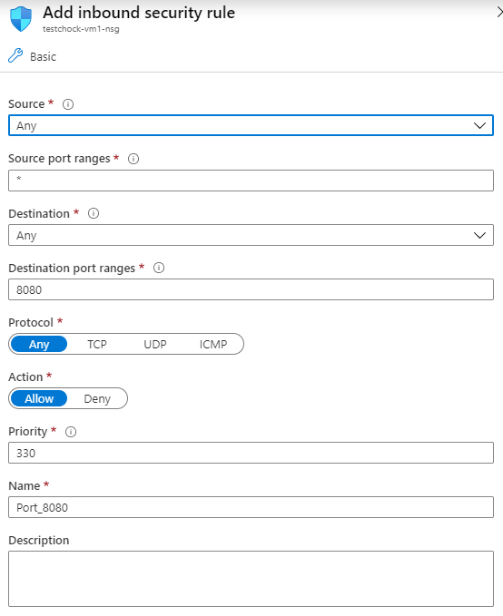

### Evaluate effective security rules

|  |  |
| --- | --- |
| **Best practice** | **Detail** |
| Don’t assign allow rules with **broad ranges** (for example, allow 0.0.0.0 through 255.255.255.255). | Ensure troubleshooting procedures discourage or ban setting up these types of rules. These allow rules lead to a false sense of security and are frequently found and exploited by red teams. |
| Segment the larger address space into subnets. | Use [CIDR](https://en.wikipedia.org/wiki/Classless_Inter-Domain_Routing)-based subnetting principles to create your subnets. |
| Create network access controls between subnets. Routing between subnets happens automatically, and you don’t need to manually configure routing tables. By default, there are no network access controls between the subnets that you create on an Azure virtual network. | Use a [network security group](https://docs.microsoft.com/en-us/azure/virtual-network/virtual-networks-nsg) to protect against unsolicited traffic into Azure subnets. Network security groups are simple, stateful packet inspection devices that use the 5-tuple approach (source IP, source port, destination IP, destination port, and layer 4 protocol) to create allow/deny rules for network traffic. You allow or deny traffic to and from a single IP address, to and from multiple IP addresses, or to and from entire subnets. |
| Avoid small virtual networks and subnets to ensure simplicity and flexibility. | Most organizations add more resources than initially planned, and re-allocating addresses is labor intensive. Using small subnets adds limited security value, and mapping a network security group to each subnet adds overhead. Define subnets broadly to ensure that you have flexibility for growth. |
| Adopt a Zero Trust approach | Networks need to evolve from traditional defenses because networks might be vulnerable to breaches |

### Implement Application Security Groups

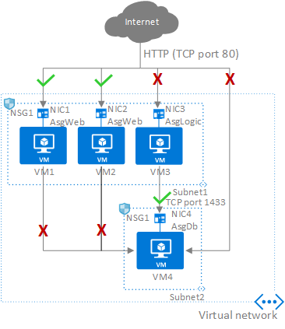

Application security groups enable you to configure network security as a natural extension of an application's structure, allowing you to group virtual machines and define network security policies based on those groups. You can reuse your security policy at scale without manual maintenance of explicit IP addresses. The platform handles the complexity of explicit IP addresses and multiple rule sets, allowing you to focus on your business logic.

**Examples**

Allow-HTTP-Inbound-Internet

Deny-Database-All

Allow-Database-BusinessLogic

<https://docs.microsoft.com/en-us/azure/virtual-network/security-overview>

## Implement Azure load balancer

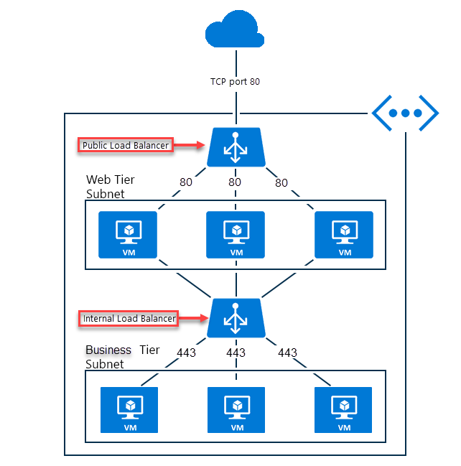

Load balancing refers to evenly distributing load (incoming network traffic) across a group of backend resources or servers. Azure offers a [variety of load balancing options](https://docs.microsoft.com/azure/architecture/guide/technology-choices/load-balancing-overview) that you can choose from based on your need.

A [**public load balancer**](https://docs.microsoft.com/en-us/azure/load-balancer/concepts-limitations#publicloadbalancer) can provide outbound connections for virtual machines (VMs) inside your virtual network. These connections are accomplished by translating their private IP addresses to public IP addresses. Public Load Balancers are used to load balance internet traffic to your VMs.

### Configure internal load balancer

An [**internal (or private) load balancer**](https://docs.microsoft.com/en-us/azure/load-balancer/concepts-limitations#internalloadbalancer) is used where private IPs are needed at the frontend only. Internal load balancers are used to load balance traffic inside a virtual network. A load balancer frontend can be accessed from an on-premises network in a hybrid scenario.

We are very excited to announce the support for ‘Internal Load Balancing’ (ILB) in Azure. Internal load balancing (ILB) enables you to run highly available services behind a private IP address which is accessible only within a cloud service or Virtual Network (VNet), giving additional security on that endpoint. When used within a Virtual Network the ILB endpoint is also accessible from on-premises and other inter-connected VNets allowing some powerful hybrid scenarios. ILB can be used in two flavors

1. Within a Cloud service, where the load balanced IP is acquired from Azure's private IP address space
2. Within a Virtual network, where the load balanced IP is acquired from a virtual subnet or a static VNet IP address specified by the customer.

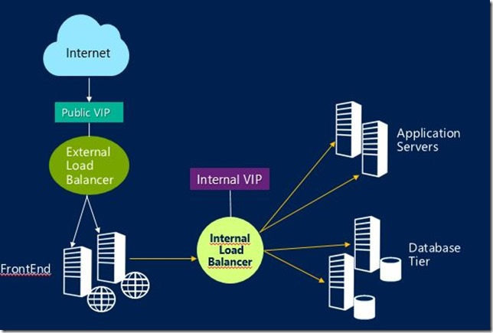

### Configure load balancing rules

* + - 1. Sign in to Azure
      2. Create a Load Balancer
      3. Create Load Balancer resources
         * Create a Backend pool
         * Create a health probe
         * Create a Load Balancer rule

### Configure public load balancer

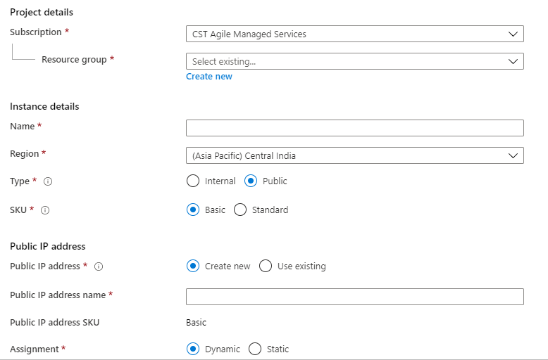

### Troubleshoot load balancing

When the Load Balancer connectivity is unavailable, the most common symptoms are as follows:

* VMs behind the Load Balancer are not responding to health probes
* VMs behind the Load Balancer are not responding to the traffic on the configured port

The Load Balancer backend pool VMs may not be responding to the probes due to any of the following reasons:

* Load Balancer backend pool VM is unhealthy
* Load Balancer backend pool VM is not listening on the probe port
* Firewall, or a network security group is blocking the port on the Load Balancer backend pool VMs
* Other misconfigurations in Load Balancer

**Validation and resolution**

1. Log in to the backend VM.
2. Open a command prompt and run the following command to validate there is an application listening on the probe port:   
   netstat -an
3. If the port state is not listed as **LISTENING**, configure the proper port.
4. Alternatively, select another port, that is listed as **LISTENING**, and update load balancer configuration accordingly.
5. If the firewall is enabled, check if it is configured to allow the probe port. If not, configure the firewall to allow traffic on the probe port, and test again.
6. From the list of network security groups, check if the incoming or outgoing traffic on the probe port has interference.
7. Also, check if a **Deny All** network security groups rule on the NIC of the VM or the subnet that has a higher priority than the default rule that allows LB probes & traffic (network security groups must allow Load Balancer IP of 168.63.129.16).
8. If any of these rules are blocking the probe traffic, remove and reconfigure the rules to allow the probe traffic.
9. Test if the VM has now started responding to the health probes.
10. Use **Psping** from one of the other VMs within the VNet to test the probe port response (example: .\psping.exe -t 10.0.0.4:3389) and record results.
11. Use **TCPing** from one of the other VMs within the VNet to test the probe port response (example: .\tcping.exe 10.0.0.4 3389) and record results.
12. If no response is received in these ping tests, then
    1. Run a simultaneous Netsh trace on the target backend pool VM and another test VM from the same VNet. Now, run a PsPing test for some time, collect some network traces, and then stop the test.
    2. Analyze the network capture and see if there are both incoming and outgoing packets related to the ping query.
       1. If no incoming packets are observed on the backend pool VM, there is potentially a network security groups or UDR mis-configuration blocking the traffic.
       2. If no outgoing packets are observed on the backend pool VM, the VM needs to be checked for any unrelated issues (for example, Application blocking the probe port).
    3. Verify if the probe packets are being forced to another destination (possibly via UDR settings) before reaching the load balancer. This can cause the traffic to never reach the backend VM.
13. Change the probe type (for example, HTTP to TCP), and configure the corresponding port in network security groups ACLs and firewall to validate if the issue is with the configuration of probe response. For more information about health probe configuration, see [Endpoint Load Balancing health probe configuration](https://blogs.msdn.microsoft.com/mast/2016/01/26/endpoint-load-balancing-heath-probe-configuration-details/).
14. Load Balancer Backend pool VM is not listening on the data port
15. Network security group is blocking the port on the Load Balancer backend pool VM
16. Accessing the Load Balancer from the same VM and NIC
17. Accessing the Internet Load Balancer frontend from the participating Load Balancer backend pool VM
18. Log in to the backend VM.
19. Open a command prompt and run the following command to validate there is an application listening on the data port:  netstat -an
20. If the port is not listed with State “LISTENING”, configure the proper listener port
21. If the port is marked as Listening, then check the target application on that port for any possible issues.
22. List the network security groups configured on the backend VM. For more information, see [Manage network security groups](https://docs.microsoft.com/en-us/azure/virtual-network/manage-network-security-group)
23. From the list of network security groups, check if:
    1. the incoming or outgoing traffic on the data port has interference.
    2. a **Deny All** network security group rule on the NIC of the VM or the subnet that has a higher priority that the default rule that allows Load Balancer probes and traffic (network security groups must allow Load Balancer IP of 168.63.129.16, that is probe port)
24. If any of the rules are blocking the traffic, remove and reconfigure those rules to allow the data traffic.
25. Test if the VM has now started to respond to the health probes.
26. Use Psping from one of the backend VMs within the VNet to test the probe port response (example: psping 10.0.0.4:3389) and record results.
27. If no response is received in these ping tests, run a simultaneous Netsh trace on the backend VM and the VNet test VM while you run PsPing then stop the Netsh trace.

## Monitor and troubleshoot virtual networking

### Monitor on-premises connectivity

You can monitor your on-premises connectivity using Network Watcher as well. It offers two different features for this, **Network Performance Monitor** and **VPN Troubleshoot**, which, just like the other features, are accessible from the Azure portal.

### Use Network resource monitoring

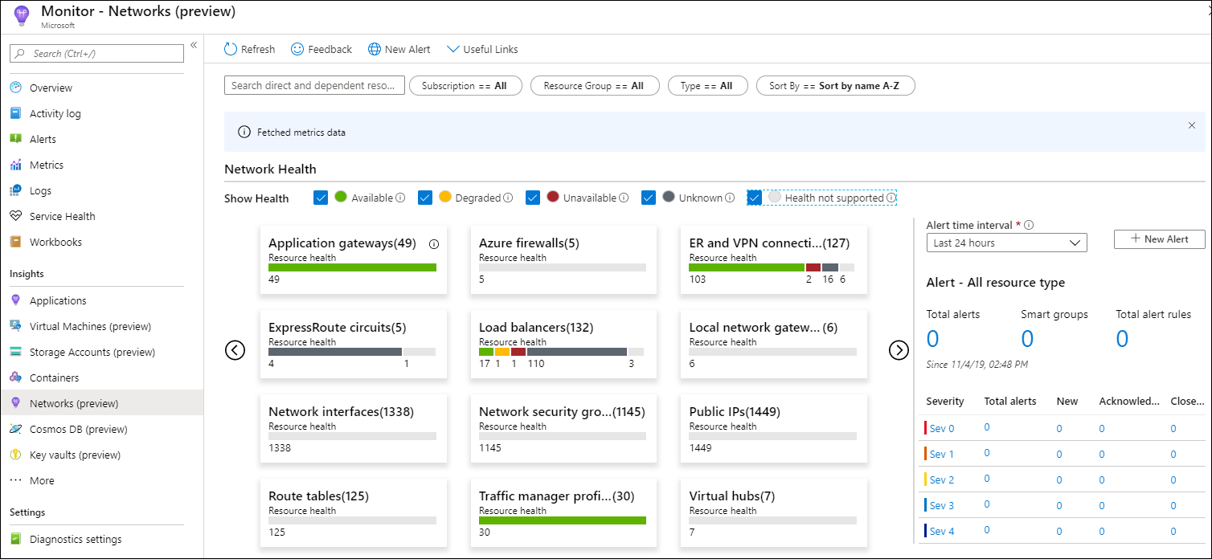

The Azure Monitor for Networks **Overview** page provides an effortless way to visualize the inventory of your networking resources along with resource health and alerts. It is divided into four key functional areas:

* Search and filtering
* Resource Health and Metrics
* Alerts
* Dependency view

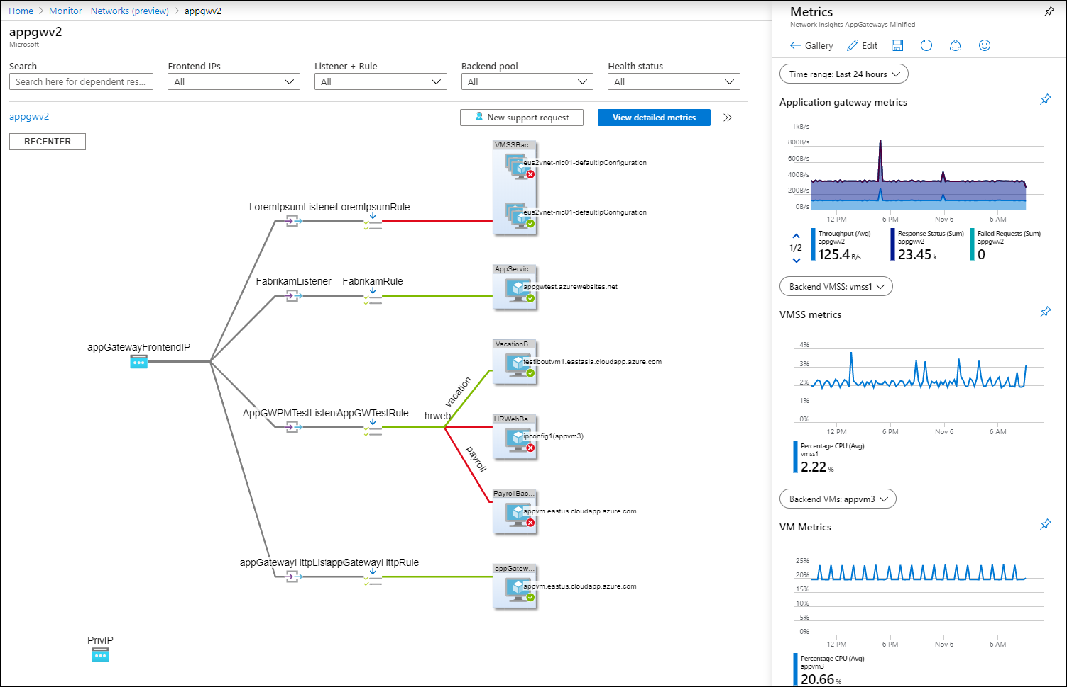

### Use Network Watcher

Network Watcher

Azure Network Watcher provides tools to monitor, diagnose, view metrics, and enable or disable logs for resources in an Azure virtual network. Network Watcher is designed to monitor and repair the network health of IaaS (Infrastructure-as-a-Service) products which includes Virtual Machines, Virtual Networks, Application Gateways, Load balancers, etc. Note: It is not intended for and will not work for PaaS monitoring or Web analytics.

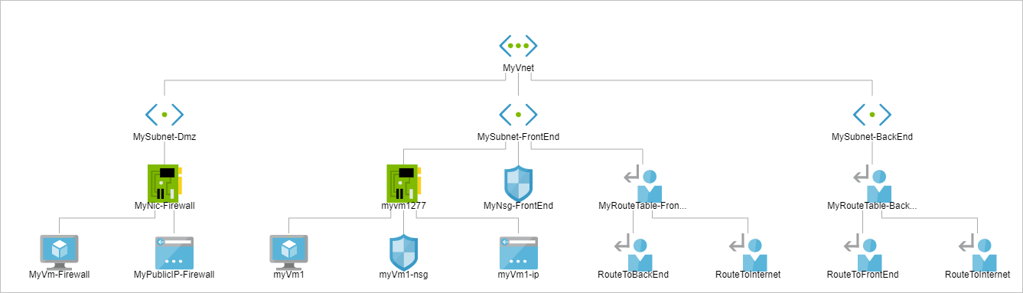

### Troubleshoot external networking

1. Go to the [Azure portal](https://portal.azure.com/).
2. Check the **Overview** page of the VPN gateway for the type information.

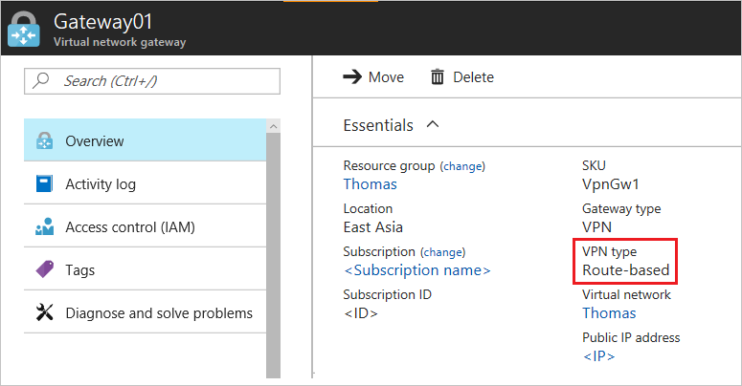

Step 1. Check whether the on-premises VPN device is validated

1. Check whether you are using a [validated VPN device and operating system version](https://docs.microsoft.com/en-us/azure/vpn-gateway/vpn-gateway-about-vpn-devices#devicetable). If the device is not a validated VPN device, you might have to contact the device manufacturer to see if there is a compatibility issue.
2. Make sure that the VPN device is correctly configured. For more information, see [Edit device configuration samples](https://docs.microsoft.com/en-us/azure/vpn-gateway/vpn-gateway-about-vpn-devices#editing).

Step 2. Verify the shared key

Compare the shared key for the on-premises VPN device to the Azure Virtual Network VPN to make sure that the keys match.

To view the shared key for the Azure VPN connection, use one of the following methods:

**Azure portal**

1. Go to the VPN gateway site-to-site connection that you created.
2. In the **Settings** section, click **Shared key**.

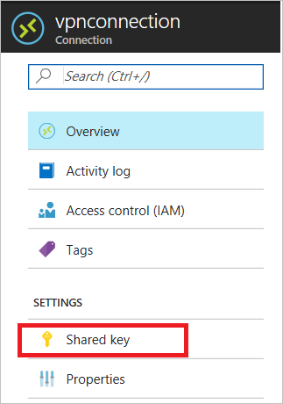

**Azure PowerShell**

**Note**

This article has been updated to use the new Azure PowerShell Az module. You can still use the AzureRM module, which will continue to receive bug fixes until at least December 2020. To learn more about the new Az module and AzureRM compatibility, see [**Introducing the new Azure PowerShell Az module**](https://docs.microsoft.com/powershell/azure/new-azureps-module-az?view=azps-3.3.0). For Az module installation instructions, see [**Install Azure PowerShell**](https://docs.microsoft.com/powershell/azure/install-az-ps?view=azps-3.3.0).

For the Azure Resource Manager deployment model:

Copy

*Get-AzVirtualNetworkGatewayConnectionSharedKey -Name <Connection name> -ResourceGroupName <Resource group name>*

For the classic deployment model:

Copy

Get-AzureVNetGatewayKey -VNetName -LocalNetworkSiteName

Step 3. Verify the VPN peer IPs

* The IP definition in the **Local Network Gateway** object in Azure should match the on-premises device IP.
* The Azure gateway IP definition that is set on the on-premises device should match the Azure gateway IP.

Step 4. Check UDR and NSGs on the gateway subnet

Check for and remove user-defined routing (UDR) or Network Security Groups (NSGs) on the gateway subnet, and then test the result. If the problem is resolved, validate the settings that UDR or NSG applied.

Step 5. Check the on-premises VPN device external interface address

* If the Internet-facing IP address of the VPN device is included in the **Local network** definition in Azure, you might experience sporadic disconnections.
* The device's external interface must be directly on the Internet. There should be no network address translation or firewall between the Internet and the device.
* To configure firewall clustering to have a virtual IP, you must break the cluster and expose the VPN appliance directly to a public interface that the gateway can interface with.

Step 6. Verify that the subnets match exactly (Azure policy-based gateways)

* Verify that the virtual network address space(s) match exactly between the Azure virtual network and on-premises definitions.
* Verify that the subnets match exactly between the **Local Network Gateway** and on-premises definitions for the on-premises network.

Step 7. Verify the Azure gateway health probe

1. Open health probe by browsing to the following URL:

https://<YourVirtualNetworkGatewayIP>:8081/healthprobe

1. Click through the certificate warning.
2. If you receive a response, the VPN gateway is considered healthy. If you don't receive a response, the gateway might not be healthy or an NSG on the gateway subnet is causing the problem. The following text is a sample response:

XMLCopy

<?xml version="1.0"?>

<string xmlns="http://schemas.microsoft.com/2003/10/Serialization/">Primary Instance: GatewayTenantWorker_IN_1 GatewayTenantVersion: 14.7.24.6</string>

Step 8. Check whether the on-premises VPN device has the perfect forward secrecy feature enabled

### Troubleshoot virtual network connectivity

ExpressRoute Monitor

To view **Metrics**, navigate to the Azure Monitor page and click Metrics. To view **ExpressRoute** metrics, filter by Resource Type ExpressRoute circuits. To view **Global Reach** metrics, filter by Resource Type ExpressRoute circuits and select an ExpressRoute circuit resource that has Global Reach enabled. To view **ExpressRoute Direct** metrics, filter Resource Type by ExpressRoute Ports.

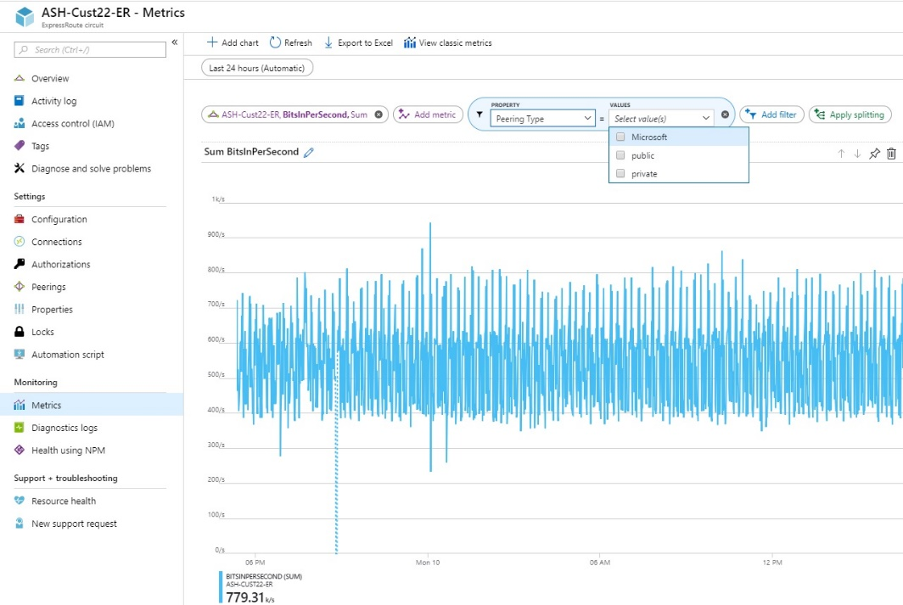

## Integrate on premises network with Azure virtual network

Communicate with on-premises resources

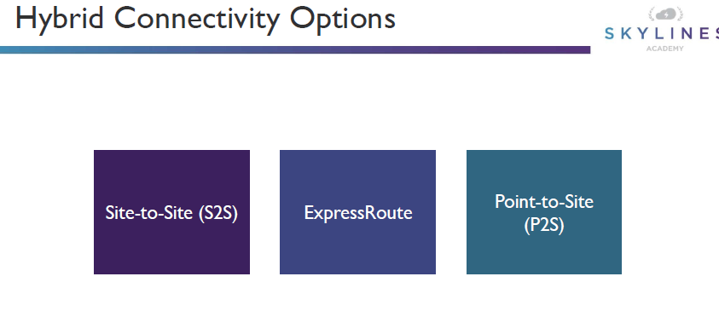

### Create and configure Azure VPN Gateway

**Point-to-site virtual private network (VPN):** You use a Point-to-Site (P2S) VPN gateway to create a secure connection to your virtual network from an individual client computer. Point-to-Site VPN connections are useful when you want to connect to your VNet from a remote location.

The Point-to-Site VPN gateway connection in this example is for a VNet that is not connected or peered with any other virtual network (VNet1). In this example, clients can access VNet1.

Architecture

Point-to-Site native Azure certificate authentication connections use the following items, which you configure in this exercise:

* A RouteBased VPN gateway.
* The public key (.cer file) for a root certificate, which is uploaded to Azure. Once the certificate is uploaded, it is considered a trusted certificate and is used for authentication.
* A client certificate that is generated from the root certificate. The client certificate installed on each client computer that will connect to the VNet. This certificate is used for client authentication.
* A VPN client configuration. The VPN client configuration files contain the necessary information for the client to connect to the VNet. The files configure the existing VPN client that is native to the operating system. Each client that connects must be configured using the settings in the configuration files.

Example

* **VNet Name:** VNet1
* **Address space:** 192.168.0.0/16  
  For this example, we use only one address space. You can have more than one address space for your VNet.
* **Subnet name:** FrontEnd
* **Subnet address range:** 192.168.1.0/24
* **Subscription:** If you have more than one subscription, verify that you are using the correct one.
* **Resource Group:** TestRG
* **Location:** East US
* **GatewaySubnet:** 192.168.200.0/24
* **Virtual network gateway name:** VNet1GW
* **Gateway type:** VPN
* **VPN type:** Route-based
* **Public IP address name:** VNet1GWpip
* **Connection type:** Point-to-site
* **Client address pool:** 172.16.201.0/24  
  VPN clients that connect to the VNet using this Point-to-Site connection receive an IP address from the client address pool.

P2S Implementation Types

* 1. One Isolated VNet
  2. Multiple Peered VNets

One isolated VNet

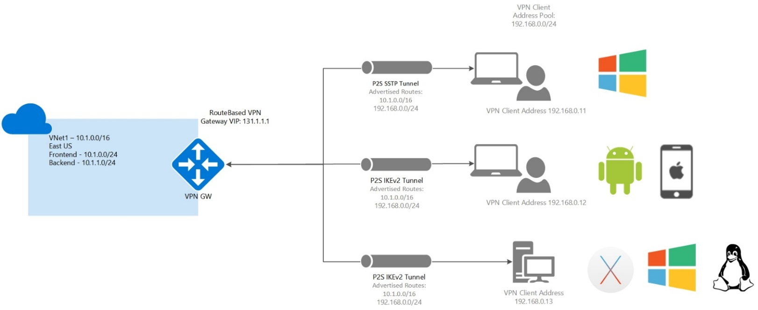

Multiple peered VNets

n this example, the Point-to-Site VPN gateway connection is for VNet1. VNet1 is peered with VNet2. VNet 2 is peered with VNet3. VNet1 is peered with VNet4. There is no direct peering between VNet1 and VNet3. VNet1 has “Allow gateway transit” and VNet2 has “Use remote gateways” enabled.

Clients using Windows can access directly peered VNets, but the VPN client must be downloaded again if any changes are made to VNet peering or the network topology. Non-Windows clients can access directly peered VNets. Access is not transitive and is limited to only directly peered VNets.

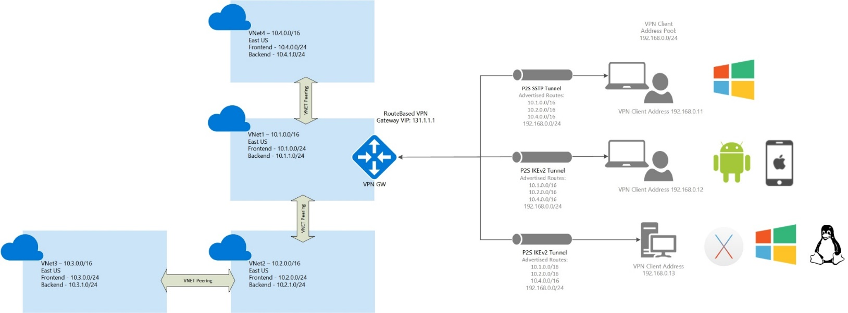

<https://docs.microsoft.com/en-us/azure/vpn-gateway/vpn-gateway-about-point-to-site-routing>

### Create and configure site to site VPN

A Site-to-Site VPN gateway connection is used to connect your on-premises network to an Azure virtual network over an IPsec/IKE (IKEv1 or IKEv2) VPN tunnel. This type of connection requires a VPN device located on-premises that has an externally facing public IP address assigned to it.

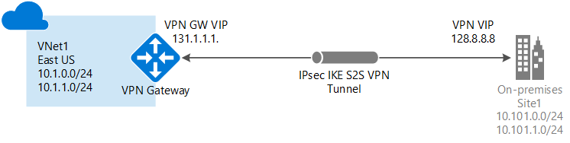

Multi-Site

his type of connection is a variation of the Site-to-Site connection. You create more than one VPN connection from your virtual network gateway, typically connecting to multiple on-premises sites. When working with multiple connections, you must use a Route Based VPN type (known as a dynamic gateway when working with classic VNets). Because each virtual network can only have one VPN gateway, all connections through the gateway share the available bandwidth. This type of connection is often called a "multi-site" connection.

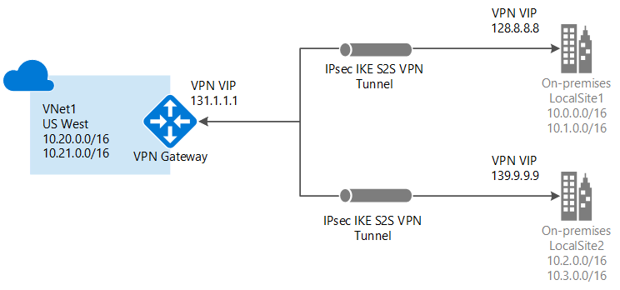

**Steps**

1. Create a virtual network
2. Create the VPN gateway
3. Create the local network gateway
4. Configure your VPN device
5. Create the VPN connection
6. Verify the VPN connection

<https://docs.microsoft.com/en-us/azure/vpn-gateway/vpn-gateway-howto-site-to-site-resource-manager-portal>

<https://docs.microsoft.com/en-us/azure/vpn-gateway/vpn-gateway-about-vpngateways>

### Configure Express Route

<https://www.beringer.net/beringerblog/microsoft-azure-express-route-options-benefits/>

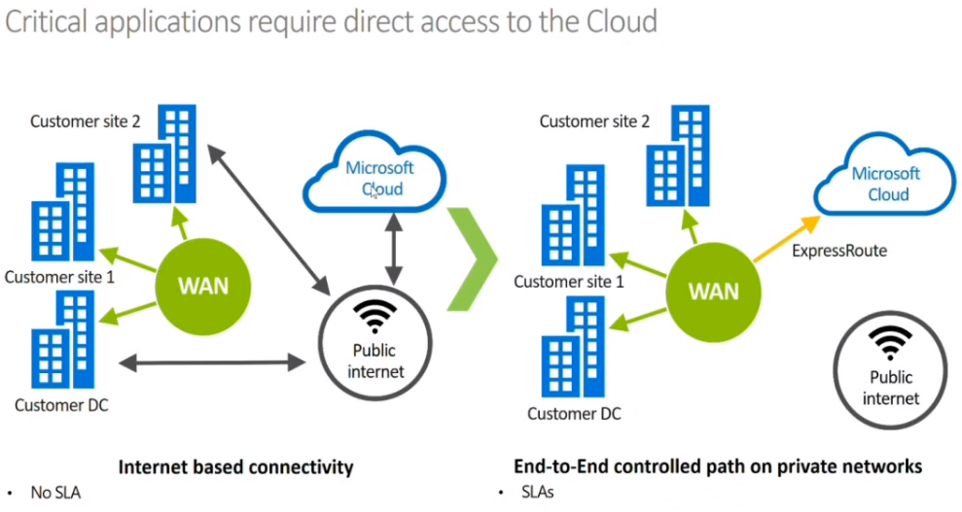

ExpressRoute lets you extend your on-premises networks into the Microsoft cloud over a private connection facilitated by a connectivity provider. With ExpressRoute, you can establish connections to Microsoft cloud services, such as Microsoft Azure and Office 365.

Connectivity can be from an any-to-any (IP VPN) network, a point-to-point Ethernet network, or a virtual cross-connection through a connectivity provider at a co-location facility. ExpressRoute connections do not go over the public Internet. This allows ExpressRoute connections to offer more reliability, faster speeds, consistent latencies, and higher security than typical connections over the Internet.

**ExpressRoute Scenarios**

Use Azure ExpressRoute to create private connections between Azure datacenters and infrastructure on your premises or in a colocation environment. ExpressRoute connections don't go over the public Internet, and they offer more reliability, faster speeds, and lower latencies than typical Internet connections. In some cases, using ExpressRoute connections to transfer data between on-premises systems and Azure can give you significant cost benefits.

**ExpressRoute Connectivity Models**

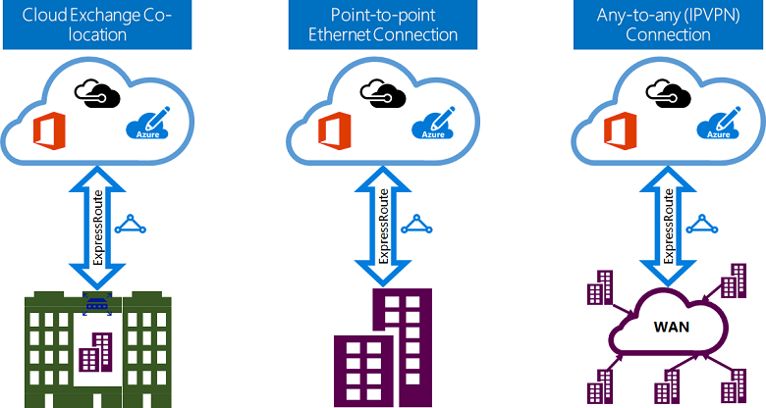

**Co-located at a cloud exchange**

If you are co-located in a facility with a cloud exchange, you can order virtual cross-connections to the Microsoft cloud through the co-location provider’s Ethernet exchange. Co-location providers can offer either Layer 2 cross-connections, or managed Layer 3 cross-connections between your infrastructure in the co-location facility and the Microsoft cloud.

**Point-to-point Ethernet connections**

You can connect your on-premises datacenters/offices to the Microsoft cloud through point-to-point Ethernet links. Point-to-point Ethernet providers can offer Layer 2 connections, or managed Layer 3 connections between your site and the Microsoft cloud.

**Any-to-any (IPVPN) networks**

You can integrate your WAN with the Microsoft cloud. IPVPN providers (typically MPLS VPN) offer any-to-any connectivity between your branch offices and data centers. The Microsoft cloud can be interconnected to your WAN to make it look just like any other branch office. WAN providers typically offer managed Layer 3 connectivity. ExpressRoute capabilities and features are all identical across all of the above connectivity models.

**ExpressRoute connectivity providers**

ExpressRoute is supported across all Azure regions and locations. The following map provides a list of Azure regions and ExpressRoute locations. ExpressRoute locations refer to those where Microsoft peers with several service providers. You will have access to Azure services across all regions within a geopolitical region if you connected to at least one ExpressRoute location within the geopolitical region.

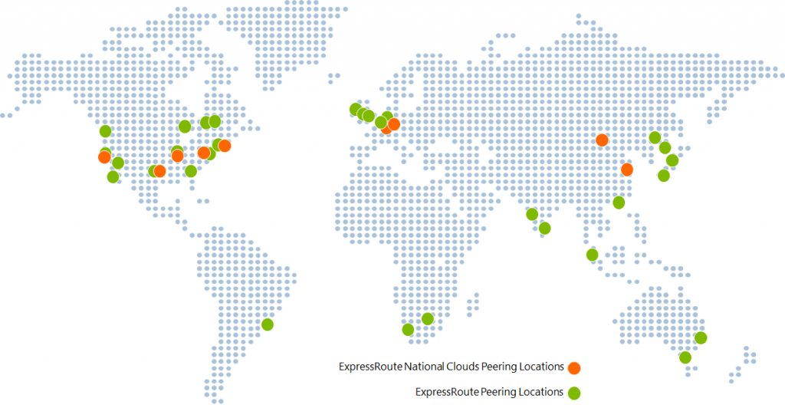

Azure regions

Azure regions are global datacenters where Azure compute, networking and storage resources are located. When creating an Azure resource, a customer needs to select a resource location. The resource location determines which Azure datacenter (or availability zone) the resource is created in.

ExpressRoute locations

ExpressRoute locations (sometimes referred to as peering locations or meet-me-locations) are co-location facilities where Microsoft Enterprise Edge (MSEE) devices are located. ExpressRoute locations are the entry point to Microsoft’s network – and are globally distributed, providing customers the opportunity to connect to Microsoft’s network around the world. These locations are where ExpressRoute partners and ExpressRoute Direct customers issue cross connections to Microsoft’s network. In general, the ExpressRoute location does not need to match the Azure region.

<https://docs.microsoft.com/en-us/azure/expressroute/expressroute-locations>

<https://docs.microsoft.com/en-us/azure/expressroute/expressroute-locations-providers>

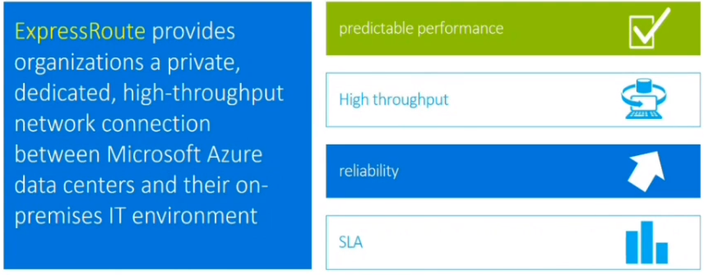

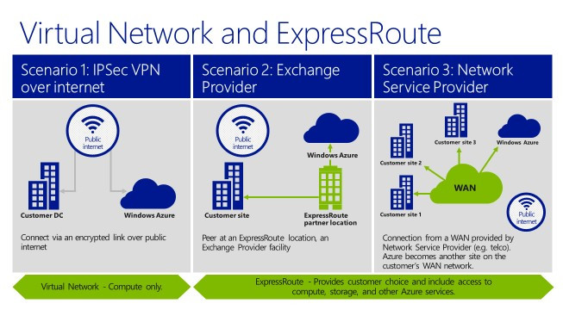

### Verify on premises connectivity

1. In the [Azure portal](https://portal.azure.com/) menu, select **All resources** or search for and select **All resources** from any page.
2. Select to your virtual network gateway.
3. On the blade for your virtual network gateway, click **Connections**. You can see the status of each connection.
4. Click the name of the connection that you want to verify to open **Essentials**. In Essentials, you can view more information about your connection. The **Status** is 'Succeeded' and 'Connected' when you have made a successful connection.

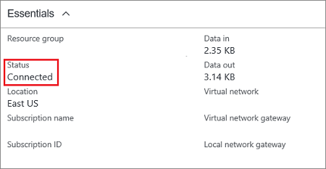

### Troubleshoot on premises connectivity with Azure

## VPN client error: A certificate could not be found

### Symptom

When you try to connect to an Azure virtual network by using the VPN client, you receive the following error message:

**A certificate could not be found that can be used with this Extensible Authentication Protocol. (Error 798)**

### Cause

This problem occurs if the client certificate is missing from **Certificates - Current User\Personal\Certificates**.

### Solution

To resolve this problem, follow these steps:

1. Open Certificate Manager: Click **Start**, type **manage computer certificates**, and then click **manage computer certificates** in the search result.
2. Make sure that the following certificates are in the correct location:

| **Certificate** | **Location** |
| --- | --- |
| AzureClient.pfx | Current User\Personal\Certificates |
| AzureRoot.cer | Local Computer\Trusted Root Certification Authorities |

1. Go to C:\Users<UserName>\AppData\Roaming\Microsoft\Network\Connections\Cm<GUID>, manually install the certificate (*.cer file) on the user and computer's store.

<https://docs.microsoft.com/en-us/azure/vpn-gateway/vpn-gateway-troubleshoot-vpn-point-to-site-connection-problems>

### Use Azure network adapter

Microsoft Azure Network Adapter found in Windows Server 2019 is a virtual network adapter that creates a point-to-site VPN connection to Microsoft Azure. This allows the ability to have a quick connectivity method from an on-premises Windows Server 2019 server to your Microsoft Azure environment with only a few clicks.

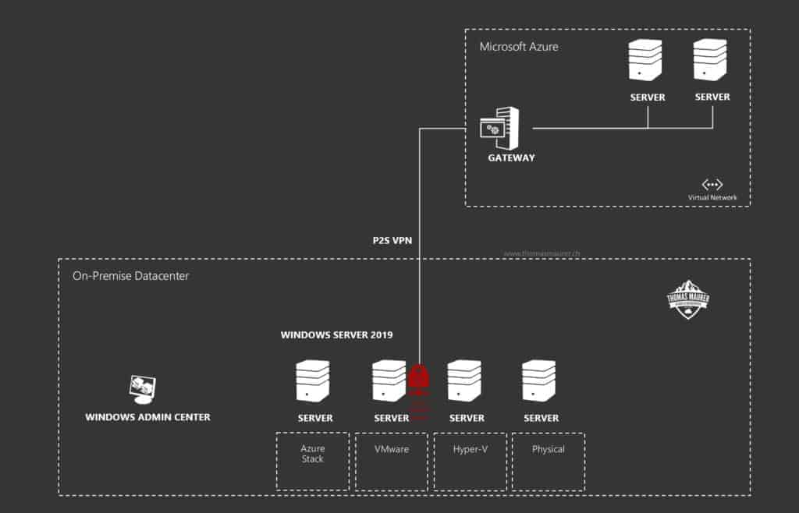

**Use Cases**

* Azure Network Adapter is a great choice for quickly connecting one-off servers to your Azure public cloud network. An edge environment potentially where infrastructure is hard to come by and there may not be a firewall with these types of capabilities in place, the Azure Network Adapter is a great way to fill this gap
* Additionally, if you have a development environment in Azure that you need to quickly connect on-premises resources for testing or POC, this would be a great solution as well

# Manage identities

## Manage Azure Active Directory (AD)

**Azure Tenant**

A tenant is a representation of an organization. It's a dedicated instance of Azure AD that an organization or app developer receives when the organization or app developer creates a relationship with Microsoft

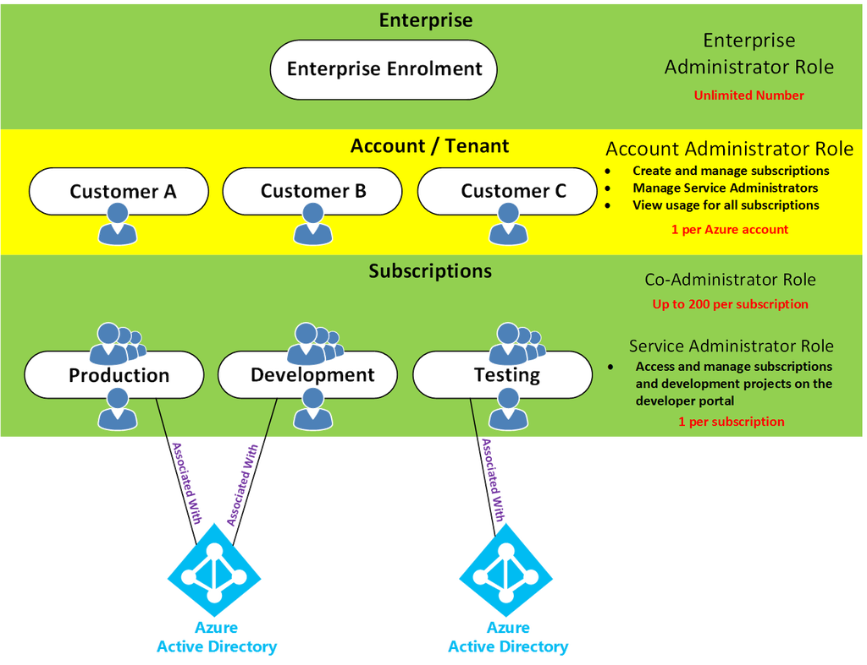

* An organization can have multiple subscriptions
* A subscription can have multiple licenses
* Licenses can be assigned to individual user accounts
* User accounts are stored in an Azure AD tenant

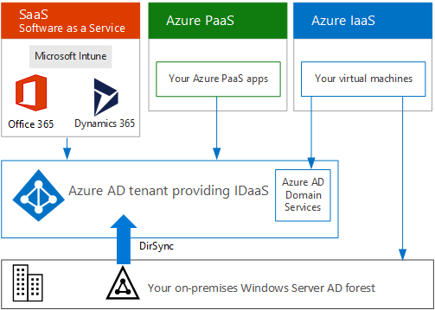

Azure tenant is a directory, 1 tenant can have many subscriptions

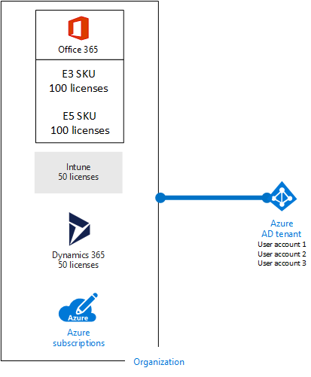

**Environment Types**

1. Work and school (Azure AD accounts) or Microsoft accounts (such as outlook.com and live.com)
2. Social and local accounts (Azure AD B2C)

### Add custom domains

1. Sign in to the [Azure portal](https://portal.azure.com/) using a Global administrator account for the directory.
2. Search for and select Azure Active Directory from any page. Then select **Custom domain names** > **Add custom domain**.

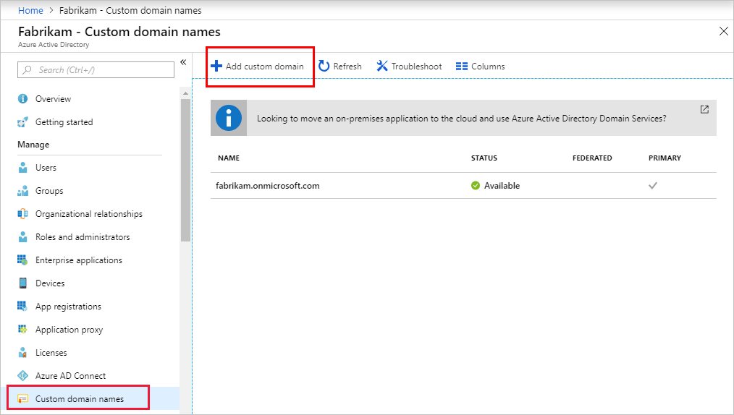

1. In **Custom domain name**, enter your organization's new name, in this example, contoso.com. Select **Add domain**.

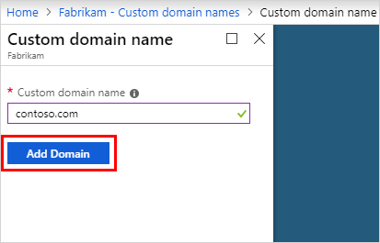

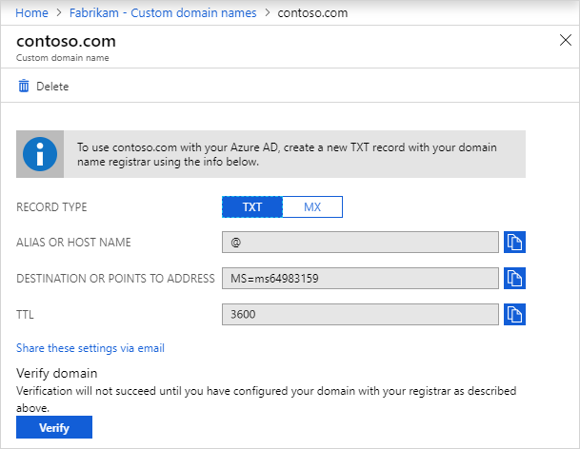

**Verify your custom domain name**

1. Sign in to the [Azure portal](https://portal.azure.com/) using a Global administrator account for the directory.
2. Search for and select Azure Active Directory from any page, then select **Custom domain names**.
3. In **Custom domain names**, select the custom domain name. In this example, select **contoso.com**.

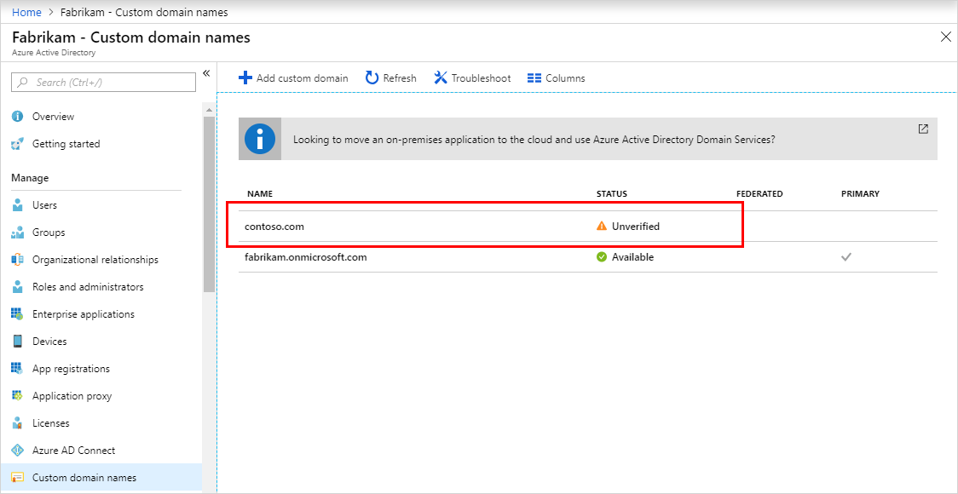

1. On the **contoso.com** page, select **Verify** to make sure your custom domain is properly registered and is valid for Azure AD.

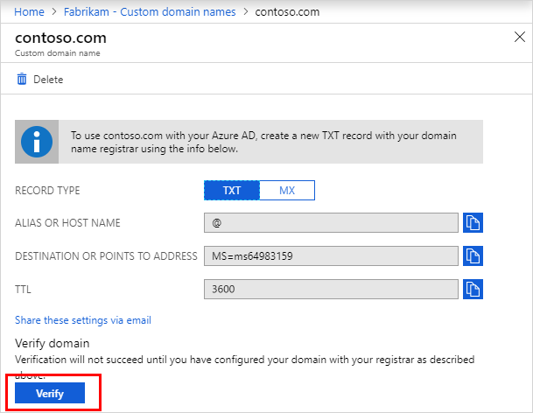

### Azure AD Join

To get a device in Azure AD, you have multiple options:

* **Azure AD registered**
  + Devices that are Azure AD registered are typically personally owned or mobile devices, and are signed into with a personal Microsoft account or another local account.
    - Windows 10
    - iOS
    - Android
    - MacOS
* **Azure AD joined**
  + Devices that are Azure AD joined are owned by an organization, and are signed in to with an Azure AD account belonging to that organization. They exist only in the cloud.
    - Windows 10
* **Hybrid Azure AD joined**
  + Devices that are hybrid Azure AD joined are owned by an organization, and are signed in to with an Azure AD account belonging to that organization. They exist in the cloud and on-premises.
    - Windows 7, 8.1, or 10
    - Windows Server 2008 or newer

### Configure self-service password reset

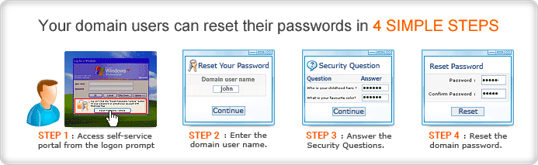

### Manage multiple directories

### In Azure Active Directory (Azure AD), each tenant is a fully independent resource: a peer that is logically independent from the other tenants that you manage.

**Resource independence**

* If you create or delete a resource in one tenant, it has no impact on any resource in another tenant, with the partial exception of external users.
* If you use one of your domain names with one tenant, it cannot be used with any other tenant.

## Administrative independence

* By default, the user who creates a tenant is added as an external user in that new tenant, and assigned the global administrator role in that tenant.
* The administrators of tenant 'Contoso' have no direct administrative privileges to tenant 'Test,' unless an administrator of 'Test' specifically grants them these privileges. However, administrators of 'Contoso' can control access to tenant 'Test' if they control the user account that created 'Test.'
* If you add/remove an administrator role for a user in one tenant, the change does not affect the administrator roles that the user has in another tenant.

## Manage Azure AD objects (users, groups, and devices)

### Create users and groups

1. Sign in to the [Azure portal](https://portal.azure.com/) using a Global administrator account for the directory.
2. Search for and select **Azure Active Directory**.

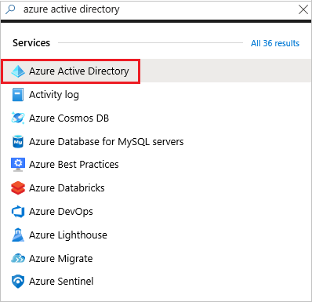

1. On the **Active Directory** page, select **Groups** and then select **New group**.

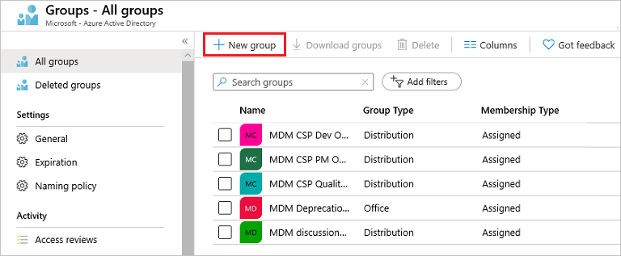

1. In the **New Group** page, fill out the required information.

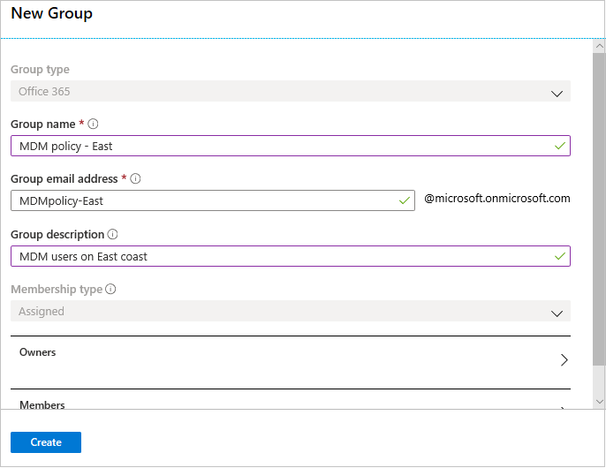

1. Select **Create**.

Your group is created and ready for you to add members.

1. Select the **Members** area from the **Group** page, and then begin searching for the members to add to your group from the **Select members** page.
2. When you're done adding members, choose **Select**.

The **Group Overview** page updates to show the number of members who are now added to the group.

### Manage user and group properties

There are four ways to assign resource access rights to your users:

* **Direct assignment.** The resource owner directly assigns the user to the resource.
* **Group assignment.** The resource owner assigns an Azure AD group to the resource, which automatically gives all of the group members access to the resource.
* **Rule-based assignment.** The resource owner creates a group and uses a rule to define which users are assigned to a specific resource.
* **External authority assignment.** Access comes from an external source, such as an on-premises directory or a SaaS app.

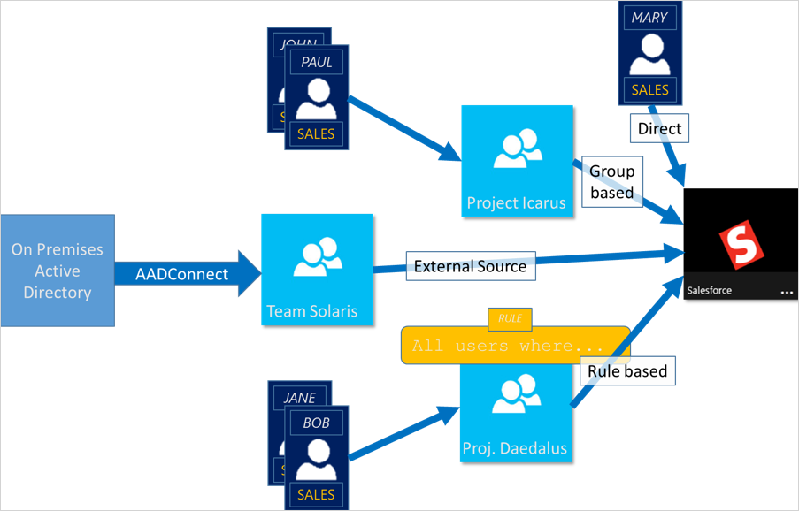

### Manage device settings

1. Sign in to the [Azure portal](https://portal.azure.com/).
2. Browse to **Azure Active Directory** > **Devices**.

The **Devices** page enables you to:

* Configure your device settings
* Locate devices
* Perform device identity management tasks
* Review device-related audit logs

Users may join devices to Azure AD

Additional local administrators on Azure AD joined devices

Users may register their devices with Azure AD

Require Multi-Factor Auth to join devices

Maximum number of devices

Users may sync settings and app data across devices

You have two options to locate registered and joined devices:

* **All devices** in the **Manage** section of the **Devices** page
* **Devices** in the **Manage** section of a **User** page

With both options, you can get to a view that:

* Enables you to search for devices using the display name or device ID as filter.
* Provides you with detailed overview of registered and joined devices
* Enables you to perform common device management tasks

### Perform bulk user updates

1. [Sign in to your Azure AD organization](https://aad.portal.azure.com/) with an account that is a User administrator in the organization.
2. In Azure AD, select **Users** > **Bulk create**.
3. On the **Bulk create user** page, select **Download** to receive a valid comma-separated values (CSV) file of user properties, and then add add users you want to create.

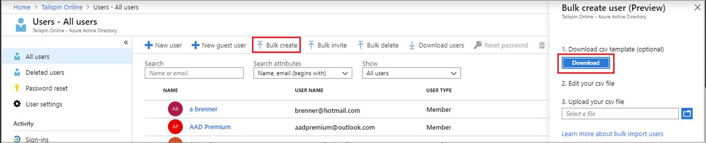

1. Open the CSV file and add a line for each user you want to create. The only required values are **Name**, **User principal name**, **Initial password** and **Block sign in (Yes/No)**. Then save the file.



1. On the **Bulk create user (Preview)** page, under Upload your CSV file, browse to the file. When you select the file and click **Submit**, validation of the CSV file starts.
2. After the file contents are validated, you’ll see **File uploaded successfully**. If there are errors, you must fix them before you can submit the job.
3. When your file passes validation, select **Submit** to start the Azure bulk operation that imports the new users.
4. When the import operation completes, you'll see a notification of the bulk operation job status.

**Verify users in the Azure portal**

1. [Sign in to the Azure AD admin center](https://aad.portal.azure.com/) with an account that is a User administrator in the organization.
2. In the navigation pane, select **Azure Active Directory**.
3. Under **Manage**, select **Users**.
4. Under **Show**, select **All users** and verify that the users you created are listed.

### Manage guest accounts

1. Sign in to the [Azure portal](https://portal.azure.com/) as an Azure AD administrator.
2. In the left pane, select **Azure Active Directory**.
3. Under **Manage**, select **Users**.
4. Select **New guest user**.
5. On the **New user** page, select **Invite user** and then add the guest user's information.
   * **Name.** The first and last name of the guest user.
   * **Email address (required)**. The email address of the guest user.
   * **Personal message (optional)** Include a personal welcome message to the guest user.
   * **Groups**: You can add the guest user to one or more existing groups, or you can do it later.
   * **Directory role**: If you require Azure AD administrative permissions for the user, you can add them to an Azure AD role.
6. Select **Invite** to automatically send the invitation to the guest user. A notification appears in the upper right with the message **Successfully invited user**.
7. After you send the invitation, the user account is automatically added to the directory as a guest.

**Assign an app to the guest user**

1. Sign in to the Azure portal as an Azure AD administrator.
2. In the left pane, select **Enterprise applications**.
3. Select **New application**.
4. Under **Add from the gallery**, search for **Salesforce**, and then select it.

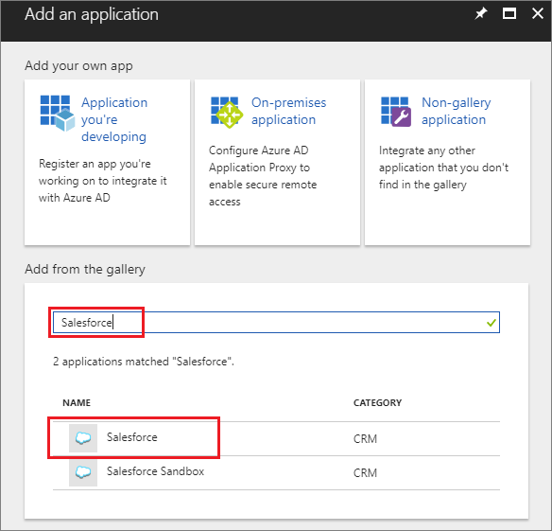

1. Select **Add**.
2. Under **Manage**, select **Single sign-on**, and under **Single Sign-on Mode**, select **Password-based Sign-on**, and click **Save**.
3. Under **Manage**, select **Users and groups** > **Add user** > **Users and groups**.
4. Use the search box to search for the test user (if necessary) and select the test user in the list. Then click **Select**.
5. Select **Assign**.

**Accept the invitation**

1. Sign in to your test guest user's email account.
2. In your inbox, find the "You're invited" email.

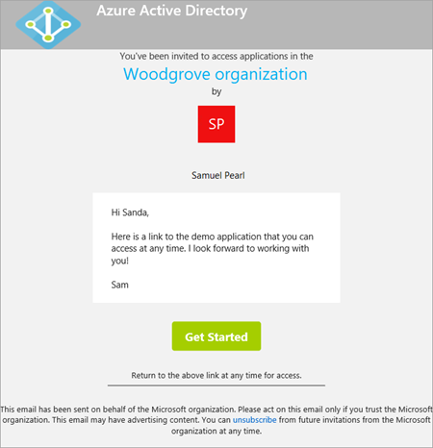

1. In the email body, select **Get Started**. A **Review permissions** page opens in the browser.
2. Select **Accept**. The Access Panel opens, which lists the applications the guest user can access.

## Implement and manage hybrid identities

Today, businesses, and corporations are becoming more and more a mixture of on-premises and cloud applications**. Users require access to those applications both on-premises and in the cloud**. Managing users both on-premises and in the cloud poses challenging scenarios.

Microsoft’s identity solutions span on-premises and cloud-based capabilities. These solutions create a common user identity for authentication and authorization to all resources, regardless of location. We call this **hybrid identity**.

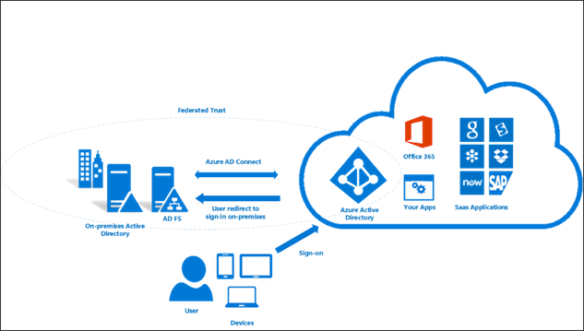

### Install Azure AD Connect, including password hash and pass-through synchronization

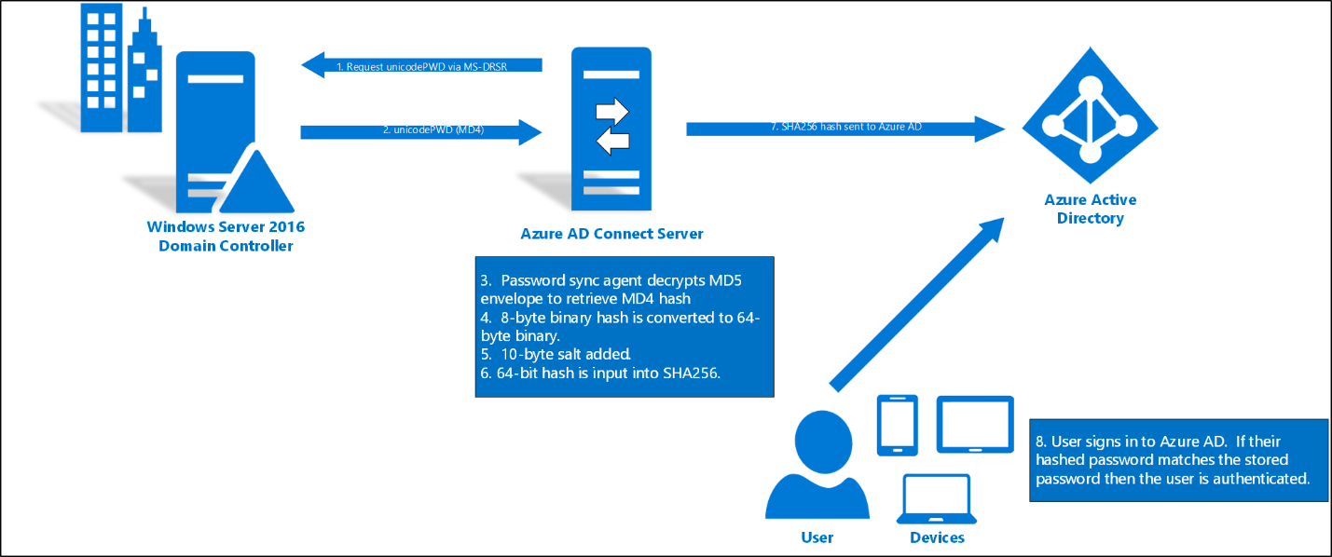

1. Every two minutes, the password hash synchronization agent on the AD Connect server requests stored password hashes (the Unicode Password attribute) from a DC. All AD permissions (granted by default on installation) to obtain the password hashes.
2. Before sending, the DC encrypts the MD4 password hash by using a key that is a [MD5](https://www.rfc-editor.org/rfc/rfc1321.txt) hash of the RPC session key and a salt. It then sends the result to the password hash synchronization agent over RPC.
3. After the password hash synchronization agent has the encrypted envelope, it uses [MD5CryptoServiceProvider](https://msdn.microsoft.com/library/System.Security.Cryptography.MD5CryptoServiceProvider.aspx) and the salt to generate a key to decrypt the received data back to its original MD4 format.
4. The password hash synchronization agent expands the 16-byte binary password hash to 64 bytes by first converting the hash to a 32-byte hexadecimal string, then converting this string back into binary with UTF-16 encoding.
5. The password hash synchronization agent adds a per user salt, consisting of a 10-byte length salt, to the 64-byte binary to further protect the original hash.
6. The password hash synchronization agent then combines the MD4 hash plus the per user salt, and inputs it into the [PBKDF2](https://www.ietf.org/rfc/rfc2898.txt) function. 1000 iterations of the [HMAC-SHA256](https://msdn.microsoft.com/library/system.security.cryptography.hmacsha256.aspx) keyed hashing algorithm are used.
7. The password hash synchronization agent takes the resulting 32-byte hash, concatenates both the per user salt and the number of SHA256 iterations to it (for use by Azure AD), then transmits the string from Azure AD Connect to Azure AD over SSL.
8. When a user attempts to sign in to Azure AD and enters their password, the password is run through the same MD4+salt+PBKDF2+HMAC-SHA256 process. If the resulting hash matches the hash stored in Azure AD, the user has entered the correct password and is authenticated.

### Use Azure AD Connect to configure federation with on-premises Active Directory Domain Services (AD DS)

Configuring AD FS with Azure AD Connect is simple and only requires a few clicks. The following is required before the configuration.

* A Windows Server 2012 R2 or later server for the federation server with remote management enabled
* A Windows Server 2012 R2 or later server for the Web Application Proxy server with remote management enabled
* An SSL certificate for the federation service name you intend to use (for example sts.contoso.com)

To configure your AD FS farm using Azure AD Connect, ensure WinRM is enabled on the remote servers.

1. Create a new AD FS farm or use an existing AD FS farm
2. Specify the AD FS servers
3. Specify the Web Application Proxy servers
4. Specify the service account for the AD FS service
5. Select the Azure AD domain that you wish to federate
6. Verify the Azure AD domain selected for federation
7. Configuring federation with PingFederate
8. Verify the domain
9. Export the PingFederate settings
10. Verify federation connectivity
11. Verify federation login
12. Configure and verify pages
13. Staging mode
14. Verify your federation configuration

<https://docs.microsoft.com/en-us/azure/active-directory/hybrid/how-to-connect-install-custom#configuring-federation-with-ad-fs>

### Manage Azure AD Connect

Add additional sync admins

Assign licenses to Azure AD Premium and Enterprise Mobility Suite users

**To assign an Azure AD Premium or Enterprise Mobility Suite License**

1. Sign in to the Azure portal as an admin.
2. On the left, select **Active Directory**.
3. On the **Active Directory** page, double-click the directory that has the users you want to set up.
4. At the top of the directory page, select **Licenses**.
5. On the **Licenses** page, select **Active Directory Premium** or **Enterprise Mobility Suite**, and then click **Assign**.
6. In the dialog box, select the users you want to assign licenses to, and then click the check mark icon to save the changes.

**To verify the scheduled synchronization task**

1. Sign in to the Azure portal as an admin.
2. On the left, select **Active Directory**.
3. On the left, select **Azure AD Connect**
4. At the top of the page, note the last synchronization.

**Start a scheduled synchronization task**

1. Double-click on the Azure AD Connect desktop shortcut to start the wizard.
2. Click **Configure**.
3. On the tasks screen, select the **Customize synchronization options** and click **Next**
4. Enter your Azure AD credentials
5. Click **Next**. Click **Next**. Click **Next**.
6. On the **Ready to Configure** screen, ensure that the **Start the synchronization process when configuration completes** box is selected.
7. Click **Configure**.

**Additional tasks available in Azure AD Connect**

|  |  |
| --- | --- |
| **Additional task** | **Description** |
| **Privacy Settings** | View what telemetry data is being shared with Microsoft. |
| **View current configuration** | View your current Azure AD Connect solution. This includes general settings, synchronized directories, and sync settings. |
| **Customize synchronization options** | Change the current configuration like adding additional Active Directory forests to the configuration, or enabling sync options such as user, group, device, or password write-back. |
| **Configure device options** | Device options available for synchronization |
| **Refresh directory schema** | Allows you to add new on-premises directory objects for synchronization |
| **Configure Staging Mode** | Stage information that is not immediately synchronized and is not exported to Azure AD or on-premises Active Directory. With this feature, you can preview the synchronizations before they occur. |
| **Change user sign-in** | Change the authentication method users are using to sign-in |
| **Manage federation** | Manage your AD FS infrastructure, renew certificates, and add AD FS servers |
| **Troubleshoot** | Help with troubleshooting Azure AD Connect issues |

### Manage password sync and password writeback

To set up the appropriate permissions for password writeback to occur, complete the following steps:

1. In your on-premises AD DS environment, open **Active Directory Users and Computers** with an account that has the appropriate *domain administrator* permissions.
2. From the **View** menu, make sure that **Advanced features** are turned on.
3. In the left panel, right-select the object that represents the root of the domain and select **Properties** > **Security** > **Advanced**.
4. From the **Permissions** tab, select **Add**.
5. For **Principal**, select the account that permissions should be applied to (the account used by Azure AD Connect).
6. In the **Applies to** drop-down list, select **Descendant User objects**.
7. Under *Permissions*, select the boxes for the following options:
   * **Change password**
   * **Reset password**
8. Under *Properties*, select the boxes for the following options. You need to scroll through the list to find these options, which may already be set by default:
   * **Write lockoutTime**
   * **Write pwdLastSet**

[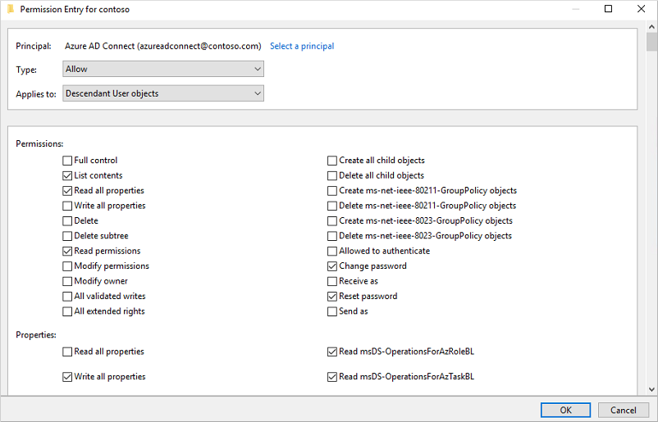](https://docs.microsoft.com/en-us/azure/active-directory/authentication/media/tutorial-enable-sspr-writeback/set-ad-ds-permissions.png#lightbox)

1. When ready, select **Apply / OK** to apply the changes and exit any open dialog boxes.

**Enable password writeback in Azure AD Connect**

1. Sign in to your Azure AD Connect server and start the **Azure AD Connect** configuration wizard.
2. On the **Welcome** page, select **Configure**.
3. On the **Additional tasks** page, select **Customize synchronization options**, and then select **Next**.
4. On the **Connect to Azure AD** page, enter a global administrator credential for your Azure tenant, and then select **Next**.
5. On the **Connect directories** and **Domain/OU** filtering pages, select **Next**.
6. On the **Optional features** page, select the box next to **Password writeback** and select **Next**.

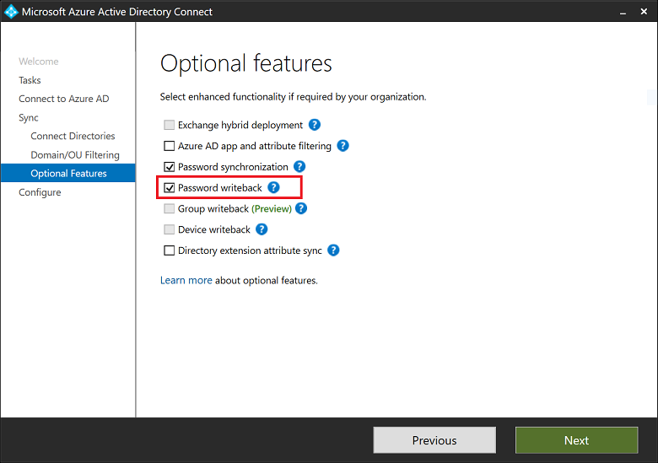

1. On the **Ready to configure** page, select **Configure** and wait for the process to finish.
2. When you see the configuration finish, select **Exit**.

<https://docs.microsoft.com/en-us/azure/active-directory/authentication/tutorial-enable-sspr-writeback>

## Implement multi-factor authentication (MFA)

The security of two-step verification lies in its layered approach. Compromising multiple authentication factors presents a significant challenge for attackers. Even if an attacker manages to learn the user's password, it is useless without also having possession of the additional authentication method. It works by requiring two or more of the following authentication methods:

* Something you know (typically a password)
* Something you have (a trusted device that is not easily duplicated, like a phone)
* Something you are (biometrics)

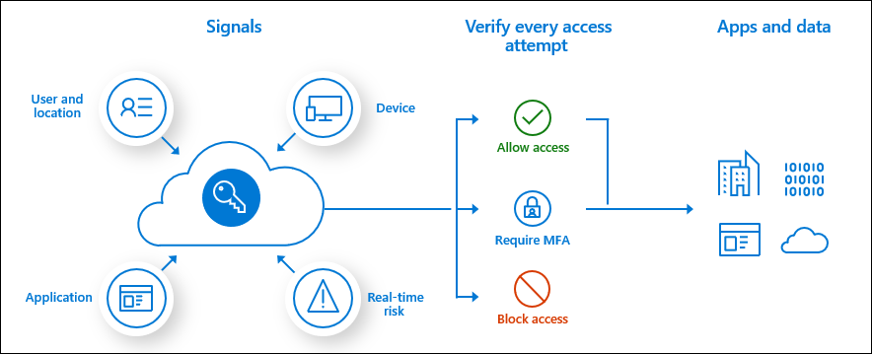

### Configure user accounts for MFA

You can access settings related to Azure Multi-Factor Authentication from the Azure portal by browsing to **Azure Active Directory** > **Security** > **MFA**.

**Block and unblock users**

Use the block and unblock users feature to prevent users from receiving authentication requests. Any authentication attempts for blocked users are automatically denied. Users remain blocked for 90 days from the time that they are blocked.

**Block a user**

1. Sign in to the [Azure portal](https://portal.azure.com/) as an administrator.
2. Browse to **Azure Active Directory** > **Security** > **MFA** > **Block/unblock users**.
3. Select **Add** to block a user.
4. Select the **Replication Group**. Enter the username for the blocked user as **username@domain.com**. Enter a comment in the **Reason** field.
5. Select **Add** to finish blocking the user.

**Unblock a user**

1. Sign in to the [Azure portal](https://portal.azure.com/) as an administrator.
2. Browse to **Azure Active Directory** > **Security** > **MFA** > **Block/unblock users**.
3. Select **Unblock** in the **Action** column next to the user to unblock.
4. Enter a comment in the **Reason for unblocking** field.
5. Select **Unblock** to finish unblocking the user.

**View the one-time bypass report**

1. Sign in to the [Azure portal](https://portal.azure.com/).
2. Browse to **Azure Active Directory** > **Security** > **MFA** > **One-time bypass**.

### Enable MFA by using bulk update

Using PowerShell is a good option when you need to bulk enable users. As an example, the following script loops through a list of users and enables MFA on their accounts:

PowerShellCopy

$users = "bsimon@contoso.com","jsmith@contoso.com","ljacobson@contoso.com"

foreach ($user in $users)

{

$st = New-Object -TypeName Microsoft.Online.Administration.StrongAuthenticationRequirement

$st.RelyingParty = "*"

$st.State = "Enabled"

$sta = @($st)

Set-MsolUser -UserPrincipalName $user -StrongAuthenticationRequirements $sta

}

### Configure fraud alerts

Configure the fraud alert feature so that your users can report fraudulent attempts to access their resources. Users can report fraud attempts by using the mobile app or through their phone.

**Turn on fraud alerts**

1. Sign in to the [Azure portal](https://portal.azure.com/) as an administrator.
2. Browse to **Azure Active Directory** > **Security** > **MFA** > **Fraud alert**.
3. Set the **Allow users to submit fraud alerts** setting to **On**.
4. Select **Save**.

### Configure bypass options

The one-time bypass feature allows a user to authenticate a single time without performing two-step verification. The bypass is temporary and expires after a specified number of seconds. In situations where the mobile app or phone is not receiving a notification or phone call, you can allow a one-time bypass so the user can access the desired resource.

**Create a one-time bypass**

1. Sign in to the [Azure portal](https://portal.azure.com/) as an administrator.
2. Browse to **Azure Active Directory** > **Security** > **MFA** > **One-time bypass**.
3. Select **Add**.
4. If necessary, select the replication group for the bypass.
5. Enter the username as **username@domain.com**. Enter the number of seconds that the bypass should last. Enter the reason for the bypass.
6. Select **Add**. The time limit goes into effect immediately. The user needs to sign in before the one-time bypass expires.

### Configure Trusted IPs

1. Sign in to the [Azure portal](https://portal.azure.com/).
2. On the left, select **Azure Active Directory** > **Security** > **Conditional Access** > **Named locations**.
3. Select **Configure MFA trusted IPs**.
4. On the **Service Settings** page, under **Trusted IPs**, choose from any of the following two options:
   * **For requests from federated users originating from my intranet**: To choose this option, select the check box. All federated users who sign in from the corporate network bypass two-step verification by using a claim that is issued by AD FS. Ensure that AD FS has a rule to add the intranet claim to the appropriate traffic. If the rule does not exist, create the following rule in AD FS:

c:[Type== "http://schemas.microsoft.com/ws/2012/01/insidecorporatenetwork"] => issue(claim = c);

* + **For requests from a specific range of public IPs**: To choose this option, enter the IP addresses in the text box by using CIDR notation.
    - For IP addresses that are in the range xxx.xxx.xxx.1 through xxx.xxx.xxx.254, use notation like **xxx.xxx.xxx.0/24**.
    - For a single IP address, use notation like **xxx.xxx.xxx.xxx/32**.
    - Enter up to 50 IP address ranges. Users who sign in from these IP addresses bypass two-step verification.

1. Select **Save**.

### Configure verification methods

1. Browse to **Azure Active Directory**, **Users**, **Multi-Factor Authentication**.

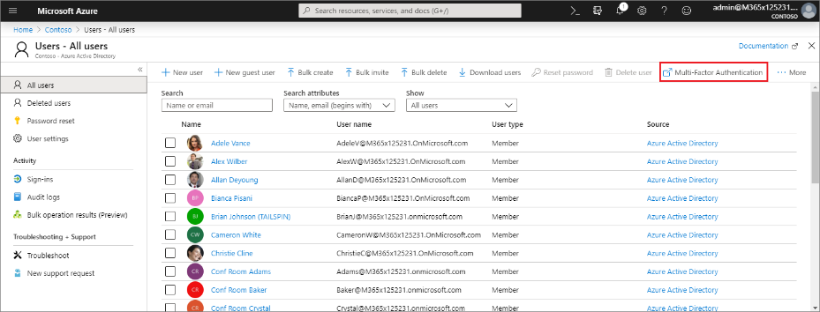

1. In the new tab that opens browse to **service settings**.
2. Under **verification options**, check all of the boxes for methods available to users.

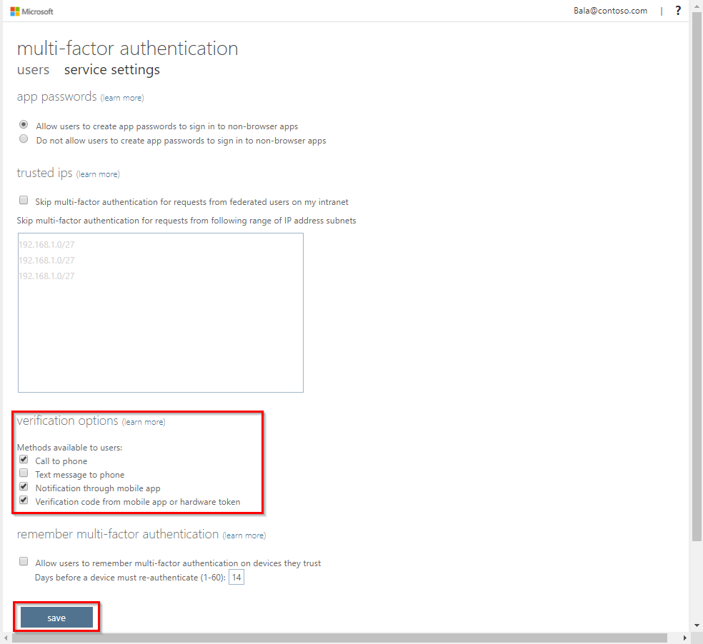

1. Click on **Save**.

Close the **service settings** tab.